**TRƯỜNG ĐẠI HỌC TÀI NGUYÊN VÀ MÔI TRƯỜNG TP.HCM**

**KHOA CÔNG NGHỆ THÔNG TIN**



**BÁO CÁO MÔN HỌC**

**LẬP TRÌNH ỨNG DỤNG DI ĐỘNG**

**TỔNG HỢP LAB THỰC HÀNH**

Giảng viên hướng dẫn: **ThS.Phạm Trọng Huynh**

Sinh viên thực hiện: **Nguyễn Trần Minh Khang**

Mã số sinh viên: **1150080056**

Lớp**: K11_THMT**

Khoá**: 2020 - 2025**

***TP. Hồ Chí Minh,2 tháng 12 năm 2025***

**TRƯỜNG ĐẠI HỌC TÀI NGUYÊN VÀ MÔI TRƯỜNG TP.HCM**

**KHOA CÔNG NGHỆ THÔNG TIN**



**BÁO CÁO MÔN HỌC**

**LẬP TRÌNH ỨNG DỤNG DI ĐỘNG**

**TỔNG HỢP LAB THỰC HÀNH**

Giảng viên hướng dẫn: **Ths.Phạm Trọng Huynh**

Sinh viên thực hiện: **Nguyễn Trần Minh Khang**

Mã số sinh viên: **1150080051**

Lớp**: K11_THMT**

Khoá**: 2020 - 2025**

***TP. Hồ Chí Minh,2 tháng 12 năm 2025***

**MỤC LỤC**

CHƯƠNG 1: THỰC HÀNH BUỔI 11 1

Lab 1: 1

Bài 1: 1

Bài 2: 8

Bài 3: 11

Lab 2: 17

CHƯƠNG 2: THỰC HÀNH BUỔI 12 34

PHẦN III: THỰC HIỆN LAB 3 (TRUYỆN CƯỜI) 45

CHƯƠNG 3: THỰC HÀNH BUỔI 13 58

Bài 6: 58

Bài 7: 87

Bài 8: 106

CHƯƠNG 4: THỰC HÀNH BUỔI 14 132

CHƯƠNG 5: THỰC HÀNH BUỔI 15 150

# CHƯƠNG 1: THỰC HÀNH BUỔI 11

## Lab 1:

### Bài 1:

Bước 1:

layout/activity_main.xml

<?xml version="1.0" encoding="utf-8"?>

<LinearLayout

xmlns:android="http://schemas.android.com/apk/res/android"

xmlns:app="http://schemas.android.com/apk/res-auto"

xmlns:tools="http://schemas.android.com/tools"

android:layout_width="match_parent"

android:layout_height="match_parent"

android:orientation="vertical"

android:padding="16dp"

tools:context=".MainActivity">

<EditText

android:id="@+id/edtA"

android:layout_width="match_parent"

android:layout_height="wrap_content"

android:hint="Nhập số A"

android:inputType="numberDecimal|numberSigned"

android:textSize="24sp" />

<EditText

android:id="@+id/edtB"

android:layout_width="match_parent"

android:layout_height="wrap_content"

android:layout_marginTop="8dp"

android:hint="Nhập số B"

android:inputType="numberDecimal|numberSigned"

android:textSize="24sp" />

<LinearLayout

android:layout_width="match_parent"

android:layout_height="wrap_content"

android:layout_marginTop="16dp"

android:orientation="horizontal"

android:weightSum="5">

<Button

android:id="@+id/btnPlus"

android:layout_width="0dp"

android:layout_height="wrap_content"

android:layout_weight="1"

android:text="+"

android:textSize="24sp" />

<Button

android:id="@+id/btnSub"

android:layout_width="0dp"

android:layout_height="wrap_content"

android:layout_weight="1"

android:text="-"

android:textSize="24sp" />

<Button

android:id="@+id/btnMul"

android:layout_width="0dp"

android:layout_height="wrap_content"

android:layout_weight="1"

android:text="*"

android:textSize="24sp" />

<Button

android:id="@+id/btnDiv"

android:layout_width="0dp"

android:layout_height="wrap_content"

android:layout_weight="1"

android:text="/"

android:textSize="24sp" />

<Button

android:id="@+id/btnMod"

android:layout_width="0dp"

android:layout_height="wrap_content"

android:layout_weight="1"

android:text="%"

android:textSize="24sp" />

</LinearLayout>

<TextView

android:id="@+id/tvResult"

android:layout_width="match_parent"

android:layout_height="wrap_content"

android:layout_marginTop="24dp"

android:gravity="center"

android:text="Kết quả"

android:textSize="30sp"

android:textStyle="bold" />

</LinearLayout>

Bước 2: MainActivity.java

java/com/example/…../……

package com.example…..; // Thay đổi tên package cho phù hợp

import androidx.appcompat.app.AppCompatActivity;

import android.os.Bundle;

import android.view.View;

import android.widget.Button;

import android.widget.EditText;

import android.widget.TextView;

import android.widget.Toast;

public class MainActivity extends AppCompatActivity {

EditText edtA, edtB;

TextView tvResult;

Button btnPlus, btnSub, btnMul, btnDiv, btnMod;

@Override

protected void onCreate(Bundle savedInstanceState) {

super.onCreate(savedInstanceState);

setContentView(R.layout.activity_main);

initControl();

}

private void initControl() {

edtA = findViewById(R.id.edtA);

edtB = findViewById(R.id.edtB);

tvResult = findViewById(R.id.tvResult);

btnPlus = findViewById(R.id.btnPlus);

btnSub = findViewById(R.id.btnSub);

btnMul = findViewById(R.id.btnMul);

btnDiv = findViewById(R.id.btnDiv);

btnMod = findViewById(R.id.btnMod);

btnPlus.setOnClickListener(new View.OnClickListener() {

@Override

public void onClick(View v) {

calculate("+");

}

});

btnSub.setOnClickListener(new View.OnClickListener() {

@Override

public void onClick(View v) {

calculate("-");

}

});

btnMul.setOnClickListener(new View.OnClickListener() {

@Override

public void onClick(View v) {

calculate("*");

}

});

btnDiv.setOnClickListener(new View.OnClickListener() {

@Override

public void onClick(View v) {

calculate("/");

}

});

btnMod.setOnClickListener(new View.OnClickListener() {

@Override

public void onClick(View v) {

calculate("%");

}

});

}

private void calculate(String operator) {

try {

String strA = edtA.getText().toString();

String strB = edtB.getText().toString();

if (strA.isEmpty() || strB.isEmpty()) {

Toast.makeText(this, "Vui lòng nhập cả hai số", Toast.LENGTH_SHORT).show();

return;

}

double a = Double.parseDouble(strA);

double b = Double.parseDouble(strB);

double result = 0;

switch (operator) {

case "+":

result = a + b;

break;

case "-":

result = a - b;

break;

case "*":

result = a * b;

break;

case "/":

if (b == 0) {

Toast.makeText(this, "Không thể chia cho 0", Toast.LENGTH_SHORT).show();

return;

}

result = a / b;

break;

case "%":

if (b == 0) {

Toast.makeText(this, "Không thể chia cho 0", Toast.LENGTH_SHORT).show();

return;

}

result = a % b;

break;

}

// Hiển thị kết quả (làm tròn nếu là số nguyên)

if (result == (long) result) {

tvResult.setText(String.format("%d", (long) result));

} else {

tvResult.setText(String.format("%.2f", result));

}

} catch (NumberFormatException e) {

Toast.makeText(this, "Đầu vào không hợp lệ", Toast.LENGTH_SHORT).show();

}

}

}

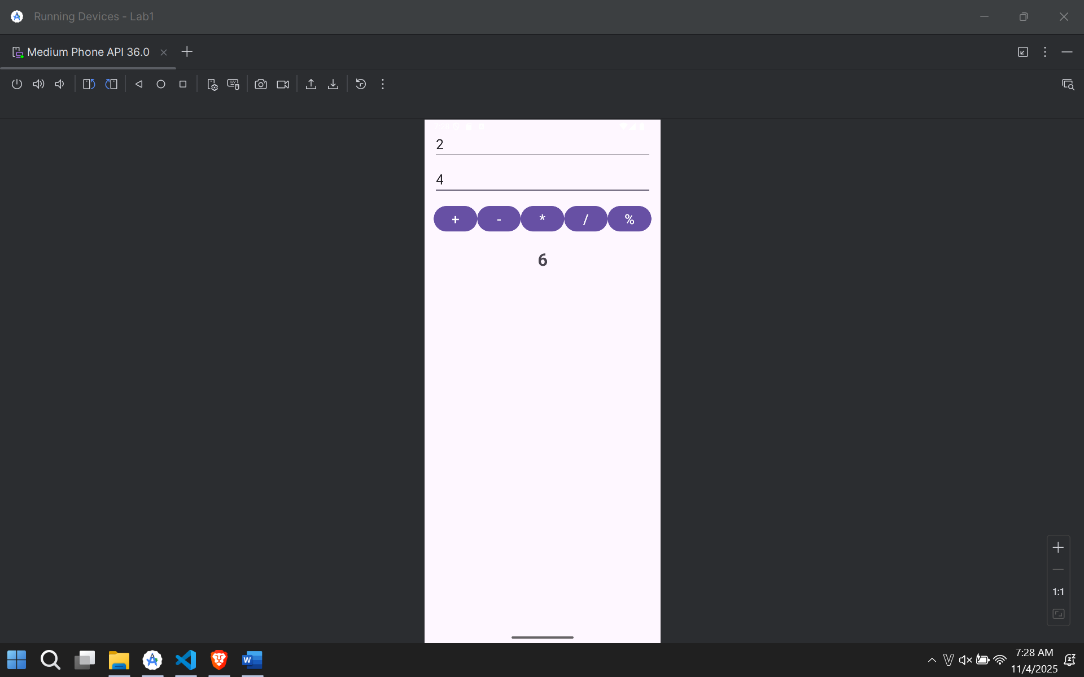

### Bài 2:

Bước 1 :

Layout/activity_main.xml

<?xml version="1.0" encoding="utf-8"?>

<LinearLayout

xmlns:android="http://schemas.android.com/apk/res/android"

xmlns:app="http://schemas.android.com/apk/res-auto"

xmlns:tools="http://schemas.android.com/tools"

android:layout_width="match_parent"

android:layout_height="match_parent"

android:orientation="vertical"

android:gravity="center"

android:padding="16dp"

tools:context=".MainActivity">

<ImageView

android:id="@+id/ivDice"

android:layout_width="200dp"

android:layout_height="200dp"

android:src="@drawable/dice_1" />

<Button

android:id="@+id/btnRoll"

android:layout_width="wrap_content"

android:layout_height="wrap_content"

android:layout_marginTop="32dp"

android:text="Tung Xúc Xắc"

android:textSize="20sp" />

</LinearLayout>

Bước 2:

MainActivity.java

package com.example.lab1;  
  
import androidx.appcompat.app.AppCompatActivity;  
import android.os.Bundle;  
import android.view.View;  
import android.widget.Button;  
import android.widget.ImageView;  
import java.util.Random;  
  
public class MainActivity extends AppCompatActivity {  
  
 ImageView ivDice;  
 Button btnRoll;  
 Random random = new Random();  
  
 @Override  
 protected void onCreate(Bundle savedInstanceState) {  
 super.onCreate(savedInstanceState);  
 setContentView(R.layout.*activity_main*);  
  
 ivDice = findViewById(R.id.*ivDice*);  
 btnRoll = findViewById(R.id.*btnRoll*);  
  
 btnRoll.setOnClickListener(new View.OnClickListener() {  
 @Override  
 public void onClick(View v) {  
 rollDice();  
 }  
 });  
 }  
  
 private void rollDice() {  
 int roll = random.nextInt(6) + 1; // Tạo số ngẫu nhiên từ 1 đến 6  
  
 switch (roll) {  
 case 1:  
 ivDice.setImageResource(R.drawable.*dice_1*);  
 break;  
 case 2:  
 ivDice.setImageResource(R.drawable.*dice_2*);  
 break;  
 case 3:  
 ivDice.setImageResource(R.drawable.*dice_3*);  
 break;  
 case 4:  
 ivDice.setImageResource(R.drawable.*dice_4*);  
 break;  
 case 5:  
 ivDice.setImageResource(R.drawable.*dice_5*);  
 break;  
 case 6:  
 ivDice.setImageResource(R.drawable.*dice_6*);  
 break;  
 }  
 }  
}

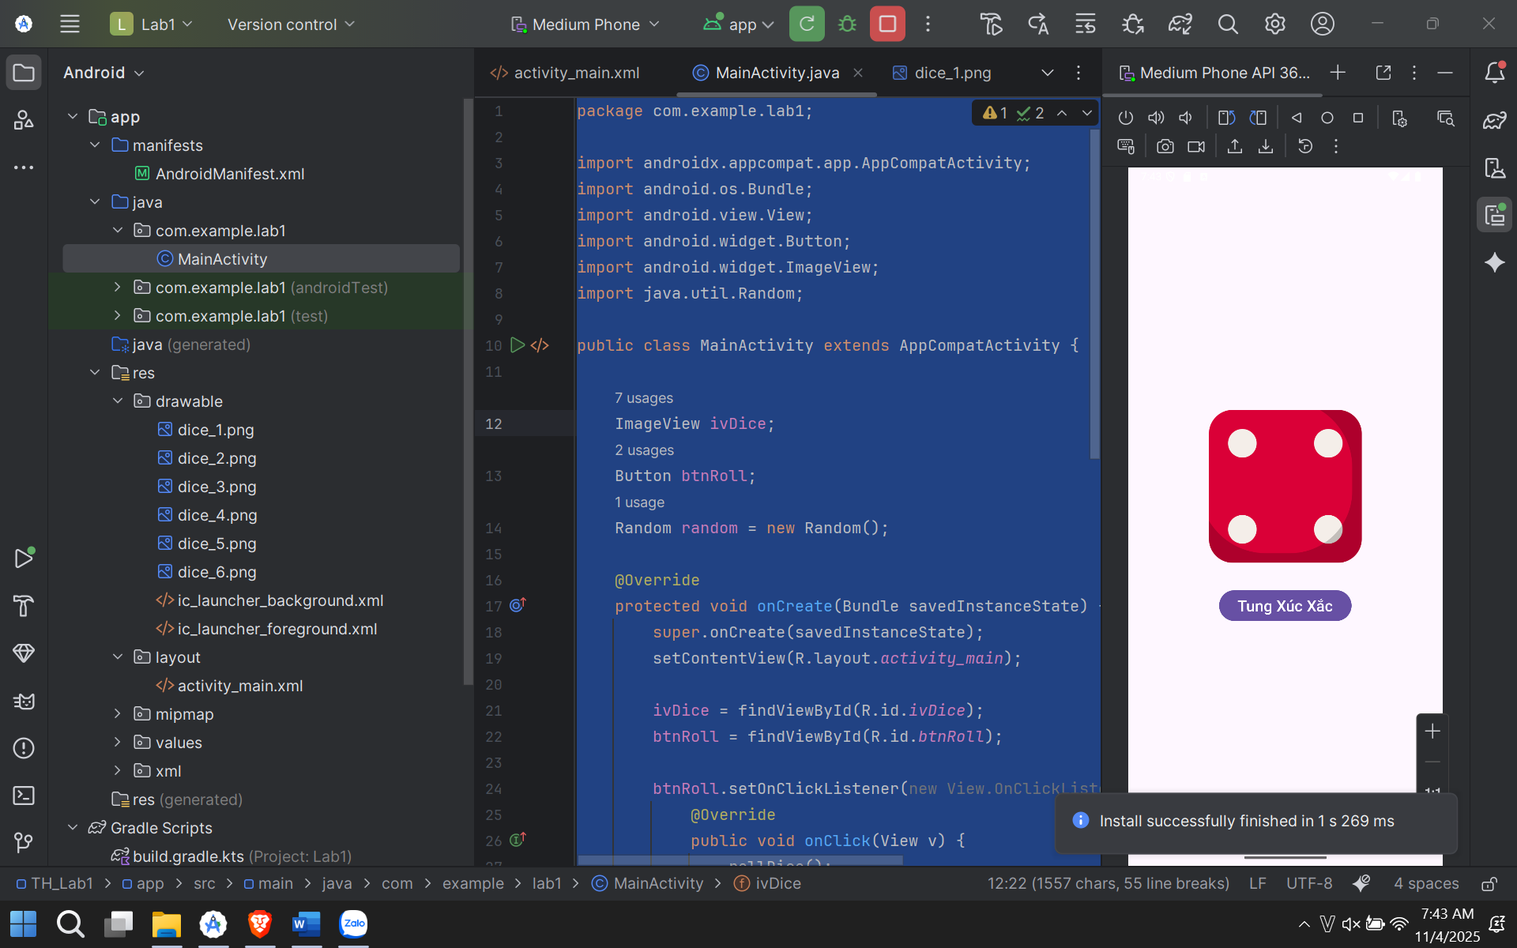

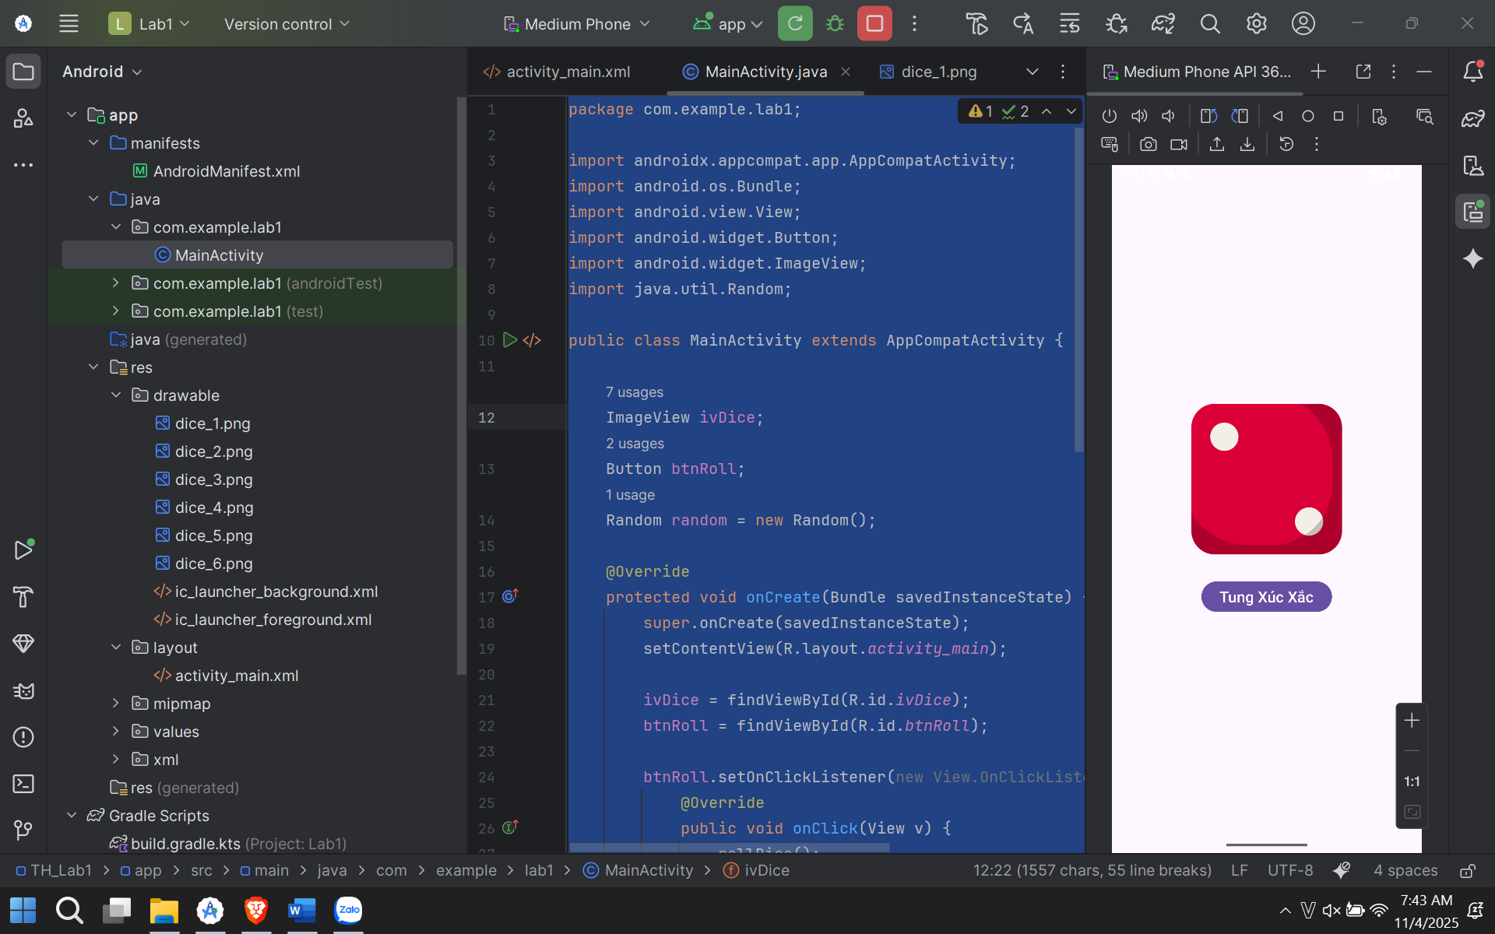

### Bài 3:

Bước 1:

layout/activity_main.xml

<?xml version="1.0" encoding="utf-8"?>  
<LinearLayout  
 xmlns:android="http://schemas.android.com/apk/res/android"  
 xmlns:app="http://schemas.android.com/apk/res-auto"  
 xmlns:tools="http://schemas.android.com/tools"  
 android:layout_width="match_parent"  
 android:layout_height="match_parent"  
 android:orientation="vertical"  
 android:padding="24dp"  
 tools:context=".MainActivity">  
  
 <com.google.android.material.textfield.TextInputLayout  
 android:id="@+id/tilPhoneNumber"  
 android:layout_width="match_parent"  
 android:layout_height="wrap_content"  
 style="@style/Widget.MaterialComponents.TextInputLayout.OutlinedBox">  
  
 <com.google.android.material.textfield.TextInputEditText  
 android:id="@+id/edtPhoneNumber"  
 android:layout_width="match_parent"  
 android:layout_height="wrap_content"  
 android:hint="@string/so_dien_thoai"  
 android:inputType="phone"  
 android:textSize="18sp" />  
 </com.google.android.material.textfield.TextInputLayout>  
  
 <com.google.android.material.button.MaterialButton  
 android:id="@+id/btnDial"  
 android:layout_width="match_parent"  
 android:layout_height="wrap_content"  
 android:layout_marginTop="16dp"  
 android:text="@string/mo_trinh_goi_dien"  
 android:paddingTop="12dp"  
 android:paddingBottom="12dp"  
 app:icon="@drawable/ic_call"  
 app:iconGravity="textStart" />  
  
 <com.google.android.material.textfield.TextInputLayout  
 android:id="@+id/tilMessage"  
 android:layout_width="match_parent"  
 android:layout_height="wrap_content"  
 android:layout_marginTop="32dp"  
 style="@style/Widget.MaterialComponents.TextInputLayout.OutlinedBox">  
  
 <com.google.android.material.textfield.TextInputEditText  
 android:id="@+id/edtMessage"  
 android:layout_width="match_parent"  
 android:layout_height="wrap_content"  
 android:hint="@string/noi_dung_tin_nhan"  
 android:inputType="textMultiLine"  
 android:minLines="3"  
 android:gravity="top"  
 android:textSize="18sp" />  
 </com.google.android.material.textfield.TextInputLayout>  
  
 <com.google.android.material.button.MaterialButton  
 android:id="@+id/btnSms"  
 android:layout_width="match_parent"  
 android:layout_height="wrap_content"  
 android:layout_marginTop="16dp"  
 android:text="@string/mo_trinh_nhan_tin"  
 android:paddingTop="12dp"  
 android:paddingBottom="12dp"  
 app:icon="@drawable/ic_sms"  
 app:iconGravity="textStart" />  
  
</LinearLayout>

Bước 2:

MainActivity.java

package com.example.; // Thay đổi tên package cho phù hợp

import androidx.appcompat.app.AppCompatActivity;  
import android.content.Intent;  
import android.net.Uri;  
import android.os.Bundle;  
import android.view.View;  
import android.widget.Button;  
import android.widget.Toast;  
import com.google.android.material.textfield.TextInputEditText;  
  
public class MainActivity extends AppCompatActivity {  
  
 TextInputEditText edtPhoneNumber, edtMessage;  
 Button btnDial, btnSms;  
  
 @Override  
 protected void onCreate(Bundle savedInstanceState) {  
 super.onCreate(savedInstanceState);  
 setContentView(R.layout.*activity_main*);  
  
 edtPhoneNumber = findViewById(R.id.*edtPhoneNumber*);  
 edtMessage = findViewById(R.id.*edtMessage*);  
 btnDial = findViewById(R.id.*btnDial*);  
 btnSms = findViewById(R.id.*btnSms*);  
  
 btnDial.setOnClickListener(new View.OnClickListener() {  
 @Override  
 public void onClick(View v) {  
 openDialer();  
 }  
 });  
  
 btnSms.setOnClickListener(new View.OnClickListener() {  
 @Override  
 public void onClick(View v) {  
 openSmsApp();  
 }  
 });  
 }  
  
 private void openDialer() {  
 String phoneNumber = edtPhoneNumber.getText().toString();  
 if (phoneNumber.isEmpty()) {  
 Toast.*makeText*(this, R.string.*vui_long_nhap_sdt*, Toast.*LENGTH_SHORT*).show();  
 return;  
 }  
  
 Intent intent = new Intent(Intent.*ACTION_DIAL*);  
 intent.setData(Uri.*parse*("tel:" + phoneNumber));  
 startActivity(intent);  
 }  
  
 private void openSmsApp() {  
 String phoneNumber = edtPhoneNumber.getText().toString();  
 String message = edtMessage.getText().toString();  
  
 if (phoneNumber.isEmpty()) {  
 Toast.*makeText*(this, R.string.*vui_long_nhap_sdt*, Toast.*LENGTH_SHORT*).show();  
 return;  
 }  
  
 Uri uri = Uri.*parse*("smsto:" + phoneNumber);  
 Intent intent = new Intent(Intent.*ACTION_SENDTO*, uri);  
 intent.putExtra("sms_body", message);  
 startActivity(intent);  
 }  
}

}

}

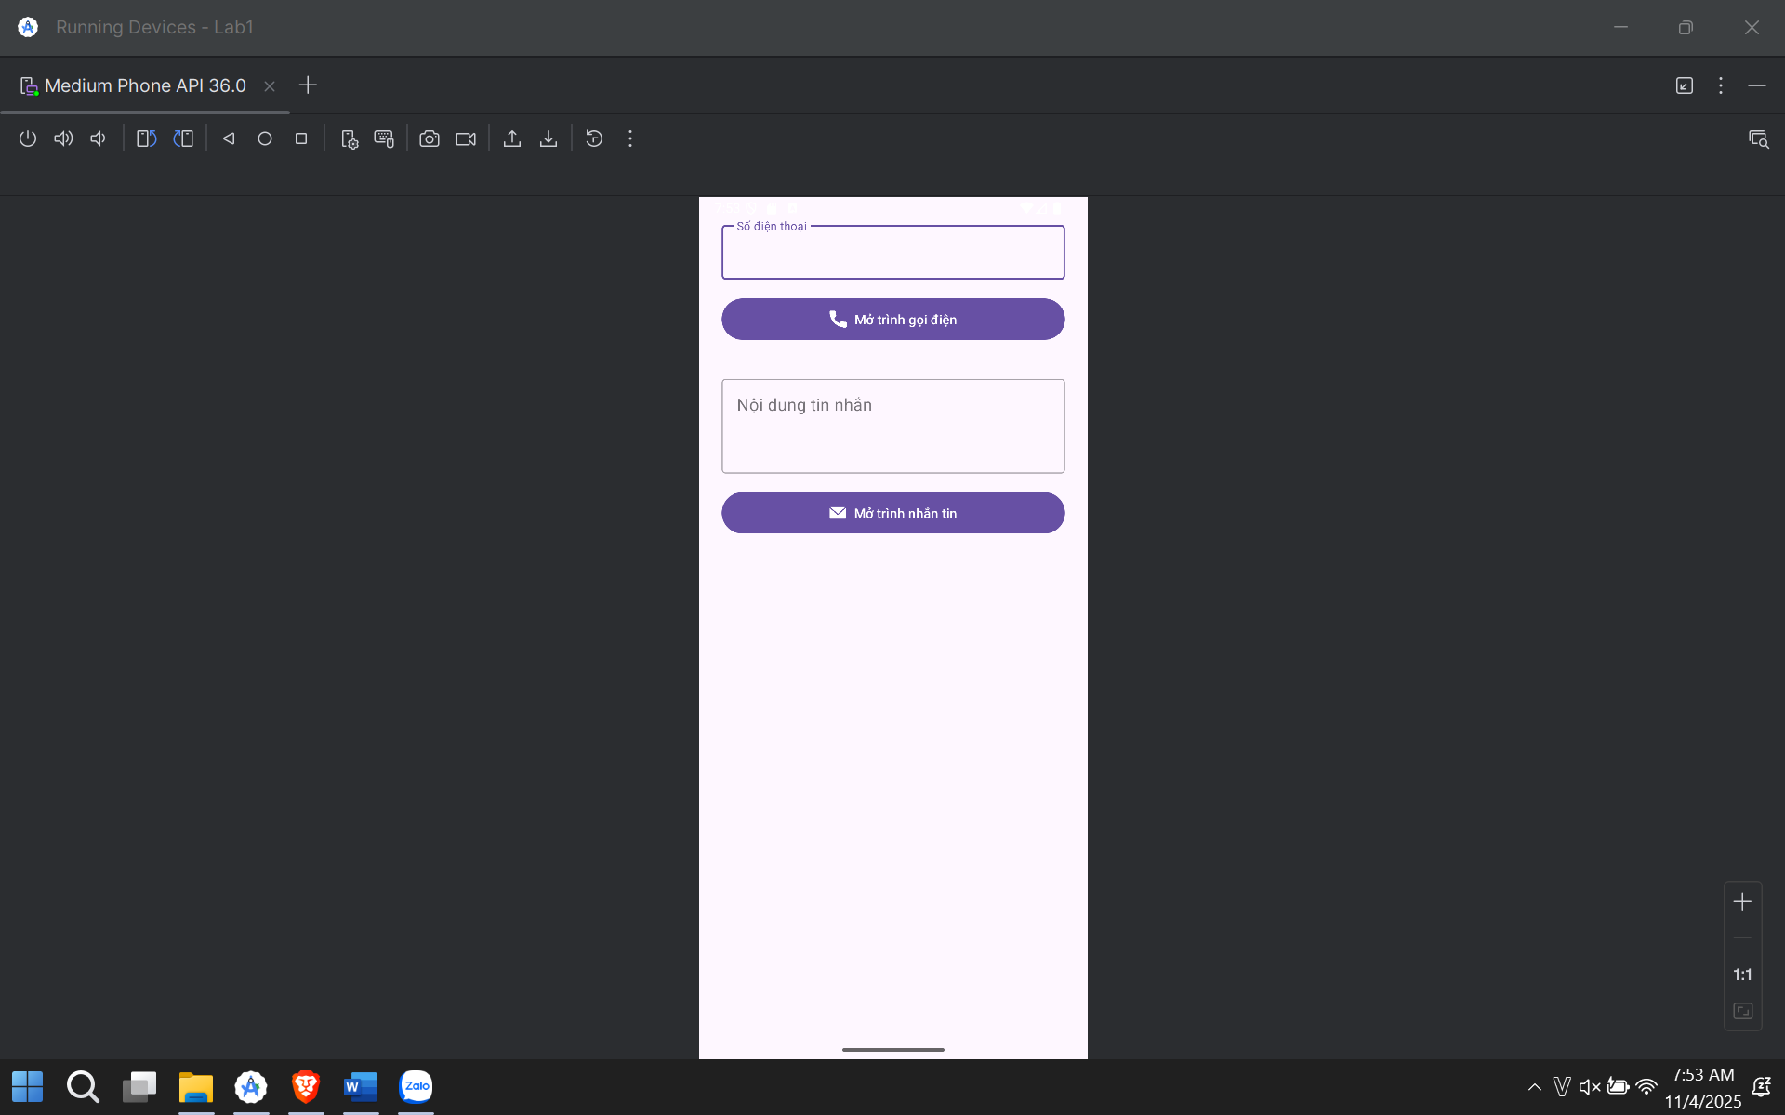

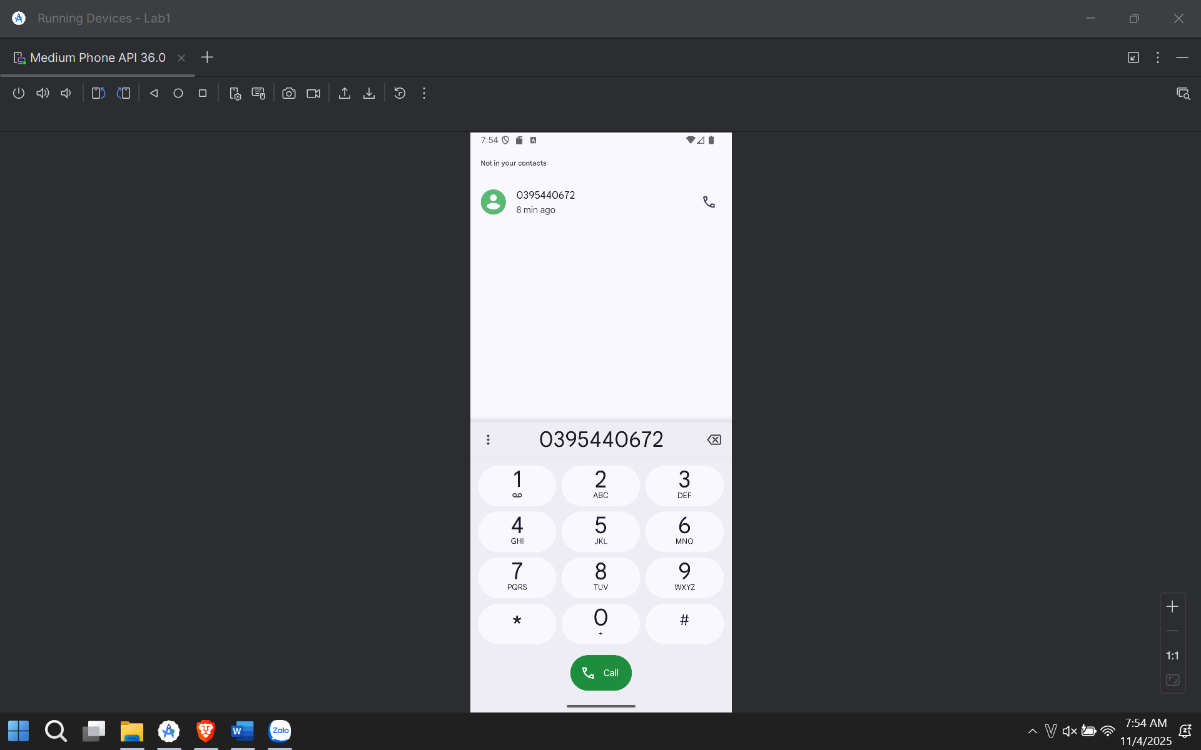

## Lab 2:

Bước 1:

*implementation* ("com.google.android.material:material:1.10.0")

bước 2: app/src/main/AndroidManifest.xml

<?xml version="1.0" encoding="utf-8"?>

<manifest xmlns:android="http://schemas.android.com/apk/res/android"

xmlns:tools="http://schemas.android.com/tools">

<application

android:allowBackup="true"

android:dataExtractionRules="@xml/data_extraction_rules"

android:fullBackupContent="@xml/backup_rules"

android:icon="@mipmap/ic_launcher"

android:label="@string/app_name"

android:roundIcon="@mipmap/ic_launcher_round"

android:supportsRtl="true"

android:theme="@style/Theme.Lab2"

tools:targetApi="31">

<activity

android:name=".MainActivity"

android:exported="true">

<intent-filter>

<action android:name="android.intent.action.MAIN" />

<category android:name="android.intent.category.LAUNCHER" />

</intent-filter>

</activity>

<activity

android:name=".M000ActSplash"

android:exported="false"

android:noHistory="true"

android:theme="@style/Full_Screen" /> <activity

android:name=".M001ActProfile"

android:exported="false"

android:theme="@style/Theme.Material3.DayNight.NoActionBar"/>

</application>

</manifest>

Bước 3: app/src/main/res/values/themes.xml

<resources xmlns:tools="http://schemas.android.com/tools">

<style name="Base.Theme.Lab2" parent="Theme.Material3.DayNight.NoActionBar">

</style>

<style name="Theme.Lab2" parent="Base.Theme.Lab2" />

<style name="Full_Screen" parent="Theme.MaterialComponents.DayNight.NoActionBar"/>

</resources>

Bước 4: app/src/main/res/values/colors.xml

<?xml version="1.0" encoding="utf-8"?>

<resources>

<color name="purple_200">#FFBB86FC</color>

<color name="purple_500">#FF6200EE</color>

<color name="purple_700">#FF3700B3</color>

<color name="teal_200">#FF03DAC5</color>

<color name="teal_700">#FF018786</color>

<color name="black">#FF000000</color>

<color name="white">#FFFFFFFF</color>

<color name="gray_mid">#979797</color>

<color name="gray_dark">#535353</color>

<color name="indigo">#424FB7</color>

<color name="gray_light">#FAFAFA</color>

<color name="splash_color_1">#3D5AFE</color>

<color name="splash_color_2">#00C853</color>

<color name="splash_color_3">#FF6D00</color>

<color name="splash_color_4">#D500F9</color>

</resources>

Bước 5: app/src/main/res/values/strings.xml

<resources>

<string name="app_name">Lab 2</string>

<string name="animal_sound">Animal Sound</string>

<string name="txt_loading">Loading</string>

<string name="txt_name">Ali Connors</string>

<string name="txt_phone1">(650) 555-1234</string>

<string name="txt_title_mobile">Mobile</string>

<string name="txt_phone2">(323) 555-6789</string>

<string name="txt_email">aliconnors@example.com</string>

<string name="open_splash">Mở màn hình Chào (Lab 1+2)</string>

<string name="open_profile">Mở màn hình Profile (Lab 3)</string>

</resources>

Bước 6: app/src/main/res/drawable/bg_oval.xml

<?xml version="1.0" encoding="utf-8"?>

<shape xmlns:android="http://schemas.android.com/apk/res/android"

android:shape="oval">

<solid android:color="#FF4181" />

</shape>

Bước 7:

app/src/main/res/drawable/custom_progress_bar.xml

<?xml version="1.0" encoding="utf-8"?>

<rotate xmlns:android="http://schemas.android.com/apk/res/android"

android:fromDegrees="0"

android:pivotX="50%"

android:pivotY="50%"

android:toDegrees="360">

<shape

android:innerRadiusRatio="3"

android:shape="ring"

android:thicknessRatio="8"

android:useLevel="false">

<gradient

android:centerColor="@color/white"

android:endColor="@color/teal_200"

android:startColor="@color/white"

android:type="sweep"

android:useLevel="false" />

</shape>

</rotate>

Bước 8

app/src/main/res/layout/activity_main.xml

<?xml version="1.0" encoding="utf-8"?>

<LinearLayout

xmlns:android="http://schemas.android.com/apk/res/android"

xmlns:tools="http://schemas.android.com/tools"

android:layout_width="match_parent"

android:layout_height="match_parent"

android:orientation="vertical"

android:gravity="center"

android:padding="24dp"

tools:context=".MainActivity">

<Button

android:id="@+id/btnGoToSplash"

android:layout_width="match_parent"

android:layout_height="wrap_content"

android:text="@string/open_splash"

android:layout_marginBottom="16dp"/>

<Button

android:id="@+id/btnGoToProfile"

android:layout_width="match_parent"

android:layout_height="wrap_content"

android:text="@string/open_profile"/>

</LinearLayout>

Bước 9

app/src/main/res/layout/item_loading.xml

<?xml version="1.0" encoding="utf-8"?>

<LinearLayout xmlns:android="http://schemas.android.com/apk/res/android"

android:layout_width="match_parent"

android:layout_height="match_parent"

android:gravity="center"

android:background="#BF000000"

android:orientation="vertical">

<ProgressBar

android:layout_width="60dp"

android:layout_height="60dp"

android:indeterminateDrawable="@drawable/custom_progress_bar" />

<TextView

android:layout_width="wrap_content"

android:layout_height="wrap_content"

android:fontFamily="sans-serif-light"

android:text="@string/txt_loading"

android:textColor="@color/white"

android:textSize="24sp" />

</LinearLayout>

Bước 10

app/src/main/res/layout/m001_act_splash.xml

<?xml version="1.0" encoding="utf-8"?>

<FrameLayout xmlns:android="http://schemas.android.com/apk/res/android"

xmlns:tools="http://schemas.android.com/tools"

android:layout_width="match_parent"

android:layout_height="match_parent"

android:background="@color/purple_700">

<LinearLayout

android:id="@+id/splash_layout"

android:layout_width="match_parent"

android:layout_height="match_parent"

android:background="@color/purple_700"

android:gravity="center"

android:orientation="vertical">

<ImageView

android:id="@+id/splash_icon"

android:layout_width="128dp"

android:layout_height="128dp"

android:src="@drawable/ic_penguin"

tools:ignore="ContentDescription" />

<TextView

android:layout_width="wrap_content"

android:layout_height="wrap_content"

android:layout_marginTop="10dp"

android:fontFamily="sans-serif-light"

android:text="@string/animal_sound"

android:textColor="@color/white"

android:textSize="24sp" />

</LinearLayout>

<include layout="@layout/item_loading" />

</FrameLayout>

Bước 11

app/src/main/res/layout/m001_act_profile.xml

<?xml version="1.0" encoding="utf-8"?>

<LinearLayout xmlns:android="http://schemas.android.com/apk/res/android"

xmlns:app="http://schemas.android.com/apk/res-auto"

xmlns:tools="http://schemas.android.com/tools"

android:layout_width="match_parent"

android:layout_height="match_parent"

android:background="@color/gray_light"

android:orientation="vertical">

<FrameLayout

android:layout_width="match_parent"

android:layout_height="350dp">

<ImageView

android:layout_width="match_parent"

android:layout_height="300dp"

android:scaleType="centerCrop"

android:src="@drawable/bg_avatar"

tools:ignore="ContentDescription" />

<TextView

android:layout_width="wrap_content"

android:layout_height="wrap_content"

android:layout_gravity="bottom"

android:layout_marginStart="70dp"

android:layout_marginBottom="90dp"

android:fontFamily="sans-serif"

android:text="@string/txt_name"

android:textColor="@color/white"

android:textSize="40sp" />

<ImageView

android:layout_width="80dp"

android:layout_height="80dp"

android:layout_gravity="end|bottom"

android:layout_marginEnd="20dp"

android:layout_marginBottom="10dp"

android:background="@drawable/bg_oval"

android:padding="20dp"

android:src="@drawable/ic_star"

app:tint="@color/white"

tools:ignore="ContentDescription" />

</FrameLayout>

<TableRow

android:layout_width="match_parent"

android:layout_height="wrap_content"

android:padding="20dp">

<ImageView

android:id="@+id/icon_phone"

android:layout_width="60dp"

android:layout_height="60dp"

android:padding="10dp"

android:src="@drawable/ic_phone"

app:tint="@color/indigo"

tools:ignore="ContentDescription" />

<LinearLayout

android:layout_width="match_parent"

android:layout_height="wrap_content"

android:layout_marginStart="30dp"

android:orientation="vertical">

<TextView

android:layout_width="match_parent"

android:layout_height="wrap_content"

android:text="@string/txt_phone1"

android:textColor="@color/gray_dark"

android:textSize="20sp" />

<TextView

android:layout_width="match_parent"

android:layout_height="wrap_content"

android:layout_marginTop="5dp"

android:text="@string/txt_title_mobile"

android:textColor="@color/gray_mid"

android:textSize="18sp" />

<TextView

android:layout_width="match_parent"

android:layout_height="wrap_content"

android:layout_marginTop="30dp"

android:text="@string/txt_phone2"

android:textColor="@color/gray_dark"

android:textSize="20sp" />

<TextView

android:layout_width="match_parent"

android:layout_height="wrap_content"

android:layout_marginTop="5dp"

android:text="@string/txt_title_mobile"

android:textColor="@color/gray_mid"

android:textSize="18sp" />

<View

android:layout_width="match_parent"

android:layout_height="0.5dp"

android:layout_marginTop="30dp"

android:background="@color/gray_mid" />

</LinearLayout>

</TableRow>

<TableRow

android:layout_width="match_parent"

android:layout_height="wrap_content"

android:padding="20dp">

<ImageView

android:layout_width="60dp"

android:layout_height="60dp"

android:padding="10dp"

android:src="@drawable/ic_email"

app:tint="@color/indigo"

tools:ignore="ContentDescription" />

<LinearLayout

android:layout_width="match_parent"

android:layout_height="match_parent"

android:layout_marginStart="30dp"

android:orientation="vertical">

<TextView

android:layout_width="match_parent"

android:layout_height="wrap_content"

android:text="@string/txt_email"

android:textColor="@color/gray_dark"

android:textSize="20sp" />

<TextView

android:layout_width="match_parent"

android:layout_height="wrap_content"

android:layout_marginTop="5dp"

android:text="@string/txt_title_mobile"

android:textColor="@color/gray_mid"

android:textSize="18sp" />

</LinearLayout>

</TableRow>

</LinearLayout>

Bước 13

MainActivity.java

package com.example.; // THAY BẰNG PACKAGE CỦA BẠN

import androidx.appcompat.app.AppCompatActivity;

import android.content.Intent;

import android.os.Bundle;

import android.widget.Button;

public class MainActivity extends AppCompatActivity {

Button btnGoToSplash, btnGoToProfile;

@Override

protected void onCreate(Bundle savedInstanceState) {

super.onCreate(savedInstanceState);

setContentView(R.layout.activity_main);

btnGoToSplash = findViewById(R.id.btnGoToSplash);

btnGoToProfile = findViewById(R.id.btnGoToProfile);

btnGoToSplash.setOnClickListener(v -> {

Intent intent = new Intent(MainActivity.this, M000ActSplash.class);

startActivity(intent);

});

btnGoToProfile.setOnClickListener(v -> {

Intent intent = new Intent(MainActivity.this, M001ActProfile.class);

startActivity(intent);

});

}

}

Bước 14 M000ActSplash.java

package com.example.; // THAY BẰNG PACKAGE CỦA BẠN

import android.os.Bundle;

import android.widget.ImageView;

import android.widget.LinearLayout;

import androidx.appcompat.app.AppCompatActivity;

import androidx.core.content.ContextCompat;

import java.util.Random;

public class M000ActSplash extends AppCompatActivity {

private LinearLayout splashLayout;

private ImageView splashIcon;

// Mảng chứa các màu và icon

private final int[] colorList = {

R.color.splash_color_1,

R.color.splash_color_2,

R.color.splash_color_3,

R.color.splash_color_4

};

// Bạn phải tự thêm các icon này vào drawable

private final int[] iconList = {

R.drawable.ic_penguin,

R.drawable.ic_cat,

R.drawable.ic_dog

};

private final Random random = new Random();

@Override

protected void onCreate(Bundle savedInstanceState) {

super.onCreate(savedInstanceState);

setContentView(R.layout.m001_act_splash);

splashLayout = findViewById(R.id.splash_layout);

splashIcon = findViewById(R.id.splash_icon);

// Chọn ngẫu nhiên màu

int randomColorIndex = random.nextInt(colorList.length);

int randomColor = ContextCompat.getColor(this, colorList[randomColorIndex]);

splashLayout.setBackgroundColor(randomColor);

// Chọn ngẫu nhiên icon

int randomIconIndex = random.nextInt(iconList.length);

int randomIcon = iconList[randomIconIndex];

splashIcon.setImageResource(randomIcon);

}

}

Bước 15: M001ActProfile.java

package com.example.; // THAY BẰNG PACKAGE CỦA BẠN

import android.content.Intent;

import android.net.Uri;

import android.os.Bundle;

import android.widget.ImageView;

import androidx.appcompat.app.AppCompatActivity;

public class M001ActProfile extends AppCompatActivity {

private ImageView iconPhone;

@Override

protected void onCreate(Bundle savedInstanceState) {

super.onCreate(savedInstanceState);

setContentView(R.layout.m001_act_profile);

// Ẩn ActionBar theo yêu cầu của Lab

if (getSupportActionBar() != null) {

getSupportActionBar().hide();

}

// Ánh xạ View

iconPhone = findViewById(R.id.icon_phone);

// Gán sự kiện click (Bài tập 3)

iconPhone.setOnClickListener(v -> {

dialPhoneNumber();

});

}

private void dialPhoneNumber() {

// Lấy số điện thoại từ strings.xml

String phoneNumber = getString(R.string.txt_phone1);

// Tạo Intent để mở trình gọi điện

Intent intent = new Intent(Intent.ACTION_DIAL);

intent.setData(Uri.parse("tel:" + phoneNumber));

startActivity(intent);

}

}

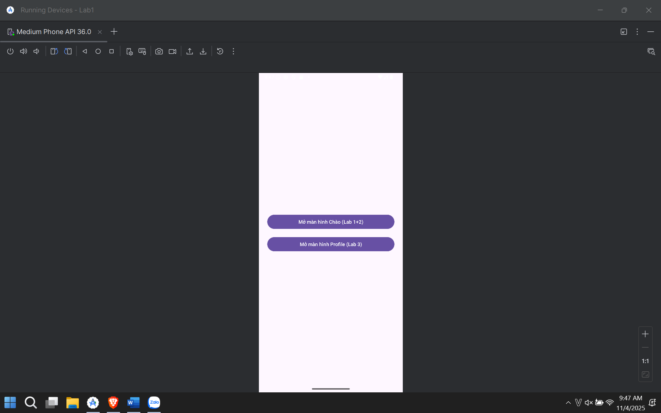

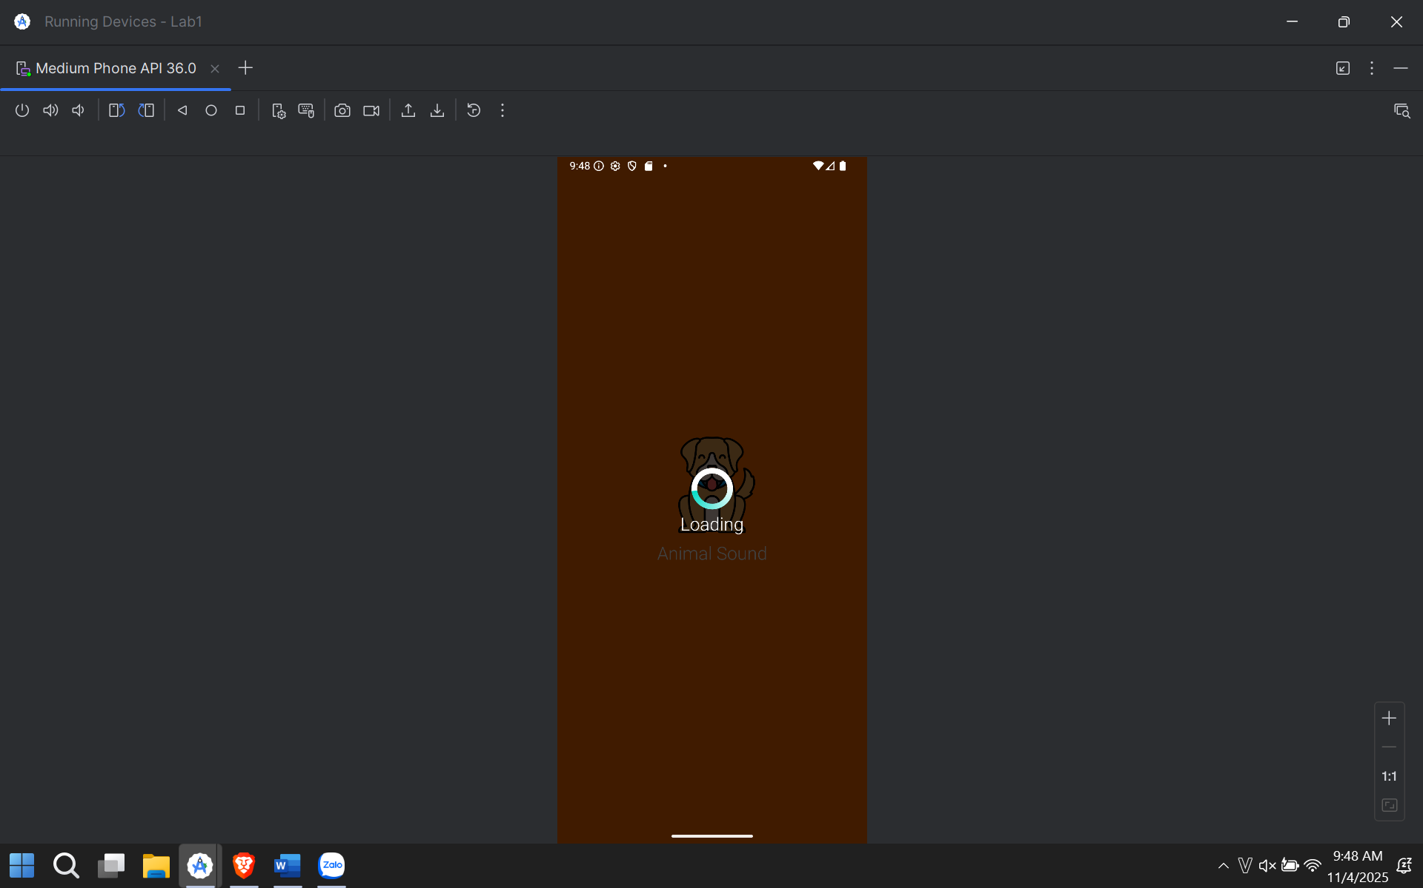

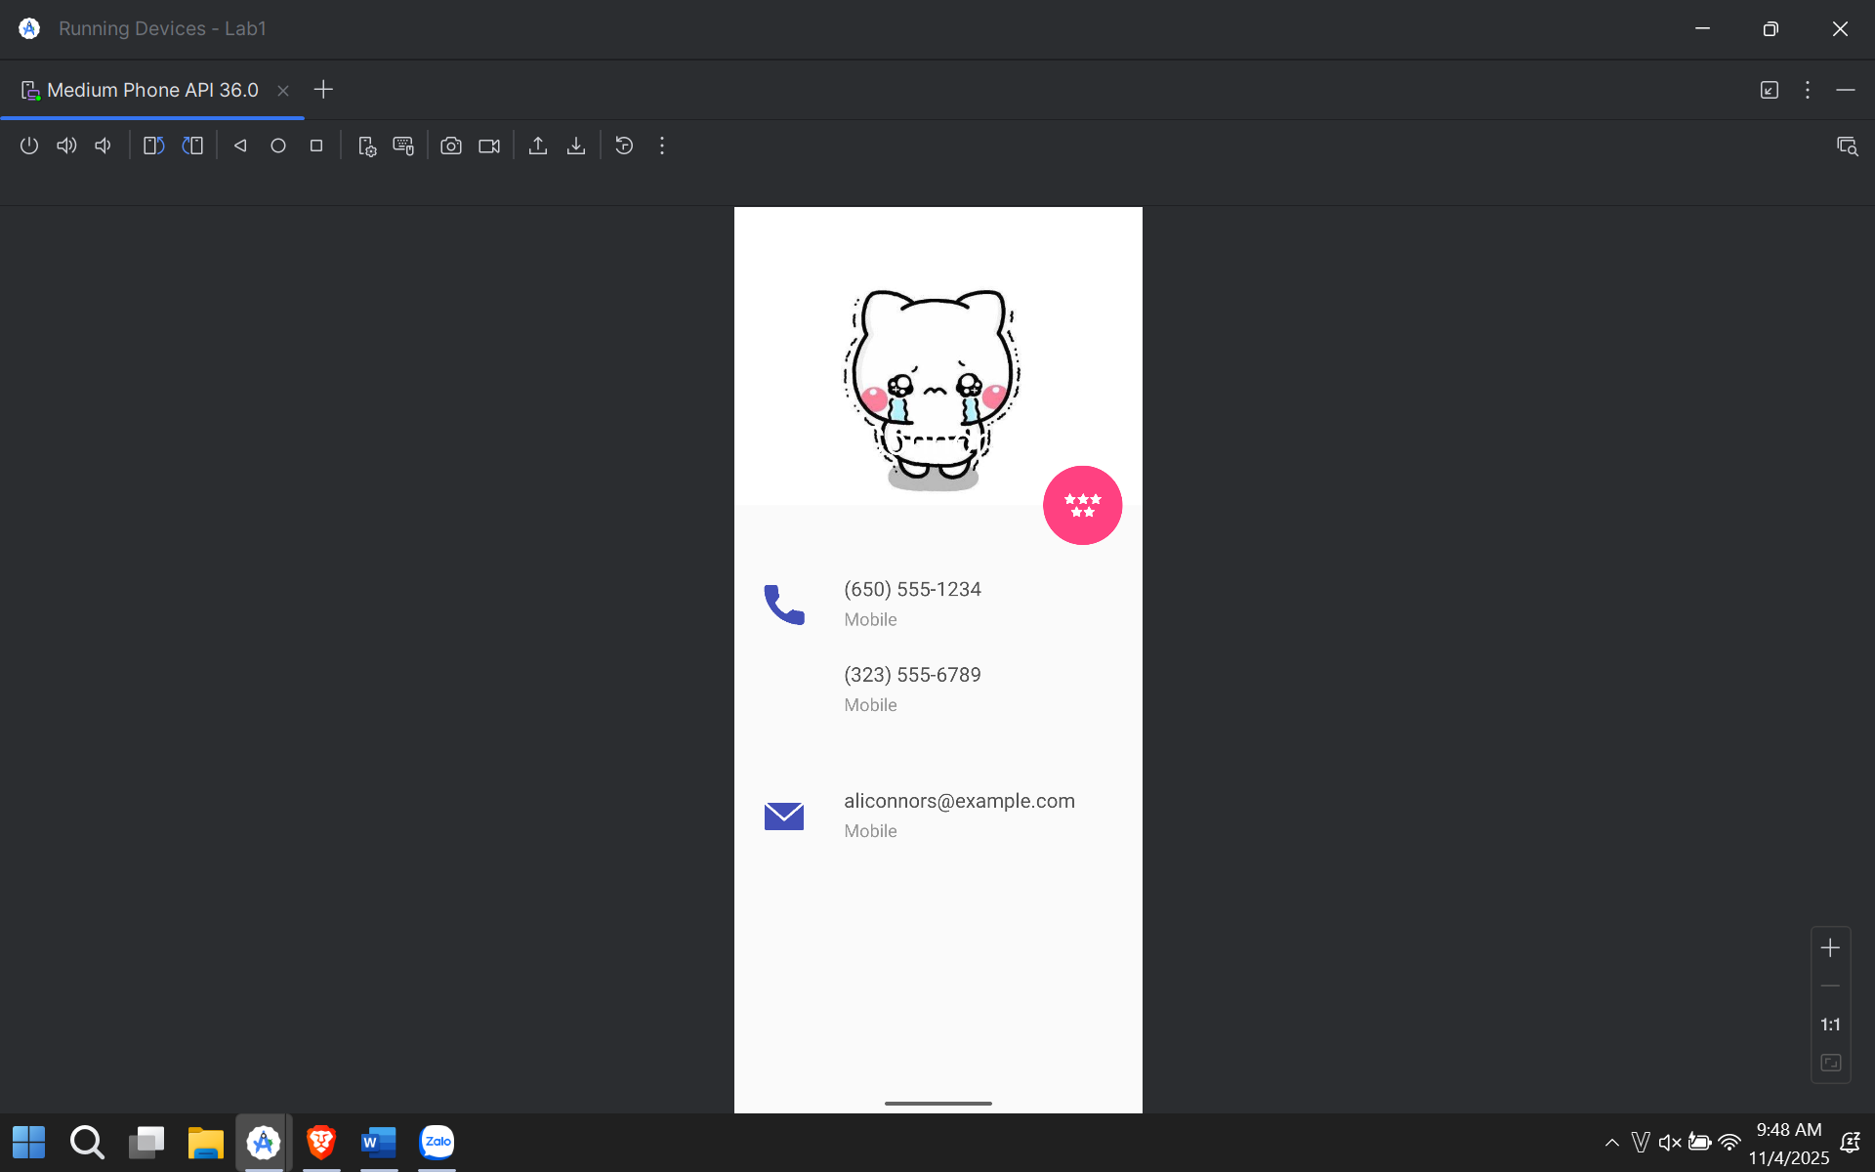

# CHƯƠNG 2: THỰC HÀNH BUỔI 12

Bước 1: Tạo dự án mới

1. Mở Android Studio và chọn New Project.
2. Chọn mẫu Empty Views Activity.
3. Đặt tên dự án là thuchanh2 (hoặc tên của bạn) và nhấn Finish.

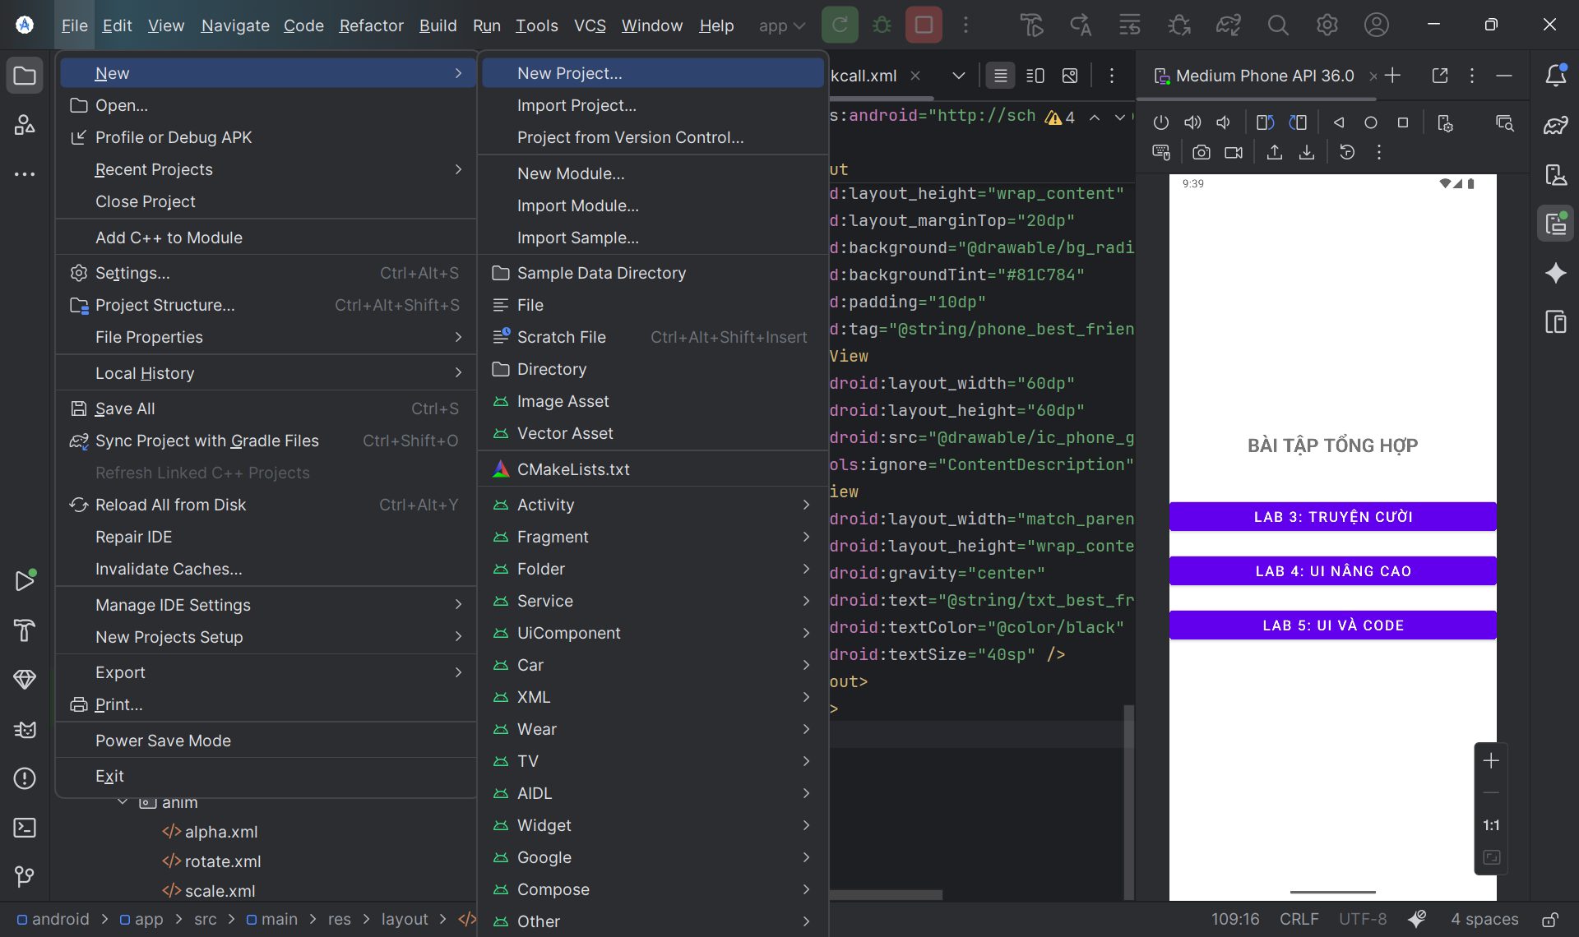

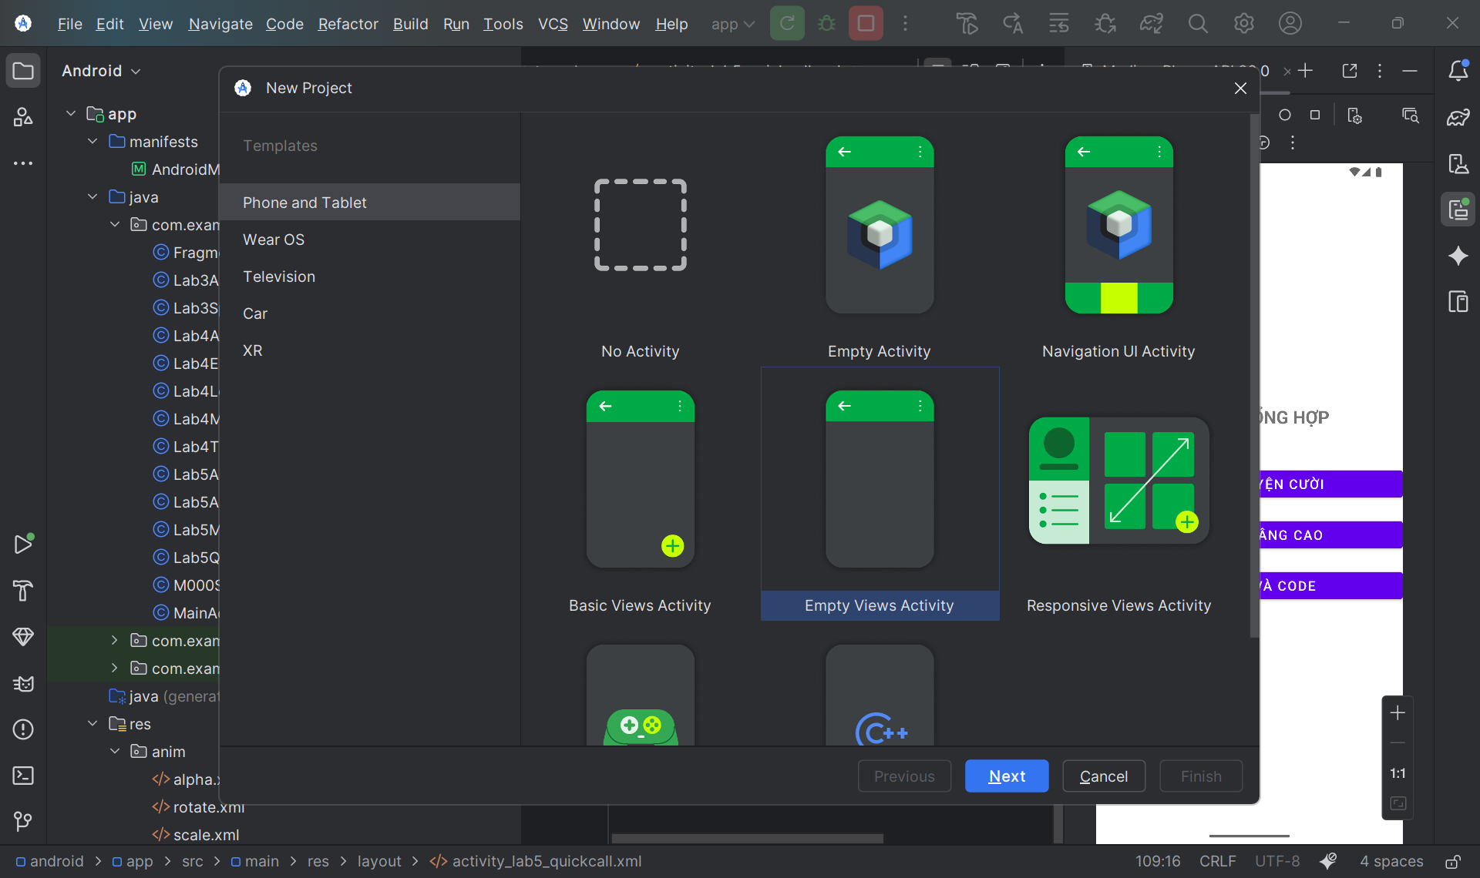

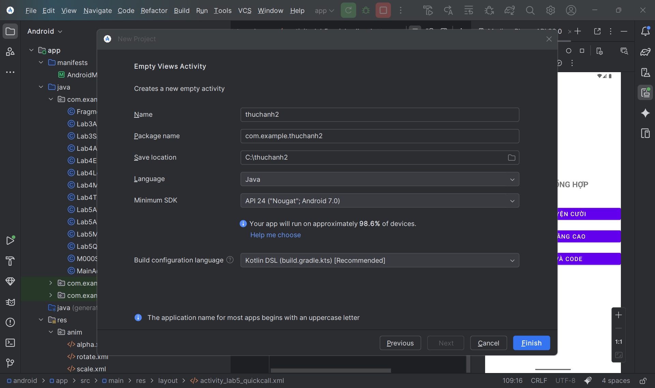

Bước 2: Thiết kế Giao diện Menu Chính

1. Mở file res/layout/activity_main.xml.
2. Xóa nội dung mặc định và dán code sau để tạo 3 nút bấm:

<?xml version="1.0" encoding="utf-8"?>

<LinearLayout xmlns:android="http://schemas.android.com/apk/res/android"

xmlns:tools="http://schemas.android.com/tools"

android:id="@+id/main"

android:layout_width="match_parent"

android:layout_height="match_parent"

android:orientation="vertical"

android:gravity="center"

android:padding="30dp"

tools:context=".MainActivity">

<TextView

android:layout_width="wrap_content"

android:layout_height="wrap_content"

android:text="BÀI TẬP TỔNG HỢP"

android:textSize="24sp"

android:textStyle="bold"

android:layout_marginBottom="50dp"/>

<Button

android:id="@+id/btnLab3"

android:layout_width="match_parent"

android:layout_height="wrap_content"

android:text="Lab 3: Truyện Cười"

android:layout_marginBottom="20dp"

android:textSize="18sp"/>

<Button

android:id="@+id/btnLab4"

android:layout_width="match_parent"

android:layout_height="wrap_content"

android:text="Lab 4: UI Nâng Cao"

android:layout_marginBottom="20dp"

android:textSize="18sp"/>

<Button

android:id="@+id/btnLab5"

android:layout_width="match_parent"

android:layout_height="wrap_content"

android:text="Lab 5: UI và Code"

android:textSize="18sp"/>

</LinearLayout>

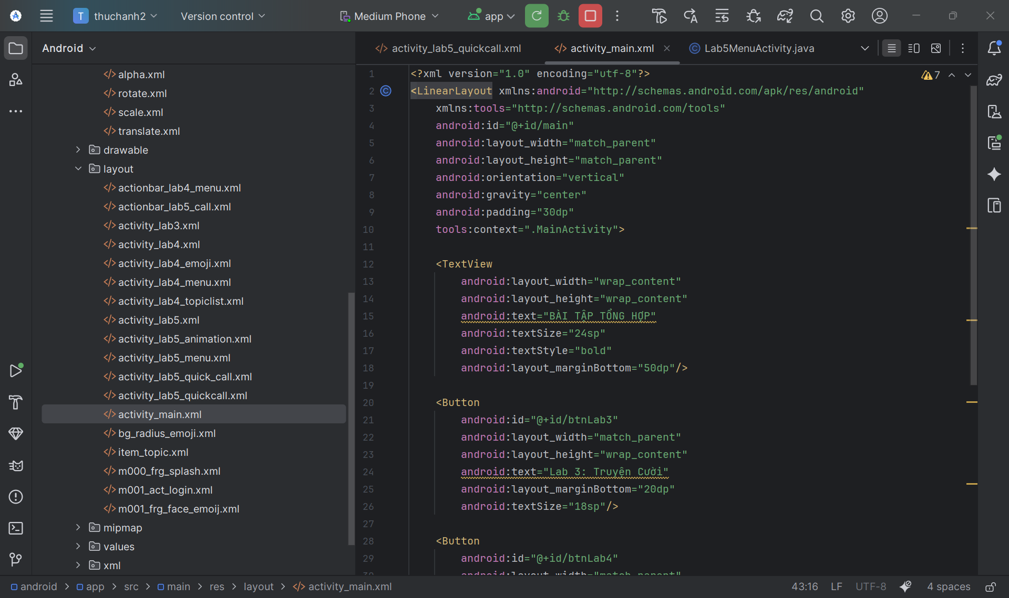

Bước 3: Tạo các file Activity (Màn hình) mới

Chúng ta cần các màn hình riêng cho mỗi Lab.

1. Nhấp chuột phải vào thư mục java/com/example/thuchanh2.
2. Chọn New > Activity > Empty Views Activity.
3. Tạo lần lượt các Activity sau:
   * Lab3SplashActivity (Layout: activity_lab3.xml)
   * Lab4MenuActivity (Layout: activity_lab4_menu.xml)
   * Lab4LoginActivity (Layout: m001_act_login.xml)
   * Lab4TopicListActivity (Layout: activity_lab4_topiclist.xml)
   * Lab4EmojiActivity (Layout: activity_lab4_emoji.xml)
   * Lab5MenuActivity (Layout: activity_lab5_menu.xml)
   * Lab5AnimationActivity (Layout: activity_lab5_animation.xml)
   * Lab5QuickCallActivity (Layout: activity_lab5_quickcall.xml)

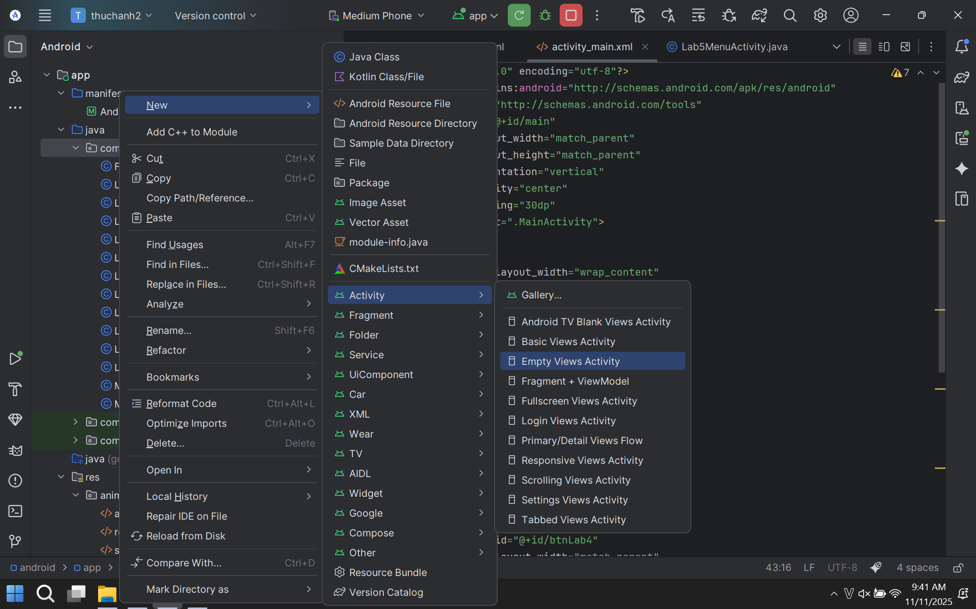

Bước 4: Lập trình Logic cho Menu Chính

1. Mở file java/com/example/thuchanh2/MainActivity.java.
2. Thay thế toàn bộ code bằng nội dung sau để liên kết 3 nút bấm:

package com.example.thuchanh2;

import android.content.Intent;

import android.os.Bundle;

import android.view.View;

import android.widget.Button;

import androidx.activity.EdgeToEdge;

import androidx.appcompat.app.AppCompatActivity;

import androidx.core.graphics.Insets;

import androidx.core.view.ViewCompat;

import androidx.core.view.WindowInsetsCompat;

public class MainActivity extends AppCompatActivity {

@Override

protected void onCreate(Bundle savedInstanceState) {

super.onCreate(savedInstanceState);

EdgeToEdge.enable(this);

setContentView(R.layout.activity_main);

// Ánh xạ các nút

Button btnLab3 = findViewById(R.id.btnLab3);

Button btnLab4 = findViewById(R.id.btnLab4);

Button btnLab5 = findViewById(R.id.btnLab5);

// Xử lý click

btnLab3.setOnClickListener(new View.OnClickListener() {

@Override

public void onClick(View v) {

startActivity(new Intent(MainActivity.this, Lab3SplashActivity.class));

}

});

btnLab4.setOnClickListener(new View.OnClickListener() {

@Override

public void onClick(View v) {

startActivity(new Intent(MainActivity.this, Lab4MenuActivity.class));

}

});

btnLab5.setOnClickListener(new View.OnClickListener() {

@Override

public void onClick(View v) {

startActivity(new Intent(MainActivity.this, Lab5MenuActivity.class));

}

});

ViewCompat.setOnApplyWindowInsetsListener(findViewById(R.id.main), (v, insets) -> {

Insets systemBars = insets.getInsets(WindowInsetsCompat.Type.systemBars());

v.setPadding(systemBars.left, systemBars.top, systemBars.right, systemBars.bottom);

return insets;

});

}

}

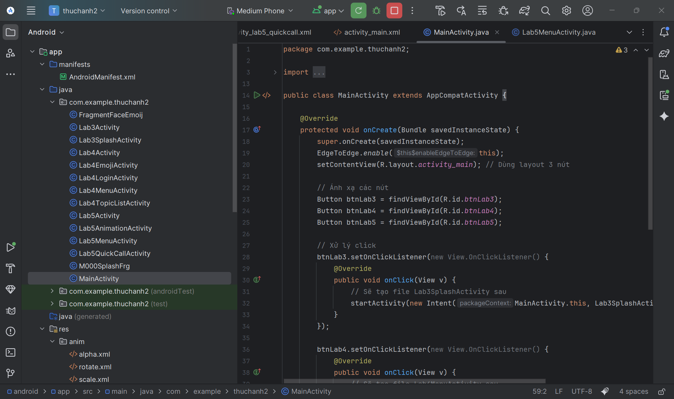

Bước 5: File strings.xml

1. Mở res/values/strings.xml.
2. Dán code sau:

<resources xmlns:tools="http://schemas.android.com/tools">

<string name="app_name">Thuchanh2</string>

<string name="app_name_lab3">TruyenCuoi</string>

<string name="txt_congai">Con gái</string>

<string name="txt_story">Vừa đúng vừa sai</string>

<string name="app_name_lab4_login">Login</string>

<string name="txt_login">Login</string>

<string name="hint_email">Email</string>

<string name="hint_password">Password</string>

<string name="txt_forgot_pass">Forgot password?</string>

<string name="txt_no_account" tools:ignore="StringEscaping">Don\'t have an account ?</string>

<string name="txt_register">Register</string>

<string name="app_name_lab4_menu">Từ vựng</string>

<string name="txt_mess">Essentials</string>

<string name="txt_flight">While Traveling</string>

<string name="txt_hospital">Help / Medical</string>

<string name="txt_hotel">At the hotel</string>

<string name="txt_restaurant">At the Restaurant</string>

<string name="txt_coctail">At the Bar</string>

<string name="txt_store">At the Store</string>

<string name="txt_work">Work</string>

<string name="txt_time">Time</string>

<string name="txt_education">Education</string>

<string name="txt_movie">Entertainment</string>

<string name="app_name_lab4_emoji">Face Emoij</string>

<string name="app_name_lab5_anim">Animation</string>

<string name="txt_scale">Scale</string>

<string name="txt_trans">Trans</string>

<string name="txt_rotate">Rotate</string>

<string name="txt_alpha">Alpha</string>

<string name="app_name_lab5_call">Quick Call</string>

<string name="txt_mom">Mom</string>

<string name="txt_dad">Dad</string>

<string name="txt_crush">Crush</string>

<string name="txt_best_friend">Best friend</string>

<string name="phone_mom">096666543</string>

<string name="phone_dad">096666544</string>

<string name="phone_crush">096886543</string>

<string name="phone_best_friend">099966543</string>

</resources>

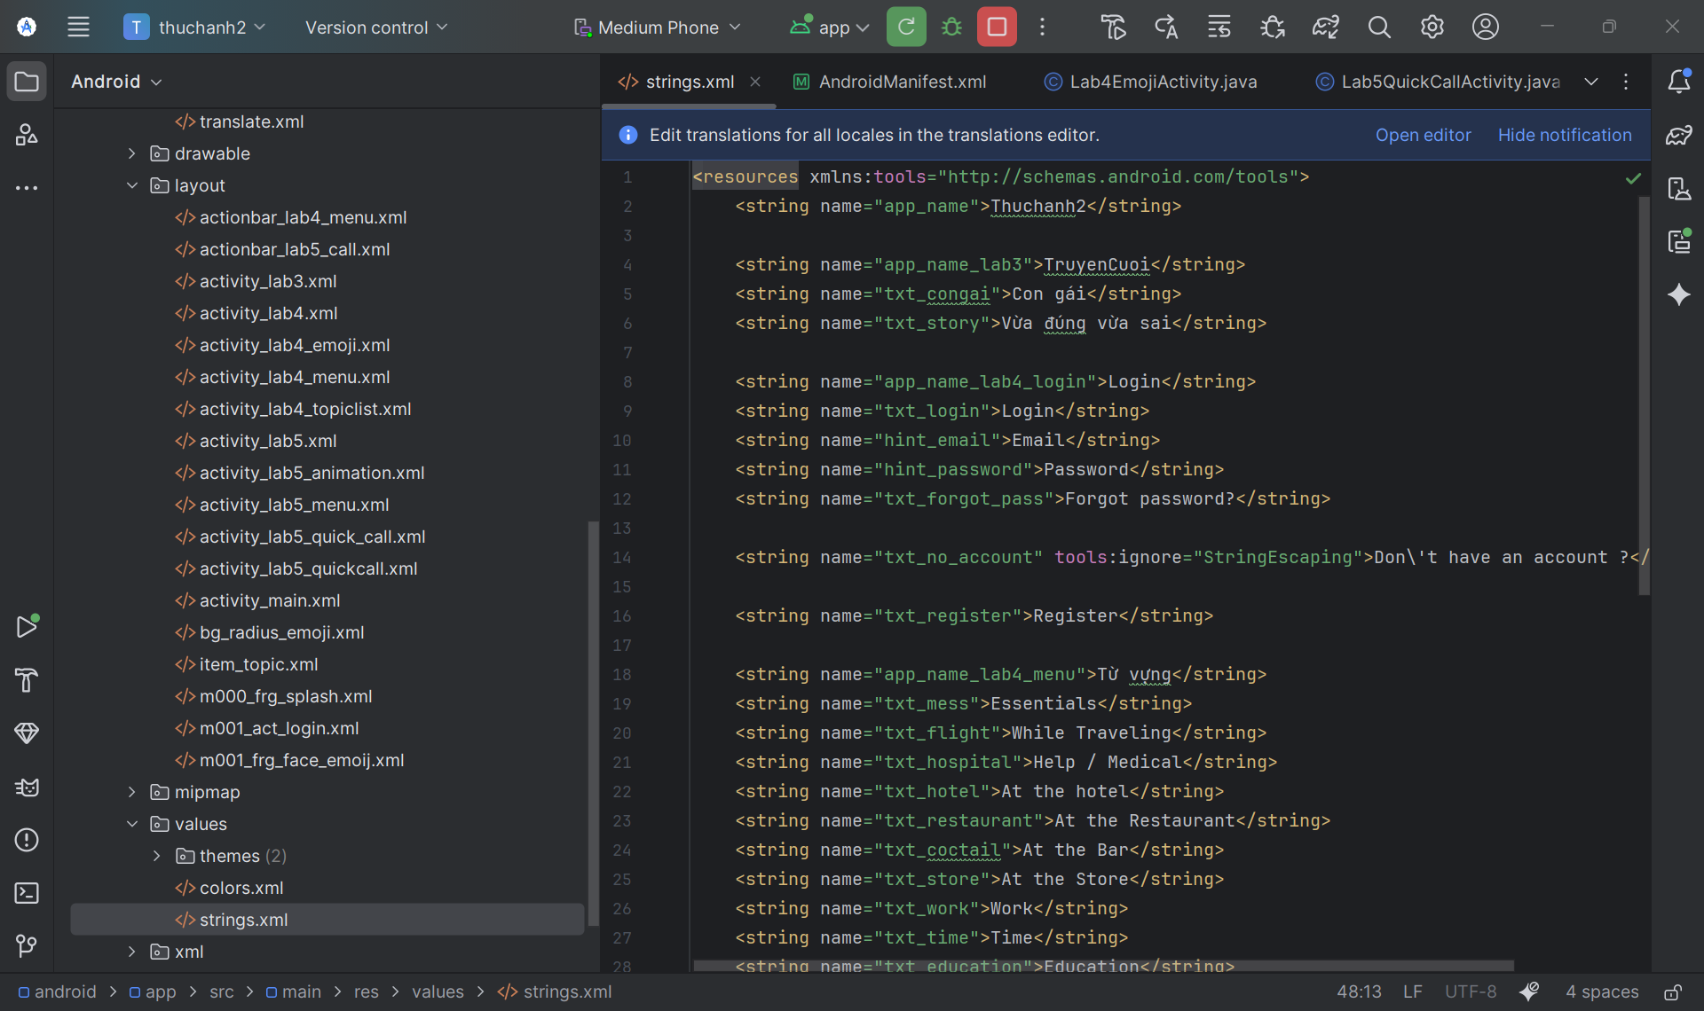

Mở res/values/colors.xml

<?xml version="1.0" encoding="utf-8"?>

<resources>

<color name="purple_200">#FFBB86FC</color>

<color name="purple_500">#FF6200EE</color>

<color name="purple_700">#FF3700B3</color>

<color name="teal_200">#FF03DAC5</color>

<color name="teal_700">#FF018786</color>

<color name="black">#FF000000</color>

<color name="white">#FFFFFFFF</color>

<color name="greenMid">#478942</color>

<color name="greenLight">#62BC5B</color>

<color name="greenSuperLight">#EFFFEE</color>

<color name="orange">#FB8C00</color>

<color name="gray">#EAE5E3</color>

<color name="orangeMid">#F4511E</color>

</resources>

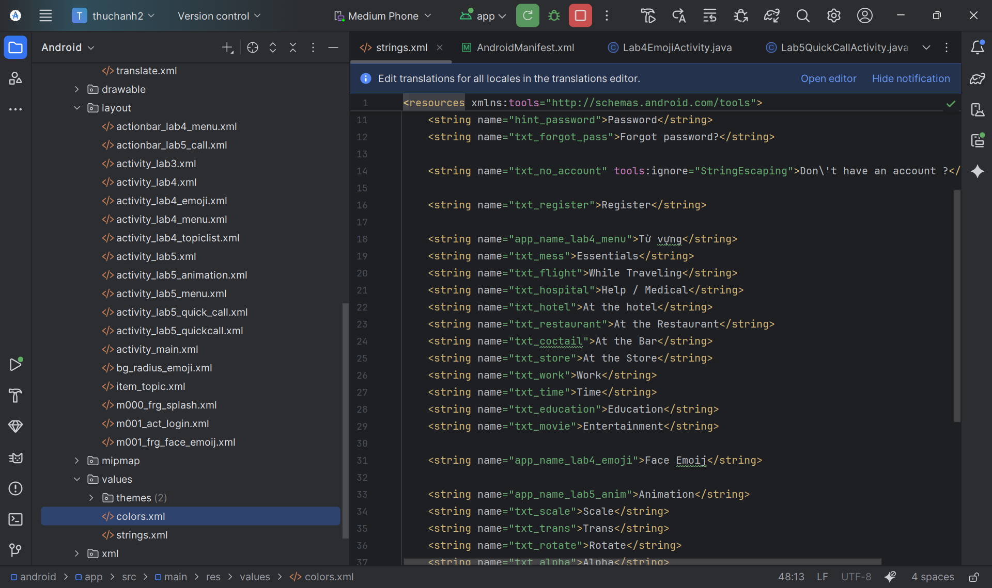

Mở res/values/themes.xml

<resources xmlns:tools="http://schemas.android.com/tools">

<style name="Theme.Thuchanh2" parent="Theme.MaterialComponents.DayNight.NoActionBar">

<item name="colorPrimary">@color/purple_500</item>

<item name="colorPrimaryVariant">@color/purple_700</item>

<item name="colorOnPrimary">@color/white</item>

<item name="colorSecondary">@color/teal_200</item>

<item name="colorSecondaryVariant">@color/teal_700</item>

<item name="colorOnSecondary">@color/black</item>

<item name="android:statusBarColor">?attr/colorPrimaryVariant</item>

</style>

</resources>

Mở manifests/AndroidManifest.xml

<?xml version="1.0" encoding="utf-8"?>

<manifest xmlns:android="http://schemas.android.com/apk/res/android"

xmlns:tools="http://schemas.android.com/tools">

<uses-permission android:name="android.permission.CALL_PHONE" />

<application

android:allowBackup="true"

android:dataExtractionRules="@xml/data_extraction_rules"

android:fullBackupContent="@xml/backup_rules"

android:icon="@mipmap/ic_launcher"

android:label="@string/app_name"

android:roundIcon="@mipmap/ic_launcher_round"

android:supportsRtl="true"

android:theme="@style/Theme.Thuchanh2"

tools:targetApi="31">

<activity

android:name=".MainActivity"

android:exported="true">

<intent-filter>

<action android:name="android.intent.action.MAIN" />

<category android:name="android.intent.category.LAUNCHER" />

</intent-filter>

</activity>

<activity android:name=".Lab3SplashActivity" />

<activity android:name=".Lab4MenuActivity" />

<activity android:name=".Lab4LoginActivity" />

<activity android:name=".Lab4TopicListActivity" />

<activity android:name=".Lab4EmojiActivity" />

<activity android:name=".Lab5MenuActivity" />

<activity android:name=".Lab5AnimationActivity" />

<activity android:name=".Lab5QuickCallActivity" />

</application>

</manifest>

## PHẦN III: THỰC HIỆN LAB 3 (TRUYỆN CƯỜI)

Bước 1: Tạo file Layout (XML)

res/layout/activity_lab3.xml

<?xml version="1.0" encoding="utf-8"?>

<LinearLayout xmlns:android="http://schemas.android.com/apk/res/android"

xmlns:tools="http://schemas.android.com/tools"

android:layout_width="match_parent"

android:layout_height="match_parent"

android:id="@+id/ln_main"

tools:context=".Lab3SplashActivity"

android:orientation="horizontal">

</LinearLayout>

res/layout/m000_frg_splash.xml

<?xml version="1.0" encoding="utf-8"?>

<FrameLayout xmlns:android="http://schemas.android.com/apk/res/android"

xmlns:tools="http://schemas.android.com/tools"

android:layout_width="match_parent"

android:layout_height="match_parent"

android:background="@color/greenMid">

<ImageView

android:layout_width="200dp"

android:layout_height="100dp"

android:layout_gravity="center"

android:src="@drawable/ic_splash"

tools:ignore="ContentDescription" />

</FrameLayout>

Bước 2: Tạo file Logic (Java)

package com.example.thuchanh2;

import android.os.Bundle;

import androidx.appcompat.app.AppCompatActivity;

import androidx.fragment.app.Fragment;

public class Lab3SplashActivity extends AppCompatActivity {

@Override

protected void onCreate(Bundle savedInstanceState) {

super.onCreate(savedInstanceState);

setContentView(R.layout.activity_lab3);

showFrg(new M000SplashFrg());

}

private void showFrg(Fragment frg) {

getSupportFragmentManager().beginTransaction()

.replace(R.id.ln_main, frg, null)

.commit();

}

public void gotoM001Screen() {

// PDF không cung cấp code cho M001Screen

}

}

M000SplashFrg.java

package com.example.thuchanh2;

import android.os.Bundle;

import android.os.Handler;

import android.view.LayoutInflater;

import android.view.View;

import android.view.ViewGroup;

import androidx.fragment.app.Fragment;

public class M000SplashFrg extends Fragment {

@Override

public View onCreateView(LayoutInflater inflater, ViewGroup container, Bundle savedInstanceState) {

View v = inflater.inflate(R.layout.m000_frg_splash, container, false);

initViews();

return v;

}

private void initViews() {

new Handler().postDelayed(this::gotoM001Screen, 2000);

}

private void gotoM001Screen() {

if (getActivity() instanceof Lab3SplashActivity) {

((Lab3SplashActivity) getActivity()).gotoM001Screen();

}

}

}

res/layout/activity_lab4_menu.xml

<?xml version="1.0" encoding="utf-8"?>

<LinearLayout xmlns:android="http://schemas.android.com/apk/res/android"

android:layout_width="match_parent"

android:layout_height="match_parent"

android:orientation="vertical"

android:gravity="center"

android:padding="30dp">

<TextView

android:layout_width="wrap_content"

android:layout_height="wrap_content"

android:text="LAB 4"

android:textSize="24sp"

android:textStyle="bold"

android:layout_marginBottom="40dp"/>

<Button

android:id="@+id/btn_lab4_login"

android:layout_width="match_parent"

android:layout_height="wrap_content"

android:text="Luyện tập 1: Login UI"

android:layout_marginBottom="20dp"/>

<Button

android:id="@+id/btn_lab4_menu"

android:layout_width="match_parent"

android:layout_height="wrap_content"

android:text="Luyện tập 2: Menu UI"

android:layout_marginBottom="20dp"/>

<Button

android:id="@+id/btn_lab4_emoji"

android:layout_width="match_parent"

android:layout_height="wrap_content"

android:text="Luyện tập 3: Emoji Toast"/>

</LinearLayout>

Lab4MenuActivity.java

package com.example.thuchanh2;

import android.content.Intent;

import android.os.Bundle;

import android.view.View;

import androidx.appcompat.app.AppCompatActivity;

public class Lab4MenuActivity extends AppCompatActivity implements View.OnClickListener {

@Override

protected void onCreate(Bundle savedInstanceState) {

super.onCreate(savedInstanceState);

setContentView(R.layout.activity_lab4_menu);

findViewById(R.id.btn_lab4_login).setOnClickListener(this);

findViewById(R.id.btn_lab4_menu).setOnClickListener(this);

findViewById(R.id.btn_lab4_emoji).setOnClickListener(this);

}

@Override

public void onClick(View v) {

int id = v.getId();

if (id == R.id.btn_lab4_login) {

startActivity(new Intent(this, Lab4LoginActivity.class));

} else if (id == R.id.btn_lab4_menu) {

startActivity(new Intent(this, Lab4TopicListActivity.class));

} else if (id == R.id.btn_lab4_emoji) {

startActivity(new Intent(this, Lab4EmojiActivity.class));

}

}

}

m001_act_login.xml

<?xml version="1.0" encoding="utf-8"?>  
<LinearLayout xmlns:android="http://schemas.android.com/apk/res/android"  
 android:layout_width="match_parent"  
 android:layout_height="match_parent"  
 android:background="@color/gray"  
 android:orientation="vertical">  
  
 <FrameLayout  
 android:layout_width="match_parent"  
 android:layout_height="wrap_content">  
 <View  
 android:layout_width="match_parent"  
 android:layout_height="300dp"  
 android:background="@drawable/bg_top" /> <TextView  
 android:layout_width="wrap_content"  
 android:layout_height="wrap_content"  
 android:layout_gravity="end"  
 android:layout_marginTop="220dp"  
 android:layout_marginEnd="30dp"  
 android:text="@string/txt_login"  
 android:textColor="@color/white"  
 android:textSize="20sp"/> </FrameLayout>  
  
 <EditText  
 android:id="@+id/et_email" android:layout_width="match_parent"  
 android:layout_height="50dp"  
 android:layout_marginHorizontal="30dp"  
 android:layout_marginTop="50dp"  
 android:layout_marginBottom="3dp"  
 android:background="@drawable/bg_radius"  
 android:drawableStart="@drawable/ic_mail"  
 android:drawablePadding="10dp"  
 android:hint="@string/hint_email"  
 android:padding="10dp"  
 android:textSize="18sp"/> <EditText  
 android:id="@+id/et_password" android:layout_width="match_parent"  
 android:layout_height="50dp"  
 android:layout_marginHorizontal="30dp"  
 android:layout_marginTop="20dp"  
 android:layout_marginBottom="3dp"  
 android:background="@drawable/bg_radius"  
 android:drawableStart="@drawable/ic_key"  
 android:drawablePadding="10dp"  
 android:hint="@string/hint_password"  
 android:padding="10dp"  
 android:textSize="18sp"/> <TextView  
 android:layout_width="wrap_content"  
 android:layout_height="wrap_content"  
 android:layout_gravity="end"  
 android:layout_marginTop="10dp"  
 android:layout_marginEnd="30dp"  
 android:text="@string/txt_forgot_pass"  
 android:textColor="@color/black"  
 android:textSize="18sp" /> <TextView  
 android:id="@+id/tv_login_button" android:layout_width="match_parent"  
 android:layout_height="50dp"  
 android:layout_gravity="end"  
 android:layout_marginHorizontal="30dp"  
 android:layout_marginTop="50dp"  
 android:background="@drawable/bg_login"  
 android:gravity="center"  
 android:padding="10dp"  
 android:text="@string/txt_login"  
 android:textColor="@color/white"  
 android:textSize="18sp" /> <TableRow  
 android:layout_width="match_parent"  
 android:layout_height="wrap_content"  
 android:layout_marginTop="50dp"  
 android:gravity="center"> <TextView  
 android:layout_width="wrap_content"  
 android:layout_height="wrap_content"  
 android:layout_gravity="end"  
 android:text="@string/txt_no_account"  
 android:textColor="@color/black"  
 android:textSize="14sp" /> <TextView  
 android:layout_width="wrap_content"  
 android:layout_height="wrap_content"  
 android:layout_gravity="end"  
 android:text="@string/txt_register"  
 android:textColor="@color/orange"  
 android:textSize="14sp"  
 android:textStyle="bold" /> </TableRow>  
</LinearLayout>

Lab4LoginActivity.java

package com.example.thuchanh2;

import android.os.Bundle;

import android.view.View;

import android.widget.EditText;

import android.widget.TextView;

import android.widget.Toast;

import androidx.appcompat.app.AppCompatActivity;

public class Lab4LoginActivity extends AppCompatActivity {

private EditText etEmail, etPassword;

private TextView tvLoginButton;

@Override

protected void onCreate(Bundle savedInstanceState) {

super.onCreate(savedInstanceState);

setContentView(R.layout.m001_act_login);

// Tìm các View bằng ID (ID này bạn phải tự thêm vào file XML)

etEmail = findViewById(R.id.et_email);

etPassword = findViewById(R.id.et_password);

tvLoginButton = findViewById(R.id.tv_login_button);

// GIẢI BÀI TẬP 1

tvLoginButton.setOnClickListener(new View.OnClickListener() {

@Override

public void onClick(View v) {

String email = etEmail.getText().toString();

String password = etPassword.getText().toString();

String message = "Bạn đã đăng nhập thành công với email: " + email + " và mật khẩu: " + password;

Toast.makeText(Lab4LoginActivity.this, message, Toast.LENGTH_LONG).show();

}

});

}

}

Bước 3: Bài 2 (Menu) + Giải Bài tập 2

(Thực hiện tương tự, chép các file activity_lab4_topiclist.xml, item_topic.xml, actionbar_lab4_menu.xml và Lab4TopicListActivity.java. Code Java đã có sẵn phần giải bài tập 2 là v.setOnClickListener).

Bước 4: Bài 3 (Emoji) + Giải Bài tập 3

(Thực hiện tương tự, chép các file activity_lab4_emoji.xml, m001_frg_face_emoij.xml (có thêm nút Random), bg_radius_emoji.xml, Lab4EmojiActivity.java, và FragmentFaceEmoij.java. Code Java đã có sẵn phần giải bài tập 3 là randomizeEmojis()).

Bước 1: Tạo Menu phụ cho Lab 5

(Làm tương tự Lab 4, tạo activity_lab5_menu.xml và Lab5MenuActivity.java để điều hướng đến 2 bài luyện tập).

Bước 2: Bài 1 (Animation) + Giải Bài tập 1

1. TẠO THƯ MỤC res/anim:
   * Nhấp chuột phải vào res > New > Android Resource Directory.
   * Chọn Resource type là anim.
   * Tạo 4 file XML bên trong: alpha.xml, rotate.xml, scale.xml, translate.xml (chép code từ PDF).
2. res/layout/activity_lab5_animation.xml: (Chép code từ PDF, nhớ thêm nút "Random" để giải Bài tập 1).
3. java/.../Lab5AnimationActivity.java: (Chép code từ PDF, code này đã bao gồm OnClickListener và logic để giải Bài tập 1).

Bước 3: Bài 2 (Quick Call) + Giải Bài tập 2

1. res/layout/activity_lab5_quickcall.xml: (Đây là file bạn bị thiếu ở lỗi trước. Chép toàn bộ code layout của nó).
2. res/layout/actionbar_lab5_call.xml: (Chép code từ PDF, nhớ thêm android:id="@+id/iv_dialer" cho ImageView để code Java có thể tìm thấy).
3. java/.../Lab5QuickCallActivity.java: (Chép code từ PDF. Code này đã bao gồm logic gọi điện, xin quyền, và phần giải Bài tập 2 là áp dụng animation ngẫu nhiên khi nhấn).

PHẦN III: THÊM TÀI NGUYÊN HÌNH ẢNH (ASSETS)

Đây là bước cuối cùng để sửa tất cả lỗi resource not found.

Bước 1: Thêm Vector Assets (Icons)

1. Nhấp chuột phải vào res/drawable > New > Vector Asset.
2. Nhấp vào ô "Clip Art" và tìm, tạo các file sau:
   * ic_mail.xml
   * ic_key.xml
   * ic_back.xml
   * ic_search.xml
   * ic_dialer.xml

Bước 2: Thêm file Ảnh (.png, .jpg)

1. Tải về tất cả các file ảnh được liệt kê trong PDF (ví dụ ic_splash.jpg, ic_elephant.png, ic_mess.png...).
2. Đảm bảo tên file chính xác tuyệt đối.
3. Kéo tất cả các file ảnh này và thả vào thư mục res/drawable trong Android Studio.

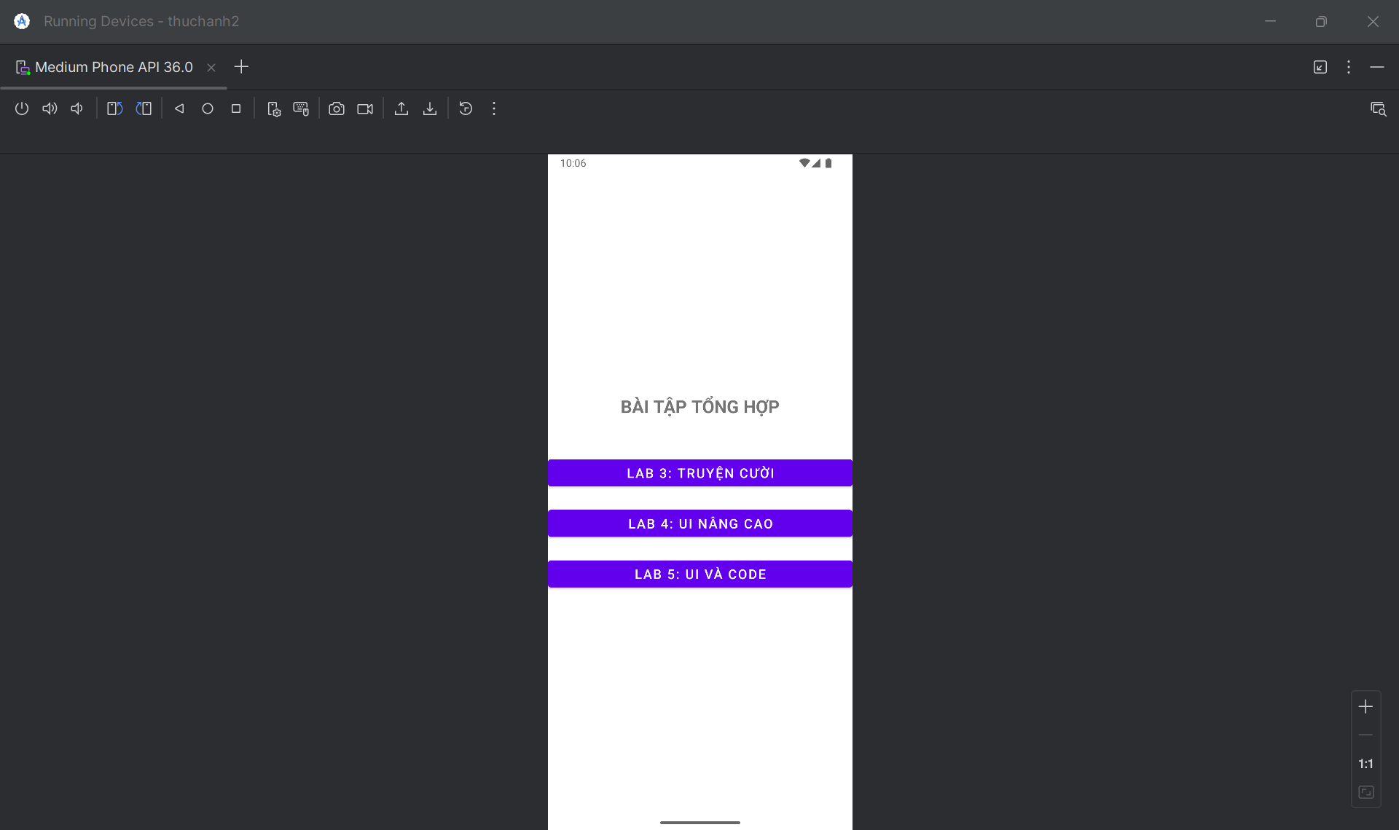

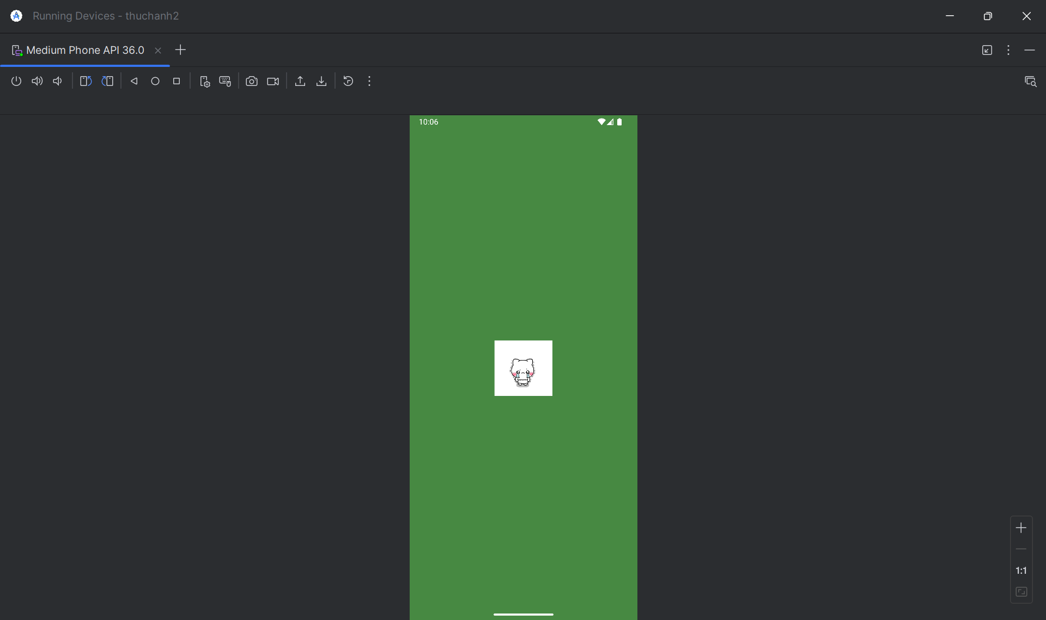

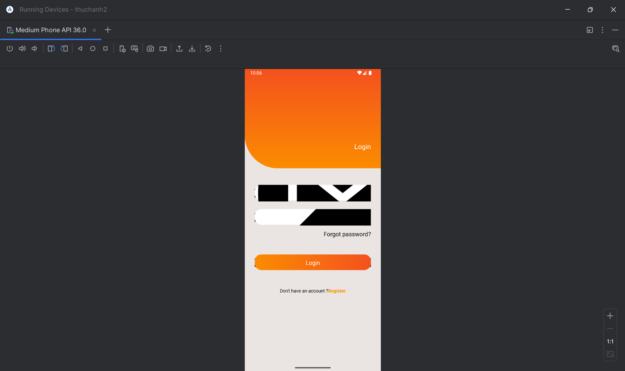

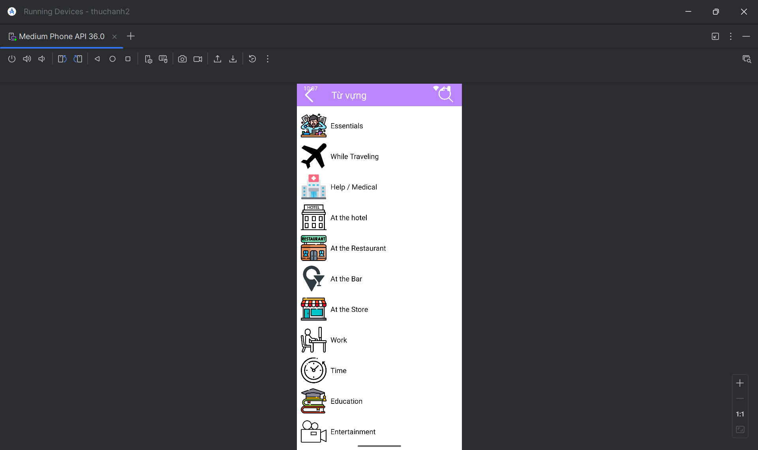

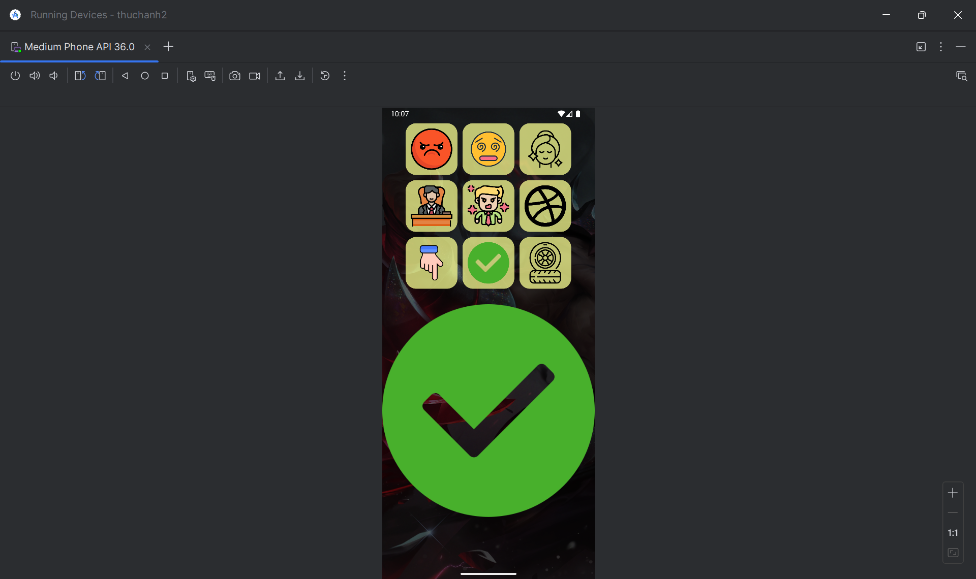

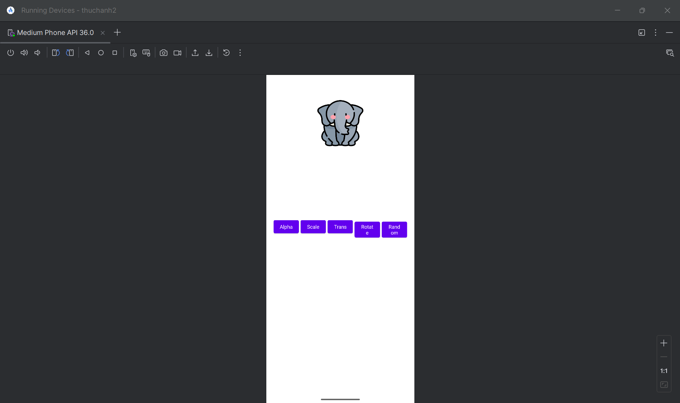

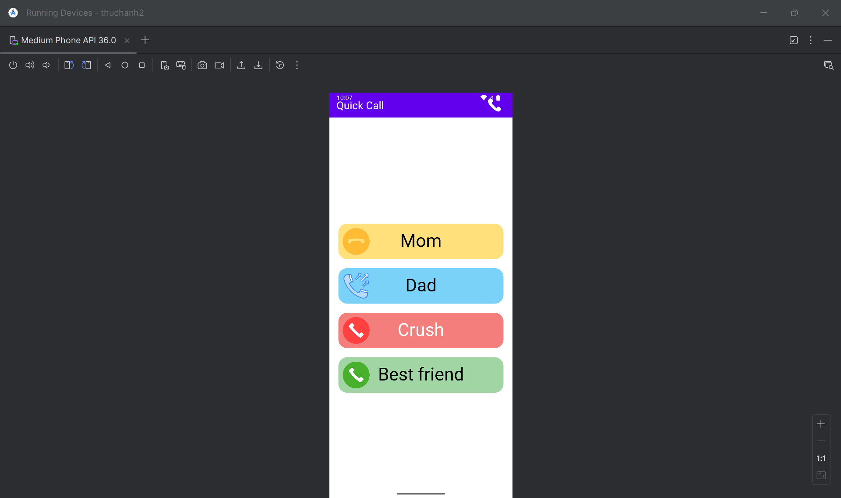

# CHƯƠNG 3: THỰC HÀNH BUỔI 13

## Bài 6:

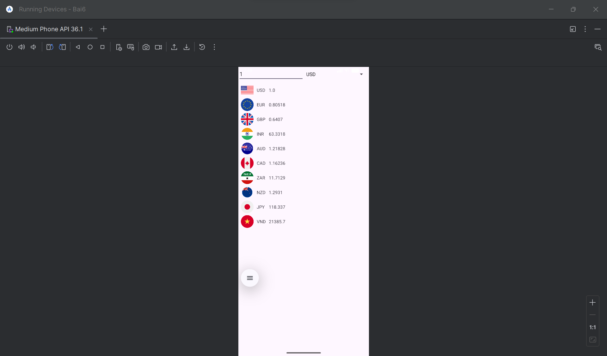

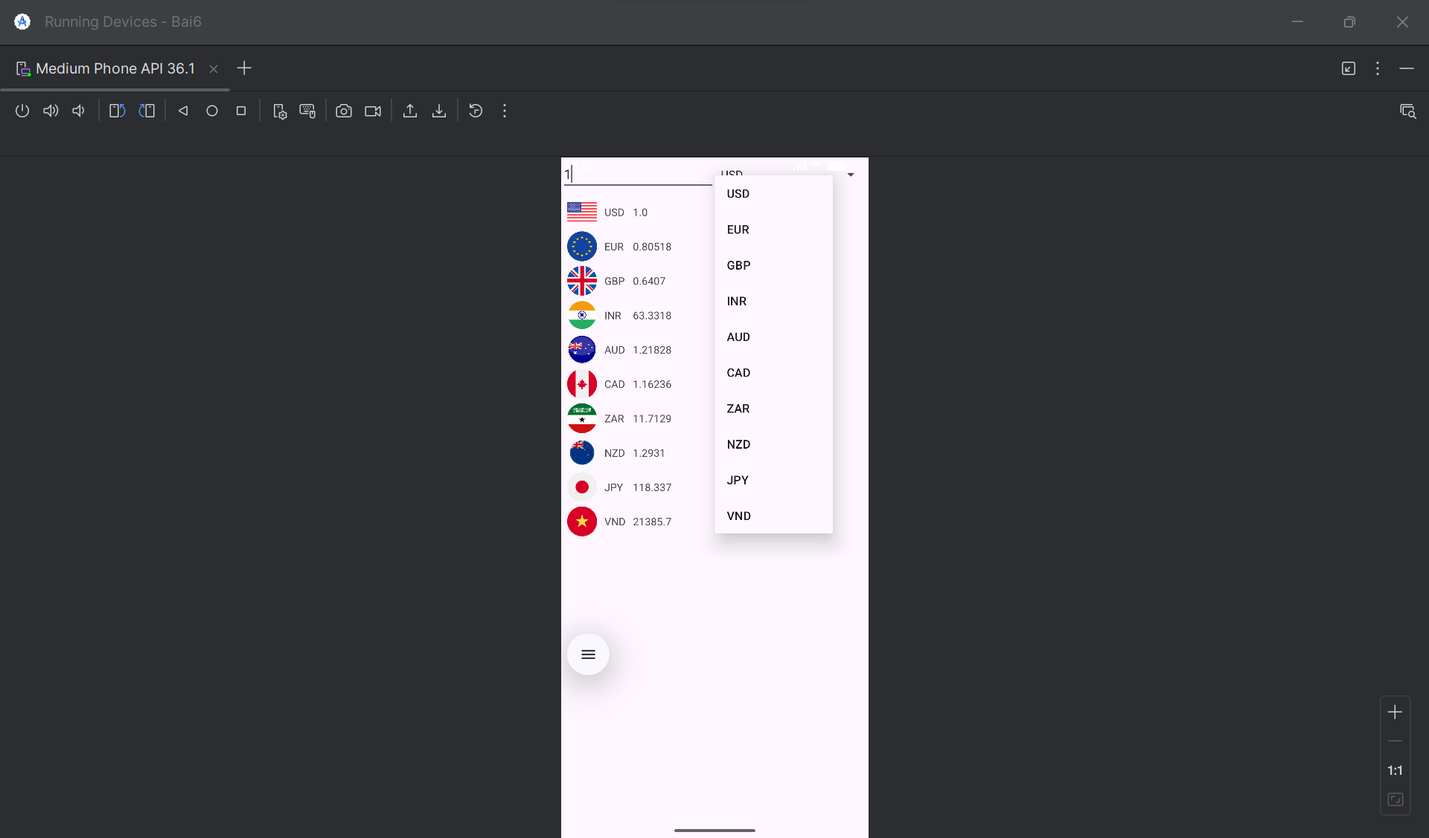

Bước 0: Chuẩn bị hình ảnh

Đây là bước quan trọng. Bạn cần sao chép 10 tệp hình ảnh lá cờ (ví dụ: usd.png, eur.png, gbp.png,...) vào thư mục res/drawable trong dự án Android Studio của bạn.

Bước 1: Tệp AndroidManifest.xml

Tệp này khai báo 3 màn hình (Activity) của bạn và đặt MainActivity làm màn hình khởi chạy.

Vị trí: app/src/main/AndroidManifest.xml

<?xml version="1.0" encoding="utf-8"?>

<manifest xmlns:android="http://schemas.android.com/apk/res/android">

<application

android:allowBackup="true"

android:icon="@mipmap/ic_launcher"

android:label="@string/app_name"

android:roundIcon="@mipmap/ic_launcher_round"

android:supportsRtl="true"

android:theme="@style/Theme.Bai6"> <activity

android:name=".MainActivity"

android:exported="true">

<intent-filter>

<action android:name="android.intent.action.MAIN" />

<category android:name="android.intent.category.LAUNCHER" />

</intent-filter>

</activity>

<activity

android:name=".CurrencyActivity"

android:label="@string/title_activity_currency" />

<activity

android:name=".LengthActivity"

android:label="@string/title_activity_length" />

</application>

</manifest>

Bước 2: Tệp strings.xml

Tệp này chứa tất cả các chuỗi văn bản cho cả 3 màn hình.

Vị trí: app/res/values/strings.xml

XML

<resources>

<string name="app_name">Bộ công cụ đổi</string>

<string name="menu_button_currency">Chương trình đổi tiền</string>

<string name="menu_button_length">Đổi đơn vị đo chiều dài</string>

<string name="title_activity_currency">Chương trình đổi tiền</string>

<string name="currency_textbox_hint">Nhập số tiền</string>

<string name="usd_name">American Dollar</string>

<string name="eur_name">European Cash</string>

<string name="gbp_name">Greate Britain</string>

<string name="inr_name">Indian Rupe</string>

<string name="aud_name">Australia Dollar</string>

<string name="cad_name">Canadian Dollar</string>

<string name="zar_name">South Africa Rand</string>

<string name="nzd_name">New Zealand Dollar</string>

<string name="jpy_name">Yên Nhật</string>

<string name="vnd_name">Việt Nam Đồng</string>

<string name="usd_unit">USD</string>

<string name="eur_unit">EUR</string>

<string name="gbp_unit">GBP</string>

<string name="inr_unit">INR</string>

<string name="aud_unit">AUD</string>

<string name="cad_unit">CAD</string>

<string name="zar_unit">ZAR</string>

<string name="nzd_unit">NZD</string>

<string name="jpy_unit">JPY</string>

<string name="vnd_unit">VND</string>

<string name="title_activity_length">Đổi đơn vị đo chiều dài</string>

<string name="length_textbox_hint">Nhập độ dài</string>

<string name="header_result">Tương đương với</string>

<string name="unit_haily">Hải lý</string>

<string name="unit_dam">Dặm</string>

<string name="unit_km">Kilometer</string>

<string name="unit_ly">Lý</string>

<string name="unit_met">Met</string>

<string name="unit_yard">Yard</string>

<string name="unit_foot">Foot</string>

<string name="unit_inch">Inches</string>

</resources>

Bước 3: Màn hình Menu (MainActivity)

Tệp Layout: activity_main.xml

Vị trí: app/res/layout/activity_main.xml

XML

<?xml version="1.0" encoding="utf-8"?>

<LinearLayout

xmlns:android="http://schemas.android.com/apk/res/android"

xmlns:tools="http://schemas.android.com/tools"

android:layout_width="match_parent"

android:layout_height="match_parent"

android:orientation="vertical"

android:gravity="center"

android:padding="20dp"

tools:context=".MainActivity">

<Button

android:id="@+id/btnGoCurrency"

android:layout_width="match_parent"

android:layout_height="wrap_content"

android:textSize="18sp"

android:text="@string/menu_button_currency" />

<Button

android:id="@+id/btnGoLength"

android:layout_width="match_parent"

android:layout_height="wrap_content"

android:layout_marginTop="20dp"

android:textSize="18sp"

android:text="@string/menu_button_length" />

</LinearLayout>

Tệp Logic: MainActivity.java

Vị trí: app/src/main/java/com/example/bai6/MainActivity.java (Thay com.example.bai6 bằng tên package của bạn)

package com.example.bai6; // <-- THAY BẰNG TÊN PACKAGE CỦA BẠN

import androidx.appcompat.app.AppCompatActivity;

import android.content.Intent;

import android.os.Bundle;

import android.view.View;

import android.widget.Button;

public class MainActivity extends AppCompatActivity {

private Button btnGoCurrency, btnGoLength;

@Override

protected void onCreate(Bundle savedInstanceState) {

super.onCreate(savedInstanceState);

setContentView(R.layout.activity_main);

// Ánh xạ các nút bấm

btnGoCurrency = (Button) findViewById(R.id.btnGoCurrency);

btnGoLength = (Button) findViewById(R.id.btnGoLength);

// Xử lý sự kiện bấm nút đổi tiền

btnGoCurrency.setOnClickListener(new View.OnClickListener() {

@Override

public void onClick(View v) {

// Tạo một "ý định" (Intent) để mở CurrencyActivity

Intent intent = new Intent(MainActivity.this, CurrencyActivity.class);

startActivity(intent); // Bắt đầu Activity mới

}

});

// Xử lý sự kiện bấm nút đổi độ dài

btnGoLength.setOnClickListener(new View.OnClickListener() {

@Override

public void onClick(View v) {

// Tạo một "ý định" (Intent) để mở LengthActivity

Intent intent = new Intent(MainActivity.this, LengthActivity.class);

startActivity(intent); // Bắt đầu Activity mới

}

});

}

}

Bước 4: Màn hình Đổi Tiền (CurrencyActivity)

Tệp Layout: activity_currency.xml

Vị trí: app/res/layout/activity_currency.xml (Đây là file đã sửa kích thước ImageView thành 40dp)

XML

<?xml version="1.0" encoding="utf-8"?>

<LinearLayout

xmlns:android="http://schemas.android.com/apk/res/android"

xmlns:tools="http://schemas.android.com/tools"

android:layout_width="match_parent"

android:layout_height="match_parent"

android:orientation="vertical"

tools:context=".CurrencyActivity">

<LinearLayout

android:layout_width="match_parent"

android:layout_height="wrap_content"

android:orientation="horizontal">

<EditText

android:id="@+id/txtNumber"

android:layout_width="0dip"

android:layout_height="wrap_content"

android:layout_weight="1"

android:ems="10"

android:hint="@string/currency_textbox_hint"

android:inputType="numberDecimal" />

<Spinner

android:id="@+id/spnUnit"

android:layout_width="0dip"

android:layout_height="wrap_content"

android:layout_weight="1" />

</LinearLayout>

<ScrollView

android:layout_width="match_parent"

android:layout_height="match_parent">

<TableLayout

android:layout_width="match_parent"

android:layout_height="wrap_content"

android:padding="5dp">

<TableRow

android:layout_width="match_parent"

android:layout_height="wrap_content"

android:gravity="center_vertical"

android:padding="3dp">

<ImageView

android:layout_width="40dp"

android:layout_height="40dp"

android:scaleType="centerInside"

android:contentDescription="@string/usd_name"

android:src="@drawable/usd" />

<TextView

android:layout_width="wrap_content"

android:layout_height="wrap_content"

android:paddingLeft="10dp"

android:text="@string/usd_unit" />

<TextView

android:id="@+id/lblUsd"

android:layout_width="wrap_content"

android:layout_height="wrap_content"

android:paddingLeft="10dp" />

</TableRow>

<TableRow

android:layout_width="match_parent"

android:layout_height="wrap_content"

android:gravity="center_vertical"

android:padding="3dp">

<ImageView

android:layout_width="40dp"

android:layout_height="40dp"

android:scaleType="centerInside"

android:contentDescription="@string/eur_name"

android:src="@drawable/eur" />

<TextView

android:layout_width="wrap_content"

android:layout_height="wrap_content"

android:paddingLeft="10dp"

android:text="@string/eur_unit" />

<TextView

android:id="@+id/lblEur"

android:layout_width="wrap_content"

android:layout_height="wrap_content"

android:paddingLeft="10dp" />

</TableRow>

<TableRow

android:layout_width="match_parent"

android:layout_height="wrap_content"

android:gravity="center_vertical"

android:padding="3dp">

<ImageView

android:layout_width="40dp"

android:layout_height="40dp"

android:scaleType="centerInside"

android:contentDescription="@string/gbp_name"

android:src="@drawable/gbp" />

<TextView

android:layout_width="wrap_content"

android:layout_height="wrap_content"

android:paddingLeft="10dp"

android:text="@string/gbp_unit" />

<TextView

android:id="@+id/lblGbp"

android:layout_width="wrap_content"

android:layout_height="wrap_content"

android:paddingLeft="10dp" />

</TableRow>

<TableRow

android:layout_width="match_parent"

android:layout_height="wrap_content"

android:gravity="center_vertical"

android:padding="3dp">

<ImageView

android:layout_width="40dp"

android:layout_height="40dp"

android:scaleType="centerInside"

android:contentDescription="@string/inr_name"

android:src="@drawable/inr" />

<TextView

android:layout_width="wrap_content"

android:layout_height="wrap_content"

android:paddingLeft="10dp"

android:text="@string/inr_unit" />

<TextView

android:id="@+id/lblInr"

android:layout_width="wrap_content"

android:layout_height="wrap_content"

android:paddingLeft="10dp" />

</TableRow>

<TableRow

android:layout_width="match_parent"

android:layout_height="wrap_content"

android:gravity="center_vertical"

android:padding="3dp">

<ImageView

android:layout_width="40dp"

android:layout_height="40dp"

android:scaleType="centerInside"

android:contentDescription="@string/aud_name"

android:src="@drawable/aud" />

<TextView

android:layout_width="wrap_content"

android:layout_height="wrap_content"

android:paddingLeft="10dp"

android:text="@string/aud_unit" />

<TextView

android:id="@+id/lblAud"

android:layout_width="wrap_content"

android:layout_height="wrap_content"

android:paddingLeft="10dp" />

</TableRow>

<TableRow

android:layout_width="match_parent"

android:layout_height="wrap_content"

android:gravity="center_vertical"

android:padding="3dp">

<ImageView

android:layout_width="40dp"

android:layout_height="40dp"

android:scaleType="centerInside"

android:contentDescription="@string/cad_name"

android:src="@drawable/cad" />

<TextView

android:layout_width="wrap_content"

android:layout_height="wrap_content"

android:paddingLeft="10dp"

android:text="@string/cad_unit" />

<TextView

android:id="@+id/lblCad"

android:layout_width="wrap_content"

android:layout_height="wrap_content"

android:paddingLeft="10dp" />

</TableRow>

<TableRow

android:layout_width="match_parent"

android:layout_height="wrap_content"

android:gravity="center_vertical"

android:padding="3dp">

<ImageView

android:layout_width="40dp"

android:layout_height="40dp"

android:scaleType="centerInside"

android:contentDescription="@string/zar_name"

android:src="@drawable/zar" />

<TextView

android:layout_width="wrap_content"

android:layout_height="wrap_content"

android:paddingLeft="10dp"

android:text="@string/zar_unit" />

<TextView

android:id="@+id/lblzar"

android:layout_width="wrap_content"

android:layout_height="wrap_content"

android:paddingLeft="10dp" />

</TableRow>

<TableRow

android:layout_width="match_parent"

android:layout_height="wrap_content"

android:gravity="center_vertical"

android:padding="3dp">

<ImageView

android:layout_width="40dp"

android:layout_height="40dp"

android:scaleType="centerInside"

android:contentDescription="@string/nzd_name"

android:src="@drawable/nzd" />

<TextView

android:layout_width="wrap_content"

android:layout_height="wrap_content"

android:paddingLeft="10dp"

android:text="@string/nzd_unit" />

<TextView

android:id="@+id/lblNzd"

android:layout_width="wrap_content"

android:layout_height="wrap_content"

android:paddingLeft="10dp" />

</TableRow>

<TableRow

android:layout_width="match_parent"

android:layout_height="wrap_content"

android:gravity="center_vertical"

android:padding="3dp">

<ImageView

android:layout_width="40dp"

android:layout_height="40dp"

android:scaleType="centerInside"

android:contentDescription="@string/jpy_name"

android:src="@drawable/jpy" />

<TextView

android:layout_width="wrap_content"

android:layout_height="wrap_content"

android:paddingLeft="10dp"

android:text="@string/jpy_unit" />

<TextView

android:id="@+id/lblJpy"

android:layout_width="wrap_content"

android:layout_height="wrap_content"

android:paddingLeft="10dp" />

</TableRow>

<TableRow

android:layout_width="match_parent"

android:layout_height="wrap_content"

android:gravity="center_vertical"

android:padding="3dp">

<ImageView

android:layout_width="40dp"

android:layout_height="40dp"

android:scaleType="centerInside"

android:contentDescription="@string/vnd_name"

android:src="@drawable/vnd" />

<TextView

android:layout_width="wrap_content"

android:layout_height="wrap_content"

android:paddingLeft="10dp"

android:text="@string/vnd_unit" />

<TextView

android:id="@+id/lblVnd"

android:layout_width="wrap_content"

android:layout_height="wrap_content"

android:paddingLeft="10dp" />

</TableRow>

</TableLayout>

</ScrollView>

</LinearLayout>

Tệp Logic: CurrencyActivity.java

Vị trí: app/src/main/java/com/example/bai6/CurrencyActivity.java (Thay com.example.bai6 bằng tên package của bạn)

package com.example.bai6; // <-- THAY BẰNG TÊN PACKAGE CỦA BẠN

import androidx.appcompat.app.AppCompatActivity;

import android.os.Bundle;

import android.text.Editable;

import android.text.TextWatcher;

import android.view.View;

import android.widget.AdapterView;

import android.widget.ArrayAdapter;

import android.widget.EditText;

import android.widget.Spinner;

import android.widget.TextView;

public class CurrencyActivity extends AppCompatActivity {

// Khai báo biến lưu danh sách đơn vị đo

private String[] units = {

"USD", "EUR", "GBP", "INR", "AUD",

"CAD", "ZAR", "NZD", "JPY", "VND"

};

// Khai báo ma trận lưu tỉ giá

private double[][] ratio = {

{1.00000, 0.80518, 0.64070, 63.3318, 1.21828, 1.16236, 11.7129, 1.29310, 118.337, 21385.7},

{1.24172, 1.00000, 0.79575, 78.6084, 1.51266, 1.44314, 14.5371, 1.60576, 146.927, 26561.8},

{1.56044, 1.25667, 1.00000, 98.7848, 1.90091, 1.81355, 18.2683, 2.01791, 184.638, 33374.9},

{0.01580, 0.01272, 0.01012, 1.00000, 0.01924, 0.01836, 0.18493, 0.02043, 1.86910, 337.811},

{0.82114, 0.66119, 0.52620, 52.0860, 1.00000, 0.95416, 9.61148, 1.06158, 97.1120, 17567.9},

{0.86059, 0.69296, 0.55148, 54.5885, 1.04804, 1.00000, 10.0732, 1.11258, 101.777, 18401.7},

{0.08541, 0.06877, 0.05473, 5.40852, 0.10398, 0.09924, 1.00000, 0.11037, 10.0996, 1825.87},

{0.77402, 0.62319, 0.49597, 49.0031, 0.94215, 0.89951, 9.06754, 1.00000, 91.5139, 16552.1},

{0.00846, 0.00681, 0.00542, 0.53547, 0.01030, 0.00983, 0.09908, 0.01093, 1.00000, 180.837},

{0.00005, 0.00004, 0.00003, 0.00296, 0.00006, 0.00005, 0.00055, 0.00006, 0.00553, 1.00000}

};

// Khai báo các đối tượng View

private EditText txtNumber;

private Spinner spnUnits;

private TextView[] lblResults;

@Override

protected void onCreate(Bundle savedInstanceState) {

super.onCreate(savedInstanceState);

setContentView(R.layout.activity_currency); // Trỏ đúng layout

// Khởi tạo các biến thành viên

txtNumber = (EditText) findViewById(R.id.txtNumber);

spnUnits = (Spinner) findViewById(R.id.spnUnit);

lblResults = new TextView[]{

(TextView) findViewById(R.id.lblUsd),

(TextView) findViewById(R.id.lblEur),

(TextView) findViewById(R.id.lblGbp),

(TextView) findViewById(R.id.lblInr),

(TextView) findViewById(R.id.lblAud),

(TextView) findViewById(R.id.lblCad),

(TextView) findViewById(R.id.lblzar), // khớp với ID trong XML

(TextView) findViewById(R.id.lblNzd),

(TextView) findViewById(R.id.lblJpy),

(TextView) findViewById(R.id.lblVnd)

};

// Đưa dữ liệu vào Spinner

ArrayAdapter<String> adapter = new ArrayAdapter<String>(

this, android.R.layout.simple_spinner_item, units);

adapter.setDropDownViewResource(android.R.layout.simple_list_item_1);

spnUnits.setAdapter(adapter);

// Thiết lập các hàm xử lý sự kiện

// Xử lý sự kiện thay item được chọn trong Spinner

spnUnits.setOnItemSelectedListener(new AdapterView.OnItemSelectedListener() {

@Override

public void onItemSelected(AdapterView<?> arg0, View arg1, int arg2, long arg3) {

changeMoneyUnit(); // Gọi hàm đổi tiền

}

@Override

public void onNothingSelected(AdapterView<?> arg0) { }

});

// Xử lý sự kiện thay đổi nội dung ô nhập

txtNumber.addTextChangedListener(new TextWatcher() {

@Override

public void onTextChanged(CharSequence arg0, int arg1, int arg2, int arg3) {

changeMoneyUnit(); // Gọi hàm đổi tiền

}

@Override

public void beforeTextChanged(CharSequence arg0, int arg1, int arg2, int arg3) { }

@Override

public void afterTextChanged(Editable arg0) { }

});

}

// Cài đặt hàm đổi tiền

private void changeMoneyUnit() {

int rowIdx = spnUnits.getSelectedItemPosition();

String input = txtNumber.getText().toString();

if (input.isEmpty()) input = "0";

double number = Double.valueOf(input);

for (int i = 0; i < lblResults.length; i++) {

double temp = number * ratio[rowIdx][i];

lblResults[i].setText(String.valueOf(temp));

}

}

}

Bước 5: Màn hình Đổi Độ Dài (LengthActivity)

Tệp Layout: activity_length.xml

Vị trí: app/res/layout/activity_length.xml (Đây là file khớp với hình ảnh )

XML

<?xml version="1.0" encoding="utf-8"?>

<LinearLayout

xmlns:android="http://schemas.android.com/apk/res/android"

xmlns:tools="http://schemas.android.com/tools"

android:layout_width="match_parent"

android:layout_height="match_parent"

android:orientation="vertical"

tools:context=".LengthActivity">

<LinearLayout

android:layout_width="match_parent"

android:layout_height="wrap_content"

android:orientation="horizontal"

android:padding="5dp">

<EditText

android:id="@+id/txtNumber"

android:layout_width="0dip"

android:layout_height="wrap_content"

android:layout_weight="1"

android:ems="10"

android:hint="@string/length_textbox_hint"

android:inputType="numberDecimal" />

<Spinner

android:id="@+id/spnUnit"

android:layout_width="0dip"

android:layout_height="wrap_content"

android:layout_weight="1" />

</LinearLayout>

<TextView

android:layout_width="match_parent"

android:layout_height="wrap_content"

android:text="@string/header_result"

android:background="#009688"

android:textColor="@android:color/white"

android:padding="10dp"

android:textSize="16sp" />

<ScrollView

android:layout_width="match_parent"

android:layout_height="match_parent">

<TableLayout

android:layout_width="match_parent"

android:layout_height="wrap_content"

android:padding="10dp">

<TableRow

android:layout_width="match_parent"

android:layout_height="wrap_content"

android:paddingVertical="5dp">

<TextView

android:id="@+id/lblHaily"

android:layout_width="0dp"

android:layout_weight="1"

android:layout_height="wrap_content"

android:textSize="18sp"

android:text="0.0"/>

<TextView

android:layout_width="wrap_content"

android:layout_height="wrap_content"

android:textSize="18sp"

android:text="@string/unit_haily" />

</TableRow>

<TableRow

android:layout_width="match_parent"

android:layout_height="wrap_content"

android:paddingVertical="5dp">

<TextView

android:id="@+id/lblDam"

android:layout_width="0dp"

android:layout_weight="1"

android:layout_height="wrap_content"

android:textSize="18sp"

android:text="0.0"/>

<TextView

android:layout_width="wrap_content"

android:layout_height="wrap_content"

android:textSize="18sp"

android:text="@string/unit_dam" />

</TableRow>

<TableRow

android:layout_width="match_parent"

android:layout_height="wrap_content"

android:paddingVertical="5dp">

<TextView

android:id="@+id/lblKm"

android:layout_width="0dp"

android:layout_weight="1"

android:layout_height="wrap_content"

android:textSize="18sp"

android:text="0.0"/>

<TextView

android:layout_width="wrap_content"

android:layout_height="wrap_content"

android:textSize="18sp"

android:text="@string/unit_km" />

</TableRow>

<TableRow

android:layout_width="match_parent"

android:layout_height="wrap_content"

android:paddingVertical="5dp">

<TextView

android:id="@+id/lblLy"

android:layout_width="0dp"

android:layout_weight="1"

android:layout_height="wrap_content"

android:textSize="18sp"

android:text="0.0"/>

<TextView

android:layout_width="wrap_content"

android:layout_height="wrap_content"

android:textSize="18sp"

android:text="@string/unit_ly" />

</TableRow>

<TableRow

android:layout_width="match_parent"

android:layout_height="wrap_content"

android:paddingVertical="5dp">

<TextView

android:id="@+id/lblMet"

android:layout_width="0dp"

android:layout_weight="1"

android:layout_height="wrap_content"

android:textSize="18sp"

android:text="0.0"/>

<TextView

android:layout_width="wrap_content"

android:layout_height="wrap_content"

android:textSize="18sp"

android:text="@string/unit_met" />

</TableRow>

<TableRow

android:layout_width="match_parent"

android:layout_height="wrap_content"

android:paddingVertical="5dp">

<TextView

android:id="@+id/lblYard"

android:layout_width="0dp"

android:layout_weight="1"

android:layout_height="wrap_content"

android:textSize="18sp"

android:text="0.0"/>

<TextView

android:layout_width="wrap_content"

android:layout_height="wrap_content"

android:textSize="18sp"

android:text="@string/unit_yard" />

</TableRow>

<TableRow

android:layout_width="match_parent"

android:layout_height="wrap_content"

android:paddingVertical="5dp">

<TextView

android:id="@+id/lblFoot"

android:layout_width="0dp"

android:layout_weight="1"

android:layout_height="wrap_content"

android:textSize="18sp"

android:text="0.0"/>

<TextView

android:layout_width="wrap_content"

android:layout_height="wrap_content"

android:textSize="18sp"

android:text="@string/unit_foot" />

</TableRow>

<TableRow

android:layout_width="match_parent"

android:layout_height="wrap_content"

android:paddingVertical="5dp">

<TextView

android:id="@+id/lblInch"

android:layout_width="0dp"

android:layout_weight="1"

android:layout_height="wrap_content"

android:textSize="18sp"

android:text="0.0"/>

<TextView

android:layout_width="wrap_content"

android:layout_height="wrap_content"

android:textSize="18sp"

android:text="@string/unit_inch" />

</TableRow>

</TableLayout>

</ScrollView>

</LinearLayout>

Tệp Logic: LengthActivity.java

Vị trí: app/src/main/java/com/example/bai6/LengthActivity.java (Thay com.example.bai6 bằng tên package của bạn)

package com.example.bai6; // <-- THAY BẰNG TÊN PACKAGE CỦA BẠN

import androidx.appcompat.app.AppCompatActivity;

import android.os.Bundle;

import android.text.Editable;

import android.text.TextWatcher;

import android.view.View;

import android.widget.AdapterView;

import android.widget.ArrayAdapter;

import android.widget.EditText;

import android.widget.Spinner;

import android.widget.TextView;

// Import thêm thư viện này để định dạng số thập phân

import java.text.DecimalFormat;

public class LengthActivity extends AppCompatActivity {

// Khai báo biến lưu danh sách đơn vị đo (8 đơn vị)

private String[] units = {

"Hải lý", "Dặm", "Km", "Lý", "Met", "Yard", "Foot", "Inch"

};

// Khai báo ma trận tỉ giá

private double[][] ratio = {

{1.00000000, 1.15077945, 1.8520000, 20.2537183, 1852.0000, 2025.37183, 6076.11549, 72913.38583},

{0.86897624, 1.00000000, 1.6093440, 17.6000000, 1609.3440, 1760.00000, 5280.00000, 63360.00000},

{0.53995680, 0.62137119, 1.0000000, 10.9361330, 1000.0000, 1093.61330, 3280.83990, 39370.07874},

{0.04937365, 0.05681818, 0.0914400, 1.0000000, 91.4400, 100.00000, 300.00000, 3600.00000},

{0.00053996, 0.00062137, 0.0010000, 0.0109361, 1.0000, 1.09361, 3.28084, 39.37008},

{0.00049374, 0.00056818, 0.0009144, 0.0100000, 0.9144, 1.00000, 3.00000, 36.00000},

{0.00016458, 0.00018939, 0.0003048, 0.0033333, 0.3048, 0.33333, 1.00000, 12.00000},

{0.00001371, 0.00001578, 0.0000254, 0.0002778, 0.0254, 0.02778, 0.08333, 1.00000}

};

// Khai báo các đối tượng View

private EditText txtNumber;

private Spinner spnUnits;

private TextView[] lblResults;

private DecimalFormat df = new DecimalFormat("#.####");

@Override

protected void onCreate(Bundle savedInstanceState) {

super.onCreate(savedInstanceState);

setContentView(R.layout.activity_length); // Trỏ đúng layout

// Kết nối các đối tượng View

txtNumber = (EditText) findViewById(R.id.txtNumber);

spnUnits = (Spinner) findViewById(R.id.spnUnit);

lblResults = new TextView[]{

(TextView) findViewById(R.id.lblHaily),

(TextView) findViewById(R.id.lblDam),

(TextView) findViewById(R.id.lblKm),

(TextView) findViewById(R.id.lblLy),

(TextView) findViewById(R.id.lblMet),

(TextView) findViewById(R.id.lblYard),

(TextView) findViewById(R.id.lblFoot),

(TextView) findViewById(R.id.lblInch)

};

// Đưa dữ liệu vào Spinner

ArrayAdapter<String> adapter = new ArrayAdapter<String>(

this, android.R.layout.simple_spinner_item, units);

adapter.setDropDownViewResource(android.R.layout.simple_list_item_1);

spnUnits.setAdapter(adapter);

// Thiết lập các hàm xử lý sự kiện

spnUnits.setOnItemSelectedListener(new AdapterView.OnItemSelectedListener() {

@Override

public void onItemSelected(AdapterView<?> arg0, View arg1, int arg2, long arg3) {

changeLengthUnit(); // Gọi hàm đổi độ dài

}

@Override

public void onNothingSelected(AdapterView<?> arg0) { }

});

txtNumber.addTextChangedListener(new TextWatcher() {

@Override

public void onTextChanged(CharSequence arg0, int arg1, int arg2, int arg3) {

changeLengthUnit(); // Gọi hàm đổi độ dài

}

@Override

public void beforeTextChanged(CharSequence arg0, int arg1, int arg2, int arg3) { }

@Override

public void afterTextChanged(Editable arg0) { }

});

changeLengthUnit(); // Tính toán lần đầu khi mở

}

// Hàm đổi đơn vị độ dài

private void changeLengthUnit() {

int rowIdx = spnUnits.getSelectedItemPosition();

String input = txtNumber.getText().toString();

if (input.isEmpty()) input = "0";

double number = Double.valueOf(input);

for (int i = 0; i < lblResults.length; i++) {

double temp = number * ratio[rowIdx][i];

lblResults[i].setText(df.format(temp));

}

}

}

## Bài 7:

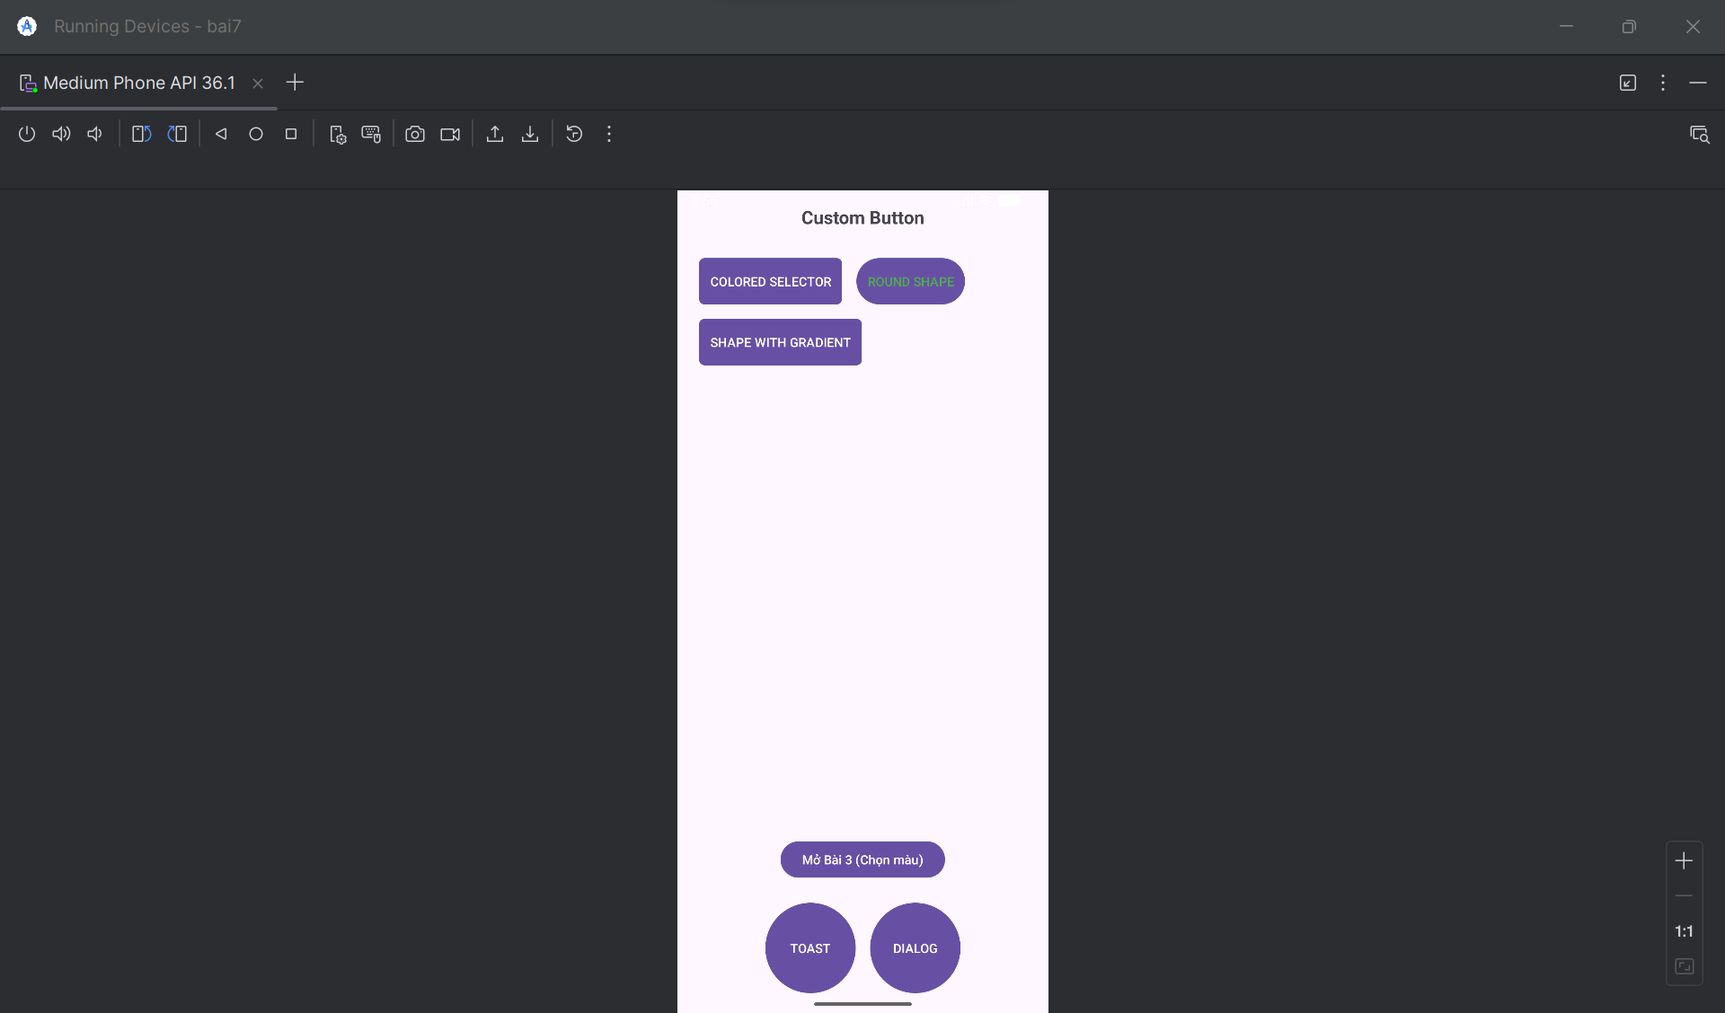

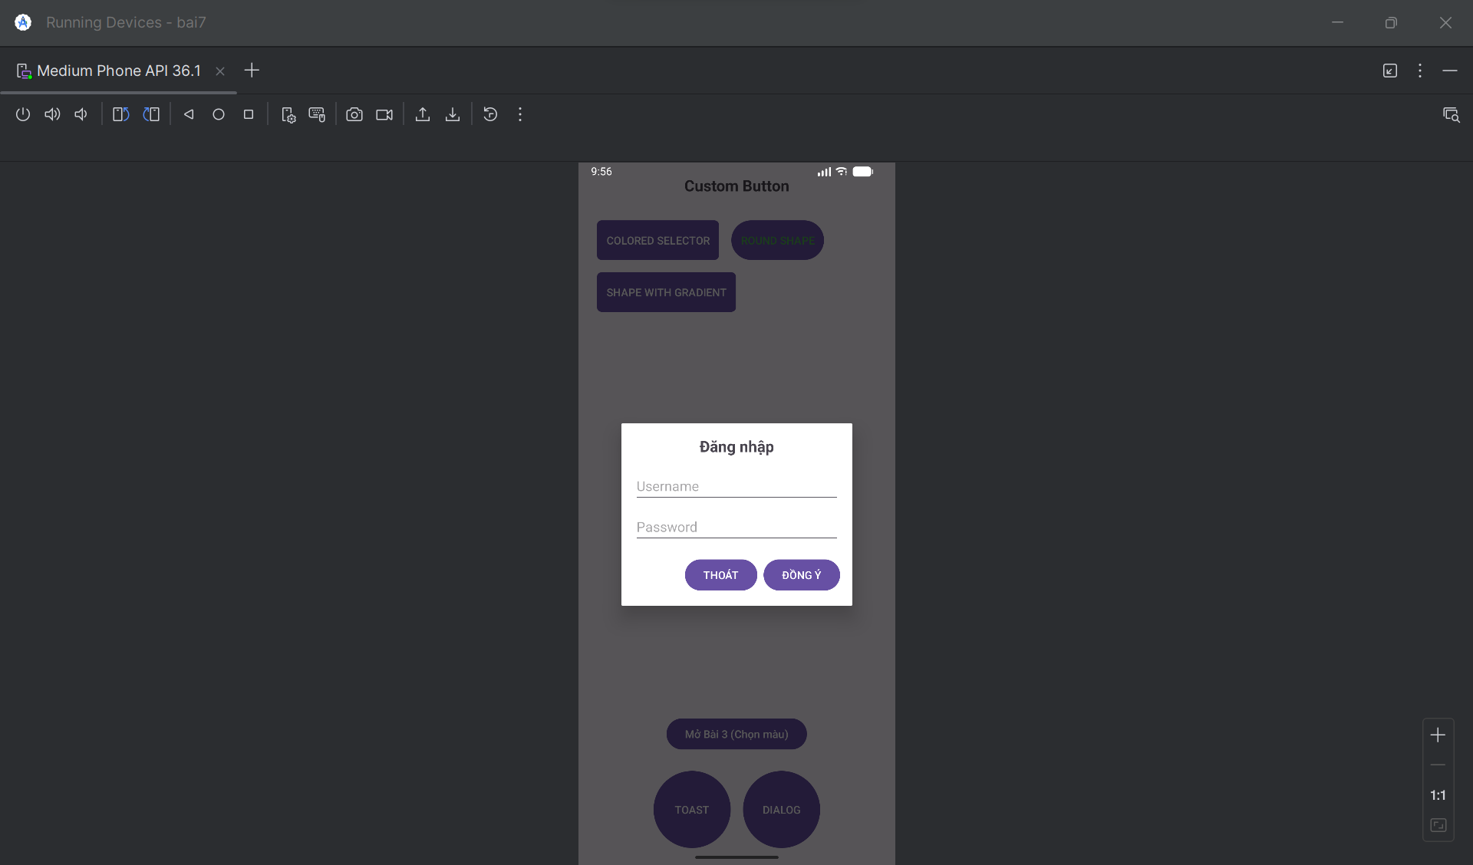

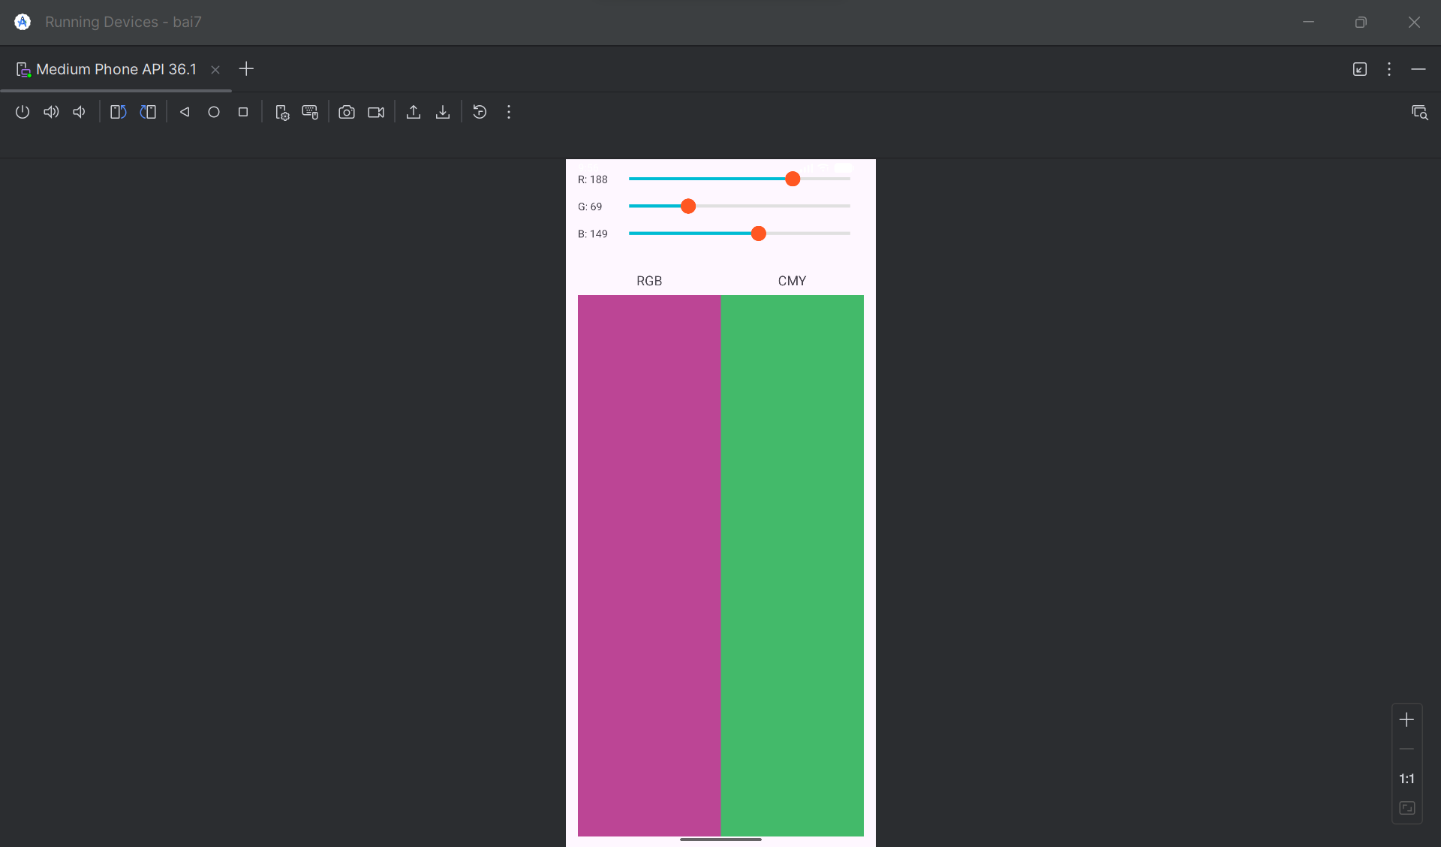

**1. Các file Drawable**

Tạo các file XML sau trong thư mục res/drawable/.

**button_colored_selector.xml**

XML

<?xml version="1.0" encoding="utf-8"?>

<selector xmlns:android="http://schemas.android.com/apk/res/android">

<item android:state_pressed="true">

<shape android:shape="rectangle">

<solid android:color="#00BCD4" />

<corners android:radius="6dp" />

</shape>

</item>

<item>

<shape android:shape="rectangle">

<solid android:color="#03A9F4" />

<corners android:radius="6dp" />

</shape>

</item>

</selector>

**button_round_shape.xml**

XML

<?xml version="1.0" encoding="utf-8"?>

<shape xmlns:android="http://schemas.android.com/apk/res/android"

android:shape="rectangle">

<solid android:color="#FFFFFF" />

<stroke

android:width="2dp"

android:color="#4CAF50" />

<corners android:radius="50dp" />

</shape>

**button_gradient_shape.xml**

XML

<?xml version="1.0" encoding="utf-8"?>

<shape xmlns:android="http://schemas.android.com/apk/res/android"

android:shape="rectangle">

<gradient

android:startColor="#FFC107"

android:endColor="#FF5722"

android:angle="0" />

<corners android:radius="6dp" />

</shape>

**button_oval_blue.xml**

XML

<?xml version="1.0" encoding="utf-8"?>

<selector xmlns:android="http://schemas.android.com/apk/res/android">

<item android:state_pressed="true">

<shape android:shape="oval">

<solid android:color="#0D47A1" />

</shape>

</item>

<item>

<shape android:shape="oval">

<solid android:color="#1976D2" />

</shape>

</item>

</selector>

**custom_toast_background.xml**

XML

<?xml version="1.0" encoding="utf-8"?>

<shape xmlns:android="http://schemas.android.com/apk/res/android"

android:shape="rectangle">

<solid android:color="#424242" />

<corners android:radius="12dp" />

<stroke

android:width="2dp"

android:color="#FFEB3B" />

</shape>

**custom_seekbar_progress.xml**

XML

<?xml version="1.0" encoding="utf-8"?>

<layer-list xmlns:android="http://schemas.android.com/apk/res/android">

<item android:id="@android:id/background">

<shape android:shape="line">

<stroke

android:width="4dp"

android:color="#E0E0E0" />

</shape>

</item>

<item android:id="@android:id/progress">

<clip>

<shape android:shape="line">

<stroke

android:width="4dp"

android:color="#00BCD4" />

</shape>

</clip>

</item>

</layer-list>

**custom_seekbar_thumb.xml**

XML

<?xml version="1.0" encoding="utf-8"?>

<shape xmlns:android="http://schemas.android.com/apk/res/android"

android:shape="oval">

<solid android:color="#FF5722" />

<size

android:width="20dp"

android:height="20dp" />

</shape>

**2. Các file Layout**

Tạo các file XML sau trong thư mục res/layout/.

**custom_toast_layout.xml**

XML

<?xml version="1.0" encoding="utf-8"?>

<LinearLayout

xmlns:android="http://schemas.android.com/apk/res/android"

android:id="@+id/custom_toast_container"

android:orientation="horizontal"

android:layout_width="wrap_content"

android:layout_height="wrap_content"

android:padding="12dp"

android:background="@drawable/custom_toast_background">

<ImageView

android:layout_width="wrap_content"

android:layout_height="wrap_content"

android:src="@android:drawable/ic_dialog_info"

android:layout_marginEnd="8dp"/>

<TextView

android:layout_width="wrap_content"

android:layout_height="wrap_content"

android:text="Custom Toast, made by..."

android:textColor="@android:color/white"

android:textSize="16sp"/>

</LinearLayout>

**custom_dialog_layout.xml**

XML

<?xml version="1.0" encoding="utf-8"?>

<LinearLayout

xmlns:android="http://schemas.android.com/apk/res/android"

android:orientation="vertical"

android:layout_width="300dp"

android:layout_height="wrap_content"

android:padding="16dp">

<TextView

android:layout_width="wrap_content"

android:layout_height="wrap_content"

android:text="Đăng nhập"

android:textSize="20sp"

android:textStyle="bold"

android:layout_gravity="center_horizontal"/>

<EditText

android:layout_width="match_parent"

android:layout_height="wrap_content"

android:hint="Username"

android:layout_marginTop="16dp"/>

<EditText

android:layout_width="match_parent"

android:layout_height="wrap_content"

android:hint="Password"

android:inputType="textPassword"

android:layout_marginTop="8dp"/>

<LinearLayout

android:layout_width="match_parent"

android:layout_height="wrap_content"

android:orientation="horizontal"

android:gravity="end"

android:layout_marginTop="16dp">

<Button

android:id="@+id/btnDialogThoat"

android:layout_width="wrap_content"

android:layout_height="wrap_content"

android:text="THOÁT"/>

<Button

android:id="@+id/btnDialogDongY"

android:layout_width="wrap_content"

android:layout_height="wrap_content"

android:text="ĐỒNG Ý"

android:layout_marginStart="8dp"/>

</LinearLayout>

</LinearLayout>

**activity_main.xml**

XML

<?xml version="1.0" encoding="utf-8"?>

<RelativeLayout

xmlns:android="http://schemas.android.com/apk/res/android"

xmlns:tools="http://schemas.android.com/tools"

android:layout_width="match_parent"

android:layout_height="match_parent"

android:padding="16dp"

tools:context=".MainActivity">

<TextView

android:id="@+id/title"

android:layout_width="wrap_content"

android:layout_height="wrap_content"

android:text="Custom Button"

android:textSize="20sp"

android:textStyle="bold"

android:layout_centerHorizontal="true"

android:layout_marginBottom="24dp" />

<Button

android:id="@+id/btnColoredSelector"

android:layout_width="wrap_content"

android:layout_height="wrap_content"

android:layout_below="@id/title"

android:text="COLORED SELECTOR"

android:textColor="@android:color/white"

android:background="@drawable/button_colored_selector"

android:layout_margin="8dp"

android:padding="12dp" />

<Button

android:id="@+id/btnRoundShape"

android:layout_width="wrap_content"

android:layout_height="wrap_content"

android:layout_below="@id/title"

android:layout_toEndOf="@id/btnColoredSelector"

android:text="ROUND SHAPE"

android:textColor="#4CAF50"

android:background="@drawable/button_round_shape"

android:layout_margin="8dp"

android:padding="12dp" />

<Button

android:id="@+id/btnGradientShape"

android:layout_width="wrap_content"

android:layout_height="wrap_content"

android:layout_below="@id/btnColoredSelector"

android:text="SHAPE WITH GRADIENT"

android:textColor="@android:color/white"

android:background="@drawable/button_gradient_shape"

android:layout_margin="8dp"

android:padding="12dp" />

<LinearLayout

android:id="@+id/bottom_buttons"

android:layout_width="match_parent"

android:layout_height="wrap_content"

android:orientation="horizontal"

android:layout_alignParentBottom="true"

android:gravity="center">

<Button

android:id="@+id/btnToast"

android:layout_width="100dp"

android:layout_height="100dp"

android:text="TOAST"

android:textColor="@android:color/white"

android:background="@drawable/button_oval_blue"

android:layout_margin="8dp"/>

<Button

android:id="@+id/btnDialog"

android:layout_width="100dp"

android:layout_height="100dp"

android:text="DIALOG"

android:textColor="@android:color/white"

android:background="@drawable/button_oval_blue"

android:layout_margin="8dp"/>

</LinearLayout>

<Button

android:id="@+id/btnOpenBai3"

android:layout_width="wrap_content"

android:layout_height="wrap_content"

android:layout_above="@id/bottom_buttons"

android:layout_centerHorizontal="true"

android:text="Mở Bài 3 (Chọn màu)"

android:layout_marginBottom="16dp"/>

</RelativeLayout>

**activity_choose_color.xml**

XML

<?xml version="1.0" encoding="utf-8"?>

<LinearLayout

xmlns:android="http://schemas.android.com/apk/res/android"

xmlns:tools="http://schemas.android.com/tools"

android:layout_width="match_parent"

android:layout_height="match_parent"

android:orientation="vertical"

android:padding="16dp"

tools:context=".ChooseColorActivity">

<LinearLayout

android:layout_width="match_parent"

android:layout_height="wrap_content"

android:orientation="horizontal"

android:gravity="center_vertical"

android:layout_marginBottom="16dp">

<TextView

android:id="@+id/tvRed"

android:layout_width="50dp"

android:layout_height="wrap_content"

android:text="R: 0"/>

<SeekBar

android:id="@+id/seekBarRed"

android:layout_width="0dp"

android:layout_height="wrap_content"

android:layout_weight="1"

android:max="255"

android:progress="0"

android:progressDrawable="@drawable/custom_seekbar_progress"

android:thumb="@drawable/custom_seekbar_thumb" />

</LinearLayout>

<LinearLayout

android:layout_width="match_parent"

android:layout_height="wrap_content"

android:orientation="horizontal"

android:gravity="center_vertical"

android:layout_marginBottom="16dp">

<TextView

android:id="@+id/tvGreen"

android:layout_width="50dp"

android:layout_height="wrap_content"

android:text="G: 0"/>

<SeekBar

android:id="@+id/seekBarGreen"

android:layout_width="0dp"

android:layout_height="wrap_content"

android:layout_weight="1"

android:max="255"

android:progress="0"

android:progressDrawable="@drawable/custom_seekbar_progress"

android:thumb="@drawable/custom_seekbar_thumb" />

</LinearLayout>

<LinearLayout

android:layout_width="match_parent"

android:layout_height="wrap_content"

android:orientation="horizontal"

android:gravity="center_vertical"

android:layout_marginBottom="16dp">

<TextView

android:id="@+id/tvBlue"

android:layout_width="50dp"

android:layout_height="wrap_content"

android:text="B: 0"/>

<SeekBar

android:id="@+id/seekBarBlue"

android:layout_width="0dp"

android:layout_height="wrap_content"

android:layout_weight="1"

android:max="255"

android:progress="0"

android:progressDrawable="@drawable/custom_seekbar_progress"

android:thumb="@drawable/custom_seekbar_thumb" />

</LinearLayout>

<LinearLayout

android:layout_width="match_parent"

android:layout_height="0dp"

android:layout_weight="1"

android:orientation="horizontal"

android:layout_marginTop="24dp">

<LinearLayout

android:layout_width="0dp"

android:layout_height="match_parent"

android:layout_weight="1"

android:orientation="vertical"

android:gravity="center_horizontal">

<TextView

android:layout_width="wrap_content"

android:layout_height="wrap_content"

android:text="RGB"

android:textSize="18sp"

android:layout_marginBottom="8dp"/>

<View

android:id="@+id/viewRGB"

android:layout_width="match_parent"

android:layout_height="match_parent"

android:background="#000000"/>

</LinearLayout>

<LinearLayout

android:layout_width="0dp"

android:layout_height="match_parent"

android:layout_weight="1"

android:orientation="vertical"

android:gravity="center_horizontal">

<TextView

android:layout_width="wrap_content"

android:layout_height="wrap_content"

android:text="CMY"

android:textSize="18sp"

android:layout_marginBottom="8dp"/>

<View

android:id="@+id/viewCMY"

android:layout_width="match_parent"

android:layout_height="match_parent"

android:background="#FFFFFF"/>

</LinearLayout>

</LinearLayout>

</LinearLayout>

**3. Mã Java**

Đây là các file .java cho các Activity.

**MainActivity.java**

package com.example.ten_du_an_cua_ban;

import androidx.appcompat.app.AppCompatActivity;

import android.app.Dialog;

import android.content.Intent;

import android.os.Bundle;

import android.view.Gravity;

import android.view.LayoutInflater;

import android.view.View;

import android.view.ViewGroup;

import android.widget.Button;

import android.widget.Toast;

public class MainActivity extends AppCompatActivity {

Button btnToast, btnDialog, btnOpenBai3;

@Override

protected void onCreate(Bundle savedInstanceState) {

super.onCreate(savedInstanceState);

setContentView(R.layout.activity_main);

btnToast = findViewById(R.id.btnToast);

btnDialog = findViewById(R.id.btnDialog);

btnOpenBai3 = findViewById(R.id.btnOpenBai3);

btnToast.setOnClickListener(new View.OnClickListener() {

@Override

public void onClick(View v) {

showCustomToast();

}

});

btnDialog.setOnClickListener(new View.OnClickListener() {

@Override

public void onClick(View v) {

showCustomDialog();

}

});

btnOpenBai3.setOnClickListener(new View.OnClickListener() {

@Override

public void onClick(View v) {

Intent intent = new Intent(MainActivity.this, ChooseColorActivity.class);

startActivity(intent);

}

});

}

private void showCustomToast() {

LayoutInflater inflater = getLayoutInflater();

View layout = inflater.inflate(R.layout.custom_toast_layout,

(ViewGroup) findViewById(R.id.custom_toast_container));

Toast toast = new Toast(getApplicationContext());

toast.setGravity(Gravity.CENTER_VERTICAL, 0, 0);

toast.setDuration(Toast.LENGTH_LONG);

toast.setView(layout);

toast.show();

}

private void showCustomDialog() {

final Dialog dialog = new Dialog(this);

dialog.setContentView(R.layout.custom_dialog_layout);

dialog.setTitle("Đăng nhập");

Button btnDongY = dialog.findViewById(R.id.btnDialogDongY);

Button btnThoat = dialog.findViewById(R.id.btnDialogThoat);

btnDongY.setOnClickListener(new View.OnClickListener() {

@Override

public void onClick(View v) {

dialog.dismiss();

}

});

btnThoat.setOnClickListener(new View.OnClickListener() {

@Override

public void onClick(View v) {

dialog.dismiss();

}

});

dialog.show();

}

}

**ChooseColorActivity.java**

package com.example.ten_du_an_cua_ban;

import androidx.appcompat.app.AppCompatActivity;

import android.graphics.Color;

import android.os.Bundle;

import android.view.View;

import android.widget.SeekBar;

import android.widget.TextView;

public class ChooseColorActivity extends AppCompatActivity {

SeekBar seekBarRed, seekBarGreen, seekBarBlue;

TextView tvRed, tvGreen, tvBlue;

View viewRGB, viewCMY;

@Override

protected void onCreate(Bundle savedInstanceState) {

super.onCreate(savedInstanceState);

setContentView(R.layout.activity_choose_color);

seekBarRed = findViewById(R.id.seekBarRed);

seekBarGreen = findViewById(R.id.seekBarGreen);

seekBarBlue = findViewById(R.id.seekBarBlue);

tvRed = findViewById(R.id.tvRed);

tvGreen = findViewById(R.id.tvGreen);

tvBlue = findViewById(R.id.tvBlue);

viewRGB = findViewById(R.id.viewRGB);

viewCMY = findViewById(R.id.viewCMY);

SeekBar.OnSeekBarChangeListener seekBarListener = new SeekBar.OnSeekBarChangeListener() {

@Override

public void onProgressChanged(SeekBar seekBar, int progress, boolean fromUser) {

updateColors();

}

@Override

public void onStartTrackingTouch(SeekBar seekBar) { }

@Override

public void onStopTrackingTouch(SeekBar seekBar) { }

};

seekBarRed.setOnSeekBarChangeListener(seekBarListener);

seekBarGreen.setOnSeekBarChangeListener(seekBarListener);

seekBarBlue.setOnSeekBarChangeListener(seekBarListener);

updateColors();

}

private void updateColors() {

int r = seekBarRed.getProgress();

int g = seekBarGreen.getProgress();

int b = seekBarBlue.getProgress();

tvRed.setText("R: " + r);

tvGreen.setText("G: " + g);

tvBlue.setText("B: " + b);

viewRGB.setBackgroundColor(Color.rgb(r, g, b));

int c = 255 - r;

int m = 255 - g;

int y = 255 - b;

viewCMY.setBackgroundColor(Color.rgb(c, m, y));

}

}

**4. File AndroidManifest.xml**

Bạn cần đảm bảo ChooseColorActivity được khai báo trong file manifest.

XML

<?xml version="1.0" encoding="utf-8"?>

<manifest xmlns:android="http://schemas.android.com/apk/res/android"

package="com.example.ten_du_an_cua_ban">

<application

android:allowBackup="true"

android:icon="@mipmap/ic_launcher"

android:label="@string/app_name"

android:roundIcon="@mipmap/ic_launcher_round"

android:supportsRtl="true"

android:theme="@style/Theme.TenDuAnCuaBan">

<activity

android:name=".MainActivity"

android:exported="true">

<intent-filter>

<action android:name="android.intent.action.MAIN" />

<category android:name="android.intent.category.LAUNCHER" />

</intent-filter>

</activity>

<activity

android:name=".ChooseColorActivity"

android:label="Choose Color" />

</application>

</manifest>

## Bài 8:

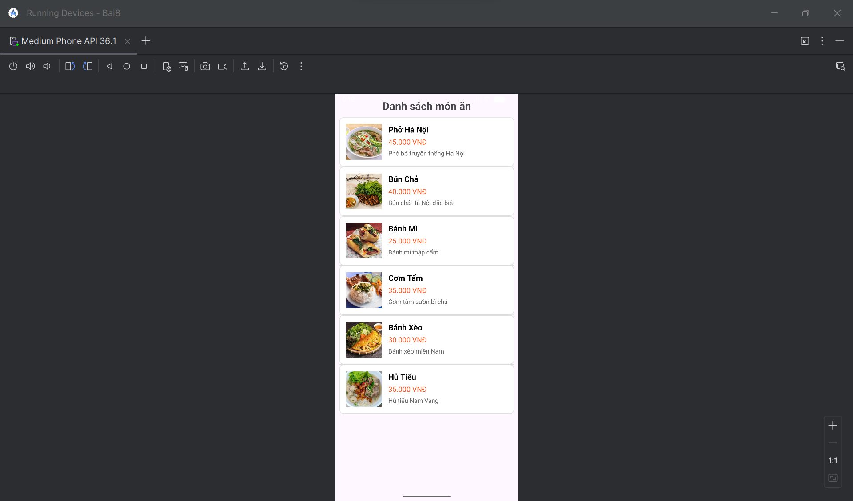

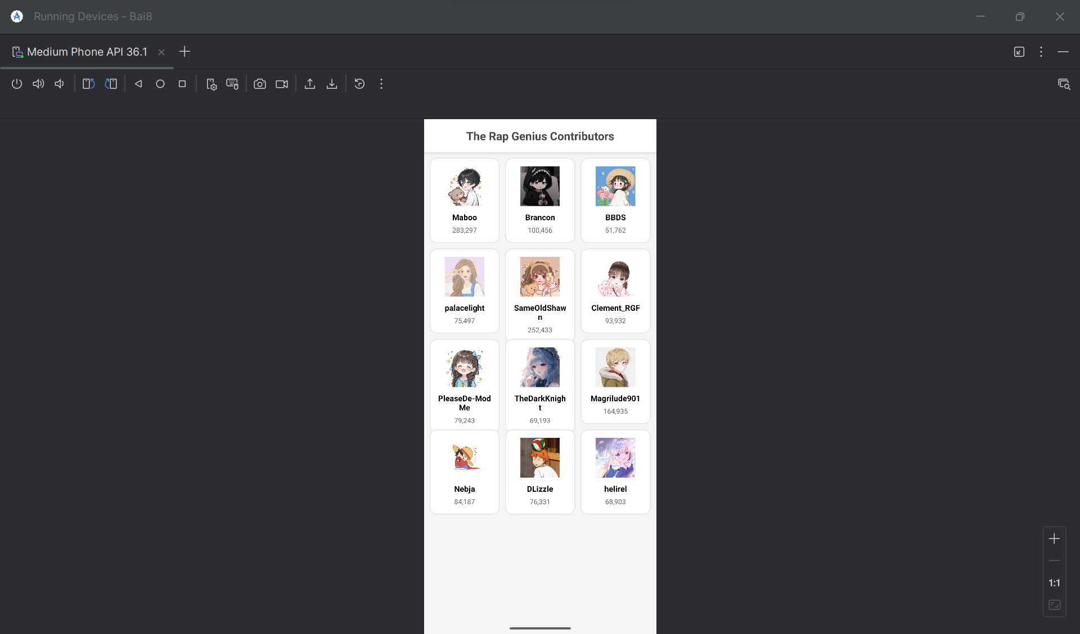

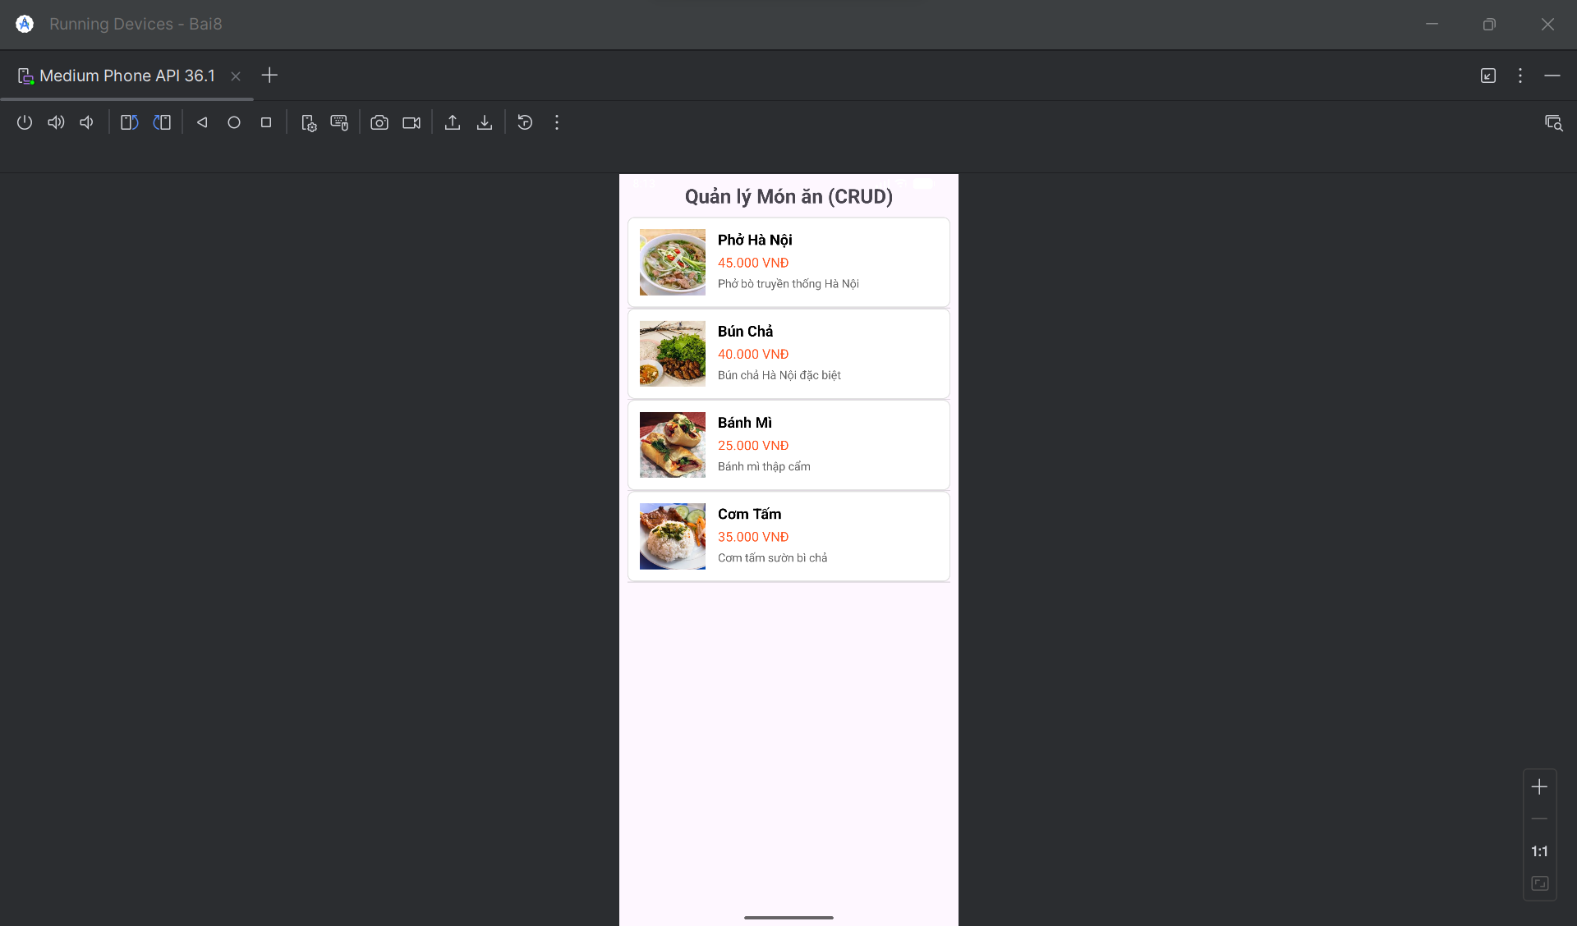

**I. TẠO PROJECT MỚI**

**Bước 1:** Mở Android Studio và tạo project mới

* File → New → New Project
* Chọn "Empty Views Activity"
* Đặt tên: Bai8
* Package name: com.example.bai8
* Language: Java
* Minimum SDK: API 21 (Android 5.0)

**Bước 2:** Chờ Android Studio tạo project xong

**II. TẠO CÁC LỚP MODEL**

**1. Tạo lớp Food.java**

Trong thư mục java/com.example.bai8, chuột phải → New → Java Class → Đặt tên Food

package com.example.bai8;

public class Food {

public int image;

public String name;

public String price;

public String description;

public Food(int image, String name, String price, String description) {

this.image = image;

this.name = name;

this.price = price;

this.description = description;

}

}

**2. Tạo lớp Contributor.java**

Chuột phải → New → Java Class → Đặt tên Contributor

package com.example.bai8;

public class Contributor {

public String name;

public String points;

public int avatar;

public Contributor(String name, String points, int avatar) {

this.name = name;

this.points = points;

this.avatar = avatar;

}

}

**III. TẠO CÁC LAYOUT**

**1. Sửa file activity_main.xml**

Mở res/layout/activity_main.xml và thay thế bằng:

xml

<?xml version="1.0" encoding="utf-8"?>

<FrameLayout xmlns:android="http://schemas.android.com/apk/res/android"

android:layout_width="match_parent"

android:layout_height="match_parent">

<!-- Main Menu -->

<LinearLayout

android:id="@+id/main_layout"

android:layout_width="match_parent"

android:layout_height="match_parent"

android:orientation="vertical"

android:padding="16dp"

android:background="#F5F5F5">

<TextView

android:layout_width="match_parent"

android:layout_height="wrap_content"

android:text="Ứng dụng Quản lý Món ăn"

android:textSize="24sp"

android:textStyle="bold"

android:gravity="center"

android:layout_marginBottom="30dp"

android:textColor="#333333" />

<Button

android:id="@+id/btnListView"

android:layout_width="match_parent"

android:layout_height="wrap_content"

android:text="Bài 1: ListView Món ăn"

android:textSize="16sp"

android:padding="15dp"

android:layout_marginBottom="15dp"

android:background="#4CAF50"

android:textColor="#FFFFFF" />

<Button

android:id="@+id/btnGridView"

android:layout_width="match_parent"

android:layout_height="wrap_content"

android:text="Bài 2: GridView Contributors"

android:textSize="16sp"

android:padding="15dp"

android:layout_marginBottom="15dp"

android:background="#2196F3"

android:textColor="#FFFFFF" />

<Button

android:id="@+id/btnCRUD"

android:layout_width="match_parent"

android:layout_height="wrap_content"

android:text="Bài 3: CRUD với Context Menu"

android:textSize="16sp"

android:padding="15dp"

android:background="#FF9800"

android:textColor="#FFFFFF" />

</LinearLayout>

<!-- List View -->

<LinearLayout

android:id="@+id/list_layout"

android:layout_width="match_parent"

android:layout_height="match_parent"

android:orientation="vertical"

android:padding="10dp"

android:visibility="gone">

<TextView

android:layout_width="match_parent"

android:layout_height="wrap_content"

android:text="Danh sách món ăn"

android:textSize="24sp"

android:textStyle="bold"

android:gravity="center"

android:layout_marginBottom="10dp" />

<ListView

android:id="@+id/listViewFood"

android:layout_width="match_parent"

android:layout_height="match_parent" />

</LinearLayout>

<!-- Grid View -->

<LinearLayout

android:id="@+id/grid_layout"

android:layout_width="match_parent"

android:layout_height="match_parent"

android:orientation="vertical"

android:background="#F5F5F5"

android:visibility="gone">

<TextView

android:layout_width="match_parent"

android:layout_height="wrap_content"

android:text="The Rap Genius Contributors"

android:textSize="20sp"

android:textStyle="bold"

android:gravity="center"

android:padding="16dp"

android:background="#FFFFFF"

android:elevation="4dp" />

<GridView

android:id="@+id/gridView"

android:layout_width="match_parent"

android:layout_height="match_parent"

android:numColumns="3"

android:verticalSpacing="10dp"

android:horizontalSpacing="10dp"

android:padding="10dp"

android:stretchMode="columnWidth" />

</LinearLayout>

<!-- CRUD View -->

<LinearLayout

android:id="@+id/crud_layout"

android:layout_width="match_parent"

android:layout_height="match_parent"

android:orientation="vertical"

android:padding="10dp"

android:visibility="gone">

<TextView

android:layout_width="match_parent"

android:layout_height="wrap_content"

android:text="Quản lý Món ăn (CRUD)"

android:textSize="24sp"

android:textStyle="bold"

android:gravity="center"

android:layout_marginBottom="10dp" />

<ListView

android:id="@+id/listViewFoodCRUD"

android:layout_width="match_parent"

android:layout_height="match_parent" />

</LinearLayout>

</FrameLayout>

**2. Tạo layout item_food.xml**

Chuột phải thư mục res/layout → New → Layout Resource File → Đặt tên item_food

xml

<?xml version="1.0" encoding="utf-8"?>

<LinearLayout xmlns:android="http://schemas.android.com/apk/res/android"

android:layout_width="match_parent"

android:layout_height="wrap_content"

android:orientation="horizontal"

android:padding="15dp"

android:background="@drawable/border_background"

android:layout_margin="5dp">

<ImageView

android:id="@+id/imgFood"

android:layout_width="80dp"

android:layout_height="80dp"

android:scaleType="centerCrop"

android:background="#E0E0E0" />

<LinearLayout

android:layout_width="0dp"

android:layout_height="wrap_content"

android:layout_weight="1"

android:orientation="vertical"

android:layout_marginLeft="15dp">

<TextView

android:id="@+id/txtFoodName"

android:layout_width="match_parent"

android:layout_height="wrap_content"

android:textSize="18sp"

android:textStyle="bold"

android:textColor="#000000" />

<TextView

android:id="@+id/txtFoodPrice"

android:layout_width="match_parent"

android:layout_height="wrap_content"

android:textSize="16sp"

android:textColor="#FF5722"

android:layout_marginTop="5dp" />

<TextView

android:id="@+id/txtFoodDescription"

android:layout_width="match_parent"

android:layout_height="wrap_content"

android:textSize="14sp"

android:textColor="#666666"

android:layout_marginTop="5dp" />

</LinearLayout>

</LinearLayout>

**3. Tạo layout item_contributor.xml**

Chuột phải thư mục res/layout → New → Layout Resource File → Đặt tên item_contributor

xml

<?xml version="1.0" encoding="utf-8"?>

<LinearLayout xmlns:android="http://schemas.android.com/apk/res/android"

android:layout_width="match_parent"

android:layout_height="wrap_content"

android:orientation="vertical"

android:gravity="center"

android:padding="15dp"

android:background="@drawable/grid_item_background">

<ImageView

android:id="@+id/imgAvatar"

android:layout_width="70dp"

android:layout_height="70dp"

android:scaleType="centerCrop"

android:background="#E0E0E0"

android:layout_marginBottom="10dp" />

<TextView

android:id="@+id/txtName"

android:layout_width="match_parent"

android:layout_height="wrap_content"

android:gravity="center"

android:textSize="14sp"

android:textStyle="bold"

android:textColor="#000000" />

<TextView

android:id="@+id/txtPoints"

android:layout_width="match_parent"

android:layout_height="wrap_content"

android:gravity="center"

android:textSize="12sp"

android:textColor="#666666"

android:layout_marginTop="5dp" />

</LinearLayout>

**4. Tạo layout dialog_add_food.xml**

Chuột phải thư mục res/layout → New → Layout Resource File → Đặt tên dialog_add_food

xml

<?xml version="1.0" encoding="utf-8"?>

<LinearLayout xmlns:android="http://schemas.android.com/apk/res/android"

android:layout_width="match_parent"

android:layout_height="wrap_content"

android:orientation="vertical"

android:padding="20dp">

<TextView

android:layout_width="match_parent"

android:layout_height="wrap_content"

android:text="Thêm món ăn mới"

android:textSize="18sp"

android:textStyle="bold"

android:gravity="center"

android:layout_marginBottom="20dp" />

<EditText

android:id="@+id/edtFoodName"

android:layout_width="match_parent"

android:layout_height="wrap_content"

android:hint="Tên món ăn"

android:layout_marginBottom="10dp" />

<EditText

android:id="@+id/edtFoodPrice"

android:layout_width="match_parent"

android:layout_height="wrap_content"

android:hint="Giá"

android:inputType="number"

android:layout_marginBottom="10dp" />

<EditText

android:id="@+id/edtFoodDescription"

android:layout_width="match_parent"

android:layout_height="wrap_content"

android:hint="Mô tả"

android:minLines="3"

android:layout_marginBottom="20dp" />

</LinearLayout>

**IV. TẠO CÁC DRAWABLE**

**1. Tạo border_background.xml**

Chuột phải thư mục res/drawable → New → Drawable Resource File → Đặt tên border_background

xml

<?xml version="1.0" encoding="utf-8"?>

<shape xmlns:android="http://schemas.android.com/apk/res/android">

<solid android:color="#FFFFFF"/>

<stroke android:width="1dp" android:color="#E0E0E0"/>

<corners android:radius="8dp"/>

<padding android:left="5dp" android:top="5dp" android:right="5dp" android:bottom="5dp"/>

</shape>

**2. Tạo grid_item_background.xml**

Chuột phải thư mục res/drawable → New → Drawable Resource File → Đặt tên grid_item_background

xml

<?xml version="1.0" encoding="utf-8"?>

<shape xmlns:android="http://schemas.android.com/apk/res/android">

<solid android:color="#FFFFFF"/>

<stroke android:width="1dp" android:color="#E0E0E0"/>

<corners android:radius="12dp"/>

<padding android:left="8dp" android:top="8dp" android:right="8dp" android:bottom="8dp"/>

</shape>

**V. TẠO CÁC MENU**

**1. Tạo main_menu.xml**

Chuột phải thư mục res → New → Android Resource Directory → Resource type: menu  
Chuột phải thư mục res/menu → New → Menu Resource File → Đặt tên main_menu

xml

<?xml version="1.0" encoding="utf-8"?>

<menu xmlns:android="http://schemas.android.com/apk/res/android">

<item

android:id="@+id/menu_add"

android:title="Thêm món ăn"

android:icon="@android:drawable/ic_menu_add" />

</menu>

**2. Tạo context_menu_food.xml**

Chuột phải thư mục res/menu → New → Menu Resource File → Đặt tên context_menu_food

xml

<?xml version="1.0" encoding="utf-8"?>

<menu xmlns:android="http://schemas.android.com/apk/res/android">

<item

android:id="@+id/menu_edit"

android:title="Sửa" />

<item

android:id="@+id/menu_delete"

android:title="Xóa" />

</menu>

**VI. TẠO CÁC ADAPTER**

**1. Tạo FoodAdapter.java**

Chuột phải thư mục java/com.example.bai8 → New → Java Class → Đặt tên FoodAdapter

package com.example.bai8;

import android.content.Context;

import android.view.LayoutInflater;

import android.view.View;

import android.view.ViewGroup;

import android.widget.BaseAdapter;

import android.widget.ImageView;

import android.widget.TextView;

import java.util.ArrayList;

public class FoodAdapter extends BaseAdapter {

private ArrayList<Food> foodList;

private Context context;

public FoodAdapter(Context context, ArrayList<Food> foodList) {

this.context = context;

this.foodList = foodList;

}

@Override

public int getCount() {

return foodList.size();

}

@Override

public Object getItem(int position) {

return foodList.get(position);

}

@Override

public long getItemId(int position) {

return position;

}

@Override

public View getView(int position, View convertView, ViewGroup parent) {

if (convertView == null) {

convertView = LayoutInflater.from(context).inflate(R.layout.item_food, parent, false);

}

Food food = foodList.get(position);

ImageView imgFood = convertView.findViewById(R.id.imgFood);

TextView txtFoodName = convertView.findViewById(R.id.txtFoodName);

TextView txtFoodPrice = convertView.findViewById(R.id.txtFoodPrice);

TextView txtFoodDescription = convertView.findViewById(R.id.txtFoodDescription);

imgFood.setImageResource(food.image);

txtFoodName.setText(food.name);

txtFoodPrice.setText(food.price);

txtFoodDescription.setText(food.description);

return convertView;

}

}

**2. Tạo ContributorAdapter.java**

Chuột phải thư mục java/com.example.bai8 → New → Java Class → Đặt tên ContributorAdapter

package com.example.bai8;

import android.content.Context;

import android.view.LayoutInflater;

import android.view.View;

import android.view.ViewGroup;

import android.widget.BaseAdapter;

import android.widget.ImageView;

import android.widget.TextView;

import java.util.ArrayList;

public class ContributorAdapter extends BaseAdapter {

private ArrayList<Contributor> contributorList;

private Context context;

public ContributorAdapter(Context context, ArrayList<Contributor> contributorList) {

this.context = context;

this.contributorList = contributorList;

}

@Override

public int getCount() {

return contributorList.size();

}

@Override

public Object getItem(int position) {

return contributorList.get(position);

}

@Override

public long getItemId(int position) {

return position;

}

@Override

public View getView(int position, View convertView, ViewGroup parent) {

if (convertView == null) {

convertView = LayoutInflater.from(context).inflate(R.layout.item_contributor, parent, false);

}

Contributor contributor = contributorList.get(position);

ImageView imgAvatar = convertView.findViewById(R.id.imgAvatar);

TextView txtName = convertView.findViewById(R.id.txtName);

TextView txtPoints = convertView.findViewById(R.id.txtPoints);

imgAvatar.setImageResource(contributor.avatar);

txtName.setText(contributor.name);

txtPoints.setText(contributor.points);

return convertView;

}

}

**VII. SỬA FILE MainActivity.java**

Mở file MainActivity.java và thay thế toàn bộ nội dung bằng:

package com.example.bai8;

import android.app.AlertDialog;

import android.content.DialogInterface;

import android.os.Bundle;

import android.view.ContextMenu;

import android.view.LayoutInflater;

import android.view.Menu;

import android.view.MenuItem;

import android.view.View;

import android.widget.AdapterView;

import android.widget.Button;

import android.widget.EditText;

import android.widget.GridView;

import android.widget.ListView;

import android.widget.Toast;

import androidx.appcompat.app.AppCompatActivity;

import java.util.ArrayList;

public class MainActivity extends AppCompatActivity {

private Button btnListView, btnGridView, btnCRUD;

private ListView listViewFood, listViewFoodCRUD;

private GridView gridView;

private ArrayList<Food> foodList;

private ArrayList<Contributor> contributorList;

private FoodAdapter foodAdapter;

private ContributorAdapter contributorAdapter;

// Các layout view

private View mainView, listView, gridViewLayout, crudView;

@Override

protected void onCreate(Bundle savedInstanceState) {

super.onCreate(savedInstanceState);

setContentView(R.layout.activity_main);

initViews();

setupMainMenu();

initData();

}

private void initViews() {

mainView = findViewById(R.id.main_layout);

listView = findViewById(R.id.list_layout);

gridViewLayout = findViewById(R.id.grid_layout);

crudView = findViewById(R.id.crud_layout);

listViewFood = findViewById(R.id.listViewFood);

listViewFoodCRUD = findViewById(R.id.listViewFoodCRUD);

gridView = findViewById(R.id.gridView);

btnListView = findViewById(R.id.btnListView);

btnGridView = findViewById(R.id.btnGridView);

btnCRUD = findViewById(R.id.btnCRUD);

}

private void setupMainMenu() {

btnListView.setOnClickListener(new View.OnClickListener() {

@Override

public void onClick(View v) {

showListView();

}

});

btnGridView.setOnClickListener(new View.OnClickListener() {

@Override

public void onClick(View v) {

showGridView();

}

});

btnCRUD.setOnClickListener(new View.OnClickListener() {

@Override

public void onClick(View v) {

showCRUDView();

}

});

}

private void showMainView() {

mainView.setVisibility(View.VISIBLE);

listView.setVisibility(View.GONE);

gridViewLayout.setVisibility(View.GONE);

crudView.setVisibility(View.GONE);

}

private void showListView() {

mainView.setVisibility(View.GONE);

listView.setVisibility(View.VISIBLE);

gridViewLayout.setVisibility(View.GONE);

crudView.setVisibility(View.GONE);

foodAdapter = new FoodAdapter(this, foodList);

listViewFood.setAdapter(foodAdapter);

}

private void showGridView() {

mainView.setVisibility(View.GONE);

listView.setVisibility(View.GONE);

gridViewLayout.setVisibility(View.VISIBLE);

crudView.setVisibility(View.GONE);

contributorAdapter = new ContributorAdapter(this, contributorList);

gridView.setAdapter(contributorAdapter);

}

private void showCRUDView() {

mainView.setVisibility(View.GONE);

listView.setVisibility(View.GONE);

gridViewLayout.setVisibility(View.GONE);

crudView.setVisibility(View.VISIBLE);

foodAdapter = new FoodAdapter(this, foodList);

listViewFoodCRUD.setAdapter(foodAdapter);

registerForContextMenu(listViewFoodCRUD);

}

private void initData() {

// Data for ListView - Bài 1

foodList = new ArrayList<>();

foodList.add(new Food(android.R.drawable.ic_media_play, "Phở Hà Nội", "45.000 VNĐ", "Phở bò truyền thống Hà Nội"));

foodList.add(new Food(android.R.drawable.ic_media_play, "Bún Chả", "40.000 VNĐ", "Bún chả Hà Nội đặc biệt"));

foodList.add(new Food(android.R.drawable.ic_media_play, "Bánh Mì", "25.000 VNĐ", "Bánh mì thập cẩm"));

foodList.add(new Food(android.R.drawable.ic_media_play, "Cơm Tấm", "35.000 VNĐ", "Cơm tấm sườn bì chả"));

foodList.add(new Food(android.R.drawable.ic_media_play, "Bánh Xèo", "30.000 VNĐ", "Bánh xèo miền Nam"));

foodList.add(new Food(android.R.drawable.ic_media_play, "Hủ Tiếu", "35.000 VNĐ", "Hủ tiếu Nam Vang"));

// Data for GridView - Bài 2

contributorList = new ArrayList<>();

contributorList.add(new Contributor("Maboo", "283,297", android.R.drawable.sym_def_app_icon));

contributorList.add(new Contributor("Brancon", "100,456", android.R.drawable.sym_def_app_icon));

contributorList.add(new Contributor("BBDS", "51,762", android.R.drawable.sym_def_app_icon));

contributorList.add(new Contributor("palacelight", "75,497", android.R.drawable.sym_def_app_icon));

contributorList.add(new Contributor("SameOldShawn", "252,433", android.R.drawable.sym_def_app_icon));

contributorList.add(new Contributor("Clement_RGF", "93,932", android.R.drawable.sym_def_app_icon));

contributorList.add(new Contributor("PleaseDe-ModMe", "79,243", android.R.drawable.sym_def_app_icon));

contributorList.add(new Contributor("TheDarkKnight", "69,193", android.R.drawable.sym_def_app_icon));

contributorList.add(new Contributor("Magrilude901", "164,935", android.R.drawable.sym_def_app_icon));

}

// CRUD methods - Bài 3

@Override

public boolean onCreateOptionsMenu(Menu menu) {

getMenuInflater().inflate(R.menu.main_menu, menu);

return true;

}

@Override

public boolean onOptionsItemSelected(MenuItem item) {

if (item.getItemId() == R.id.menu_add) {

showAddDialog();

return true;

}

return super.onOptionsItemSelected(item);

}

@Override

public void onCreateContextMenu(ContextMenu menu, View v, ContextMenu.ContextMenuInfo menuInfo) {

super.onCreateContextMenu(menu, v, menuInfo);

getMenuInflater().inflate(R.menu.context_menu_food, menu);

}

@Override

public boolean onContextItemSelected(MenuItem item) {

AdapterView.AdapterContextMenuInfo info = (AdapterView.AdapterContextMenuInfo) item.getMenuInfo();

int position = info.position;

if (item.getItemId() == R.id.menu_edit) {

showEditDialog(position);

return true;

} else if (item.getItemId() == R.id.menu_delete) {

showDeleteDialog(position);

return true;

}

return super.onContextItemSelected(item);

}

private void showAddDialog() {

AlertDialog.Builder builder = new AlertDialog.Builder(this);

LayoutInflater inflater = getLayoutInflater();

View dialogView = inflater.inflate(R.layout.dialog_add_food, null);

final EditText edtFoodName = dialogView.findViewById(R.id.edtFoodName);

final EditText edtFoodPrice = dialogView.findViewById(R.id.edtFoodPrice);

final EditText edtFoodDescription = dialogView.findViewById(R.id.edtFoodDescription);

builder.setView(dialogView)

.setTitle("Thêm món ăn")

.setPositiveButton("Thêm", new DialogInterface.OnClickListener() {

@Override

public void onClick(DialogInterface dialog, int which) {

String name = edtFoodName.getText().toString();

String price = edtFoodPrice.getText().toString();

String description = edtFoodDescription.getText().toString();

if (!name.isEmpty() && !price.isEmpty()) {

foodList.add(new Food(android.R.drawable.ic_media_play, name, price + " VNĐ", description));

foodAdapter.notifyDataSetChanged();

Toast.makeText(MainActivity.this, "Đã thêm món ăn", Toast.LENGTH_SHORT).show();

} else {

Toast.makeText(MainActivity.this, "Vui lòng nhập đầy đủ thông tin", Toast.LENGTH_SHORT).show();

}

}

})

.setNegativeButton("Hủy", null)

.show();

}

private void showEditDialog(final int position) {

AlertDialog.Builder builder = new AlertDialog.Builder(this);

LayoutInflater inflater = getLayoutInflater();

View dialogView = inflater.inflate(R.layout.dialog_add_food, null);

final EditText edtFoodName = dialogView.findViewById(R.id.edtFoodName);

final EditText edtFoodPrice = dialogView.findViewById(R.id.edtFoodPrice);

final EditText edtFoodDescription = dialogView.findViewById(R.id.edtFoodDescription);

Food food = foodList.get(position);

edtFoodName.setText(food.name);

edtFoodPrice.setText(food.price.replace(" VNĐ", ""));

edtFoodDescription.setText(food.description);

builder.setView(dialogView)

.setTitle("Sửa món ăn")

.setPositiveButton("Lưu", new DialogInterface.OnClickListener() {

@Override

public void onClick(DialogInterface dialog, int which) {

String name = edtFoodName.getText().toString();

String price = edtFoodPrice.getText().toString();

String description = edtFoodDescription.getText().toString();

if (!name.isEmpty() && !price.isEmpty()) {

Food updatedFood = new Food(foodList.get(position).image, name, price + " VNĐ", description);

foodList.set(position, updatedFood);

foodAdapter.notifyDataSetChanged();

Toast.makeText(MainActivity.this, "Đã cập nhật món ăn", Toast.LENGTH_SHORT).show();

} else {

Toast.makeText(MainActivity.this, "Vui lòng nhập đầy đủ thông tin", Toast.LENGTH_SHORT).show();

}

}

})

.setNegativeButton("Hủy", null)

.show();

}

private void showDeleteDialog(final int position) {

new AlertDialog.Builder(this)

.setTitle("Xóa món ăn")

.setMessage("Bạn có chắc muốn xóa món ăn '" + foodList.get(position).name + "'?")

.setPositiveButton("Xóa", new DialogInterface.OnClickListener() {

@Override

public void onClick(DialogInterface dialog, int which) {

String deletedName = foodList.get(position).name;

foodList.remove(position);

foodAdapter.notifyDataSetChanged();

Toast.makeText(MainActivity.this, "Đã xóa món ăn: " + deletedName, Toast.LENGTH_SHORT).show();

}

})

.setNegativeButton("Hủy", null)

.show();

}

@Override

public void onBackPressed() {

if (listView.getVisibility() == View.VISIBLE ||

gridViewLayout.getVisibility() == View.VISIBLE ||

crudView.getVisibility() == View.VISIBLE) {

showMainView();

} else {

super.onBackPressed();

}

}}

# CHƯƠNG 4: THỰC HÀNH BUỔI 14

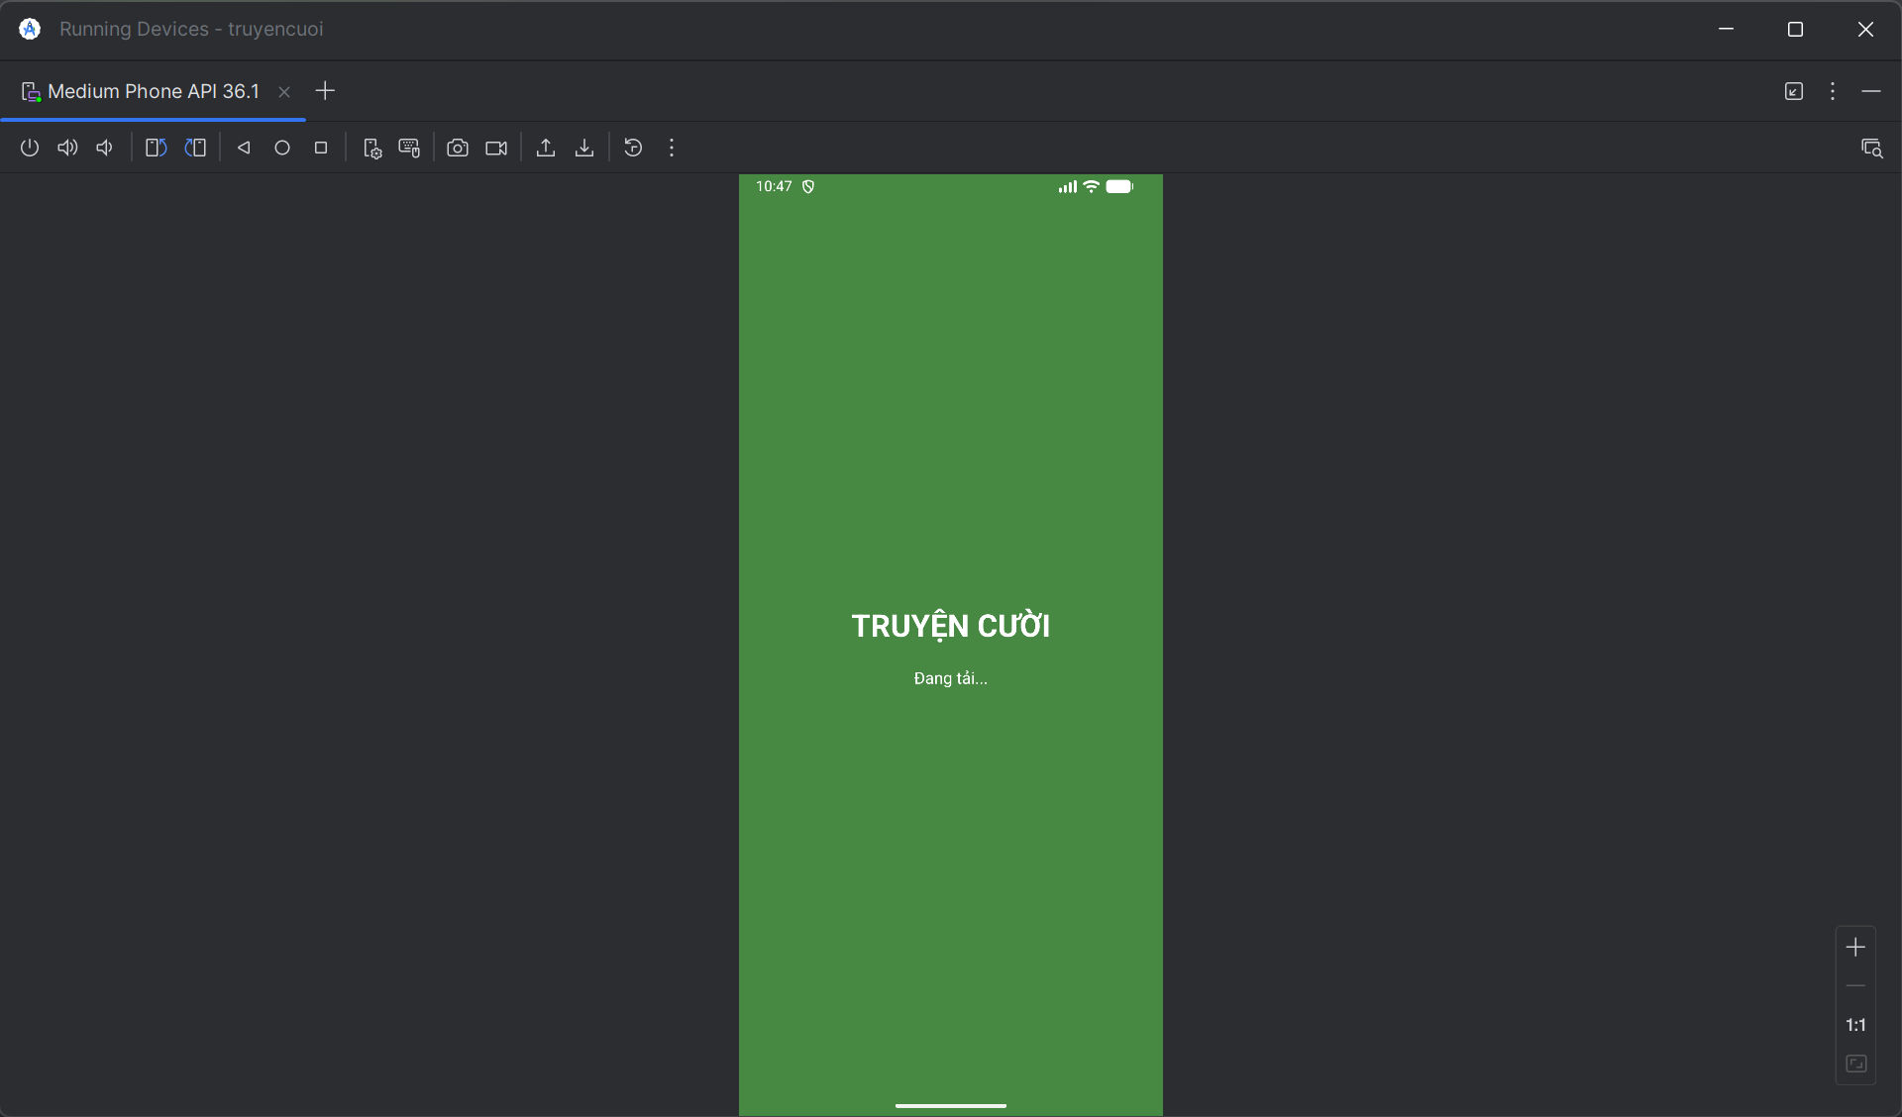

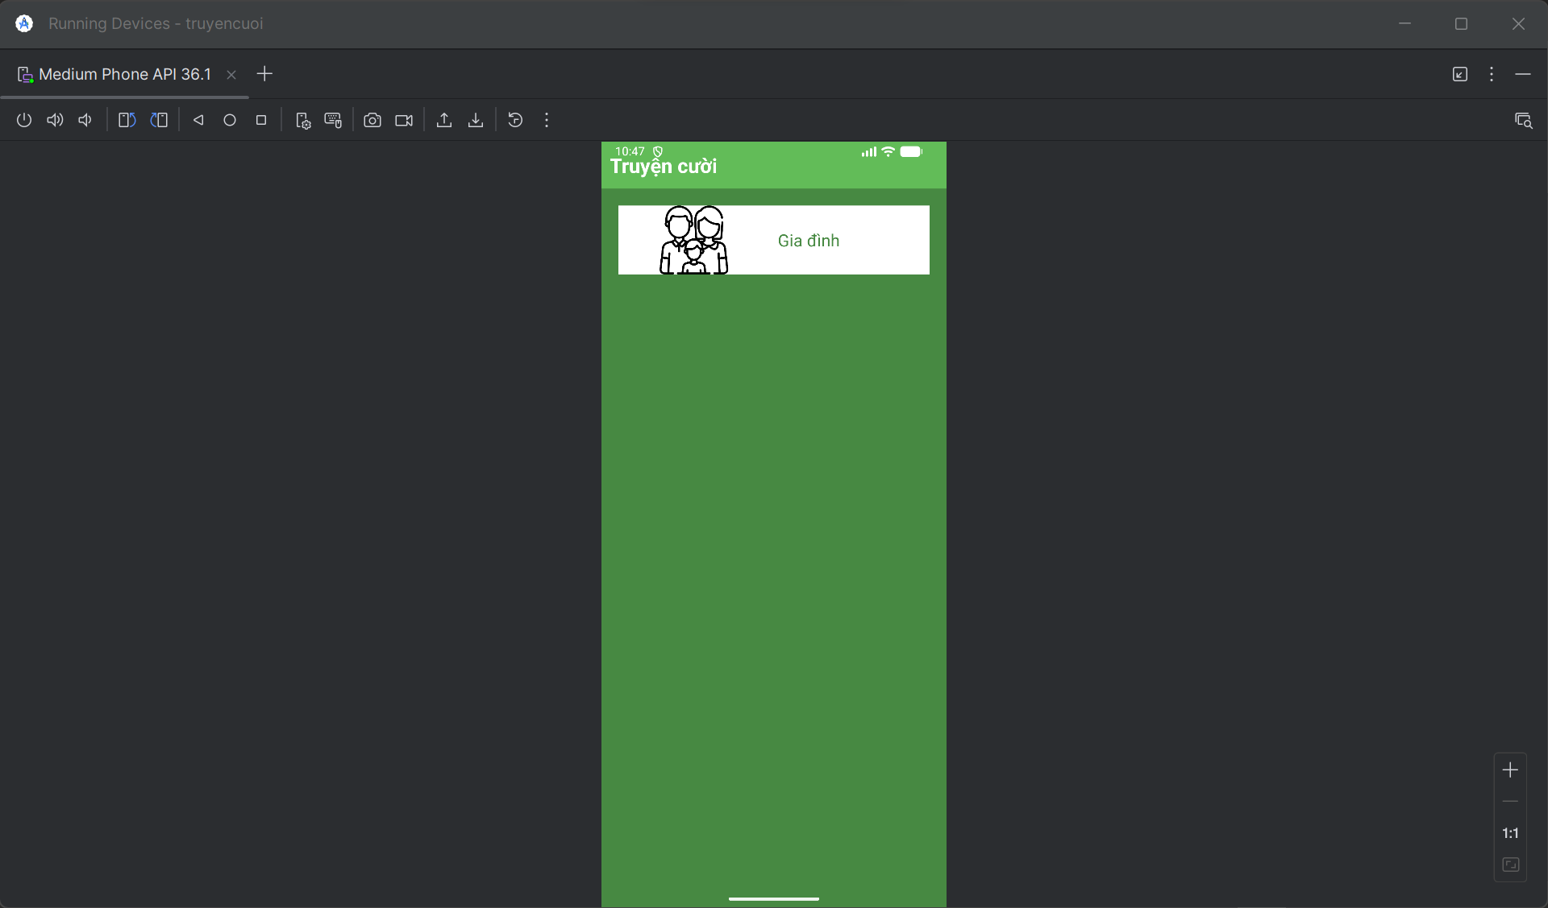

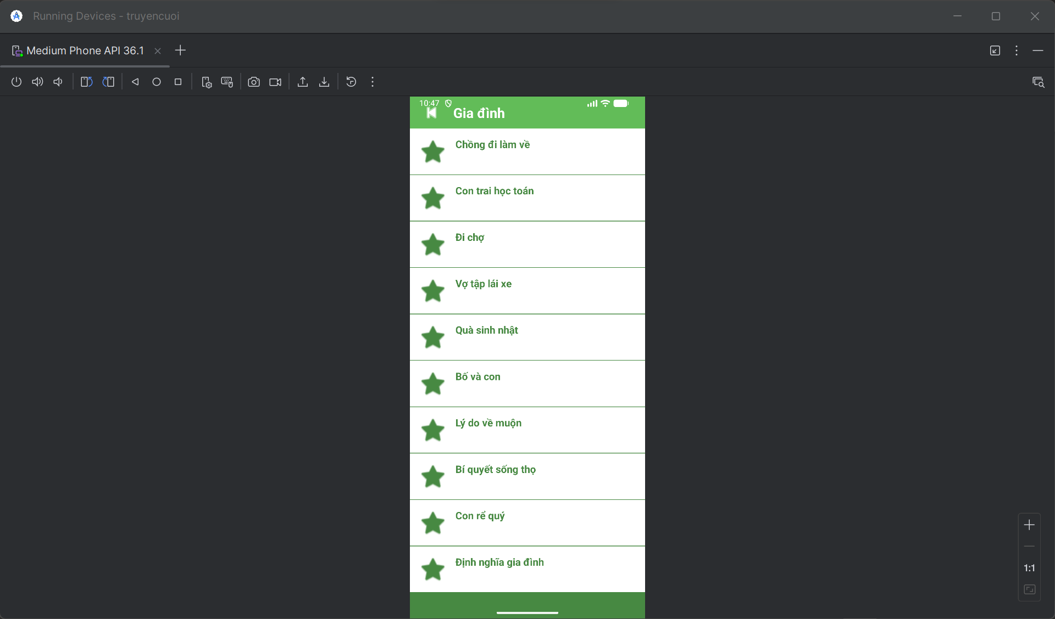

M000SplashFrg.java

package com.techja.truyencuoi;  
  
import android.os.Bundle;  
import android.os.Handler;  
import android.util.Log;  
import android.view.LayoutInflater;  
import android.view.View;  
import android.view.ViewGroup;  
import androidx.fragment.app.Fragment;  
  
public class M000SplashFrg extends Fragment {  
 private static final String *TAG* = "M000SplashFrg";  
  
 @Override  
 public View onCreateView(LayoutInflater inflater, ViewGroup container, Bundle savedInstanceState) {  
 Log.*d*(*TAG*, "onCreateView: Tạo view splash");  
 View view = inflater.inflate(R.layout.*m000_frg_splash*, container, false);  
 initViews();  
 return view;  
 }  
  
 private void initViews() {  
 Log.*d*(*TAG*, "initViews: Bắt đầu đếm ngược 2 giây");  
 new Handler().postDelayed(() -> {  
 Log.*d*(*TAG*, "initViews: Đã đợi 2 giây, chuyển màn hình");  
 gotoM001Screen();  
 }, 2000);  
 }  
  
 private void gotoM001Screen() {  
 try {  
 Log.*d*(*TAG*, "gotoM001Screen: Gọi MainActivity");  
 ((MainActivity) getActivity()).gotoM001Screen();  
 } catch (Exception e) {  
 Log.*e*(*TAG*, "Lỗi gotoM001Screen: " + e.getMessage(), e);  
 }  
 }  
}

M001TopicFrg.java

package com.techja.truyencuoi;  
  
import android.content.Context;  
import android.os.Bundle;  
import android.util.Log;  
import android.view.LayoutInflater;  
import android.view.View;  
import android.view.ViewGroup;  
import android.widget.ImageView;  
import android.widget.LinearLayout;  
import android.widget.TextView;  
import androidx.fragment.app.Fragment;  
  
public class M001TopicFrg extends Fragment implements View.OnClickListener {  
 private Context mContext;  
 private static final String *TAG* = "M001TopicFrg";  
  
 @Override  
 public View onCreateView(LayoutInflater inflater, ViewGroup container, Bundle savedInstanceState) {  
 View rootView = inflater.inflate(R.layout.*m001_frg_topic*, container, false);  
 initViews(rootView);  
 return rootView;  
 }  
  
 @Override  
 public void onAttach(Context context) {  
 super.onAttach(context);  
 mContext = context;  
 }  
  
 private void initViews(View v) {  
 LinearLayout lnMain = v.findViewById(R.id.*ln_topic*);  
 lnMain.removeAllViews();  
  
 try {  
 // Tạo chủ đề "Gia đình"  
 View vTopic = LayoutInflater.*from*(mContext).inflate(R.layout.*item_topic*, null);  
  
 // --- SỬA Ở ĐÂY: KHÔNG can thiệp vào ImageView nữa để nó tự lấy ảnh từ XML ---  
 // ImageView ivTopic = vTopic.findViewById(R.id.iv_topic);  
 // ivTopic.setImageResource(android.R.drawable.ic_menu_gallery); // <--- DÒNG NÀY GÂY LỖI MẤT ẢNH  
  
 TextView tvTopic = vTopic.findViewById(R.id.*tv_topic*);  
 tvTopic.setText("Gia đình");  
  
 lnMain.addView(vTopic);  
  
 // Chỉnh khoảng cách (Margin)  
 LinearLayout.LayoutParams params = (LinearLayout.LayoutParams) vTopic.getLayoutParams();  
 params.bottomMargin = 40;  
 vTopic.setLayoutParams(params);  
  
 // Gắn tag để biết user chọn chủ đề nào  
 vTopic.setTag("gia_dinh");  
 vTopic.setOnClickListener(this);  
  
 } catch (Exception e) {  
 e.printStackTrace();  
 }  
 }  
  
 @Override  
 public void onClick(View v) {  
 String topicName = (String) v.getTag();  
 ((MainActivity) getActivity()).gotoM002Screen(topicName);  
 }  
}

M002StoryFrg.java

package com.techja.truyencuoi;  
  
import android.content.Context;  
import android.os.Bundle;  
import android.view.LayoutInflater;  
import android.view.View;  
import android.view.ViewGroup;  
import android.widget.TextView;  
import androidx.fragment.app.Fragment;  
import androidx.recyclerview.widget.LinearLayoutManager;  
import androidx.recyclerview.widget.RecyclerView;  
import java.io.BufferedReader;  
import java.io.IOException;  
import java.io.InputStreamReader;  
import java.util.ArrayList;  
  
public class M002StoryFrg extends Fragment {  
 private Context mContext;  
 private ArrayList<StoryEntity> listStory;  
 private String topicName;  
  
 @Override  
 public View onCreateView(LayoutInflater inflater, ViewGroup container, Bundle savedInstanceState) {  
 View rootView = inflater.inflate(R.layout.*m002_frg_story*, container, false);  
 initViews(rootView);  
 return rootView;  
 }  
  
 @Override  
 public void onAttach(Context context) {  
 super.onAttach(context);  
 mContext = context;  
 }  
  
 private void initViews(View v) {  
 v.findViewById(R.id.*iv_back*).setVisibility(View.*VISIBLE*);  
 v.findViewById(R.id.*iv_back*).setOnClickListener(v1 -> backToM001Screen());  
  
 TextView tvName = v.findViewById(R.id.*tv_name*);  
  
 // --- SỬA 1: Hiển thị tên chủ đề đẹp hơn ---  
 if (topicName.equals("gia_dinh")) {  
 tvName.setText("Gia đình");  
 } else {  
 tvName.setText(topicName);  
 }  
  
 RecyclerView rv = v.findViewById(R.id.*rv_story*);  
 listStory = readStory();  
 StoryAdapter adapter = new StoryAdapter(listStory, mContext);  
 rv.setAdapter(adapter);  
 rv.setLayoutManager(new LinearLayoutManager(mContext));  
 }  
  
 private ArrayList<StoryEntity> readStory() {  
 ArrayList<StoryEntity> listStory = new ArrayList<>();  
 BufferedReader reader = null;  
 try {  
 reader = new BufferedReader(  
 new InputStreamReader(mContext.getAssets().open("story/" + topicName + ".txt"), "UTF-8"));  
  
 String mLine;  
 // --- SỬA 2: Thuật toán đọc file mới (chống lỗi mất tên truyện) ---  
 while ((mLine = reader.readLine()) != null) {  
 // Nếu gặp dòng trống thì bỏ qua, đọc dòng tiếp theo  
 if (mLine.trim().isEmpty()) {  
 continue;  
 }  
  
 // Dòng có chữ đầu tiên sẽ là Tiêu đề (Title)  
 String title = mLine;  
  
 // Các dòng tiếp theo là nội dung, đọc cho đến khi gặp ký tự kết thúc ','0'),  
 StringBuilder contentBuilder = new StringBuilder();  
 while ((mLine = reader.readLine()) != null) {  
 if (mLine.contains("','0'),")) {  
 break; // Dừng lại khi gặp ký tự kết thúc truyện  
 }  
 contentBuilder.append(mLine).append("\n");  
 }  
  
 // Tạo đối tượng truyện và thêm vào danh sách  
 StoryEntity storyEntity = new StoryEntity(topicName, title, contentBuilder.toString());  
 listStory.add(storyEntity);  
 }  
 } catch (IOException e) {  
 e.printStackTrace();  
 }  
 return listStory;  
 }  
  
 public void setTopicName(String topicName) {  
 this.topicName = topicName;  
 }  
  
 private void backToM001Screen() {  
 ((MainActivity) getActivity()).backToM001Screen();  
 }  
}

MainActivity.java

package com.techja.truyencuoi;  
  
import android.os.Bundle;  
import android.widget.Toast;  
import androidx.appcompat.app.AppCompatActivity;  
import androidx.fragment.app.Fragment;  
import java.util.ArrayList;  
  
public class MainActivity extends AppCompatActivity {  
 private String topicName; // Lưu tên chủ đề đang chọn  
  
 @Override  
 protected void onCreate(Bundle savedInstanceState) {  
 super.onCreate(savedInstanceState);  
 setContentView(R.layout.*activity_main*);  
  
 // Bắt đầu vào màn hình Splash  
 showFrg(new M000SplashFrg());  
 }  
  
 private void showFrg(Fragment frg) {  
 try {  
 getSupportFragmentManager().beginTransaction()  
 .replace(R.id.*ln_main*, frg, null)  
 .commit();  
 } catch (Exception e) {  
 e.printStackTrace();  
 }  
 }  
  
 public void gotoM001Screen() {  
 showFrg(new M001TopicFrg());  
 }  
  
 public void gotoM002Screen(String topicName) {  
 this.topicName = topicName; // Lưu lại để dùng khi back  
 M002StoryFrg frg = new M002StoryFrg();  
 frg.setTopicName(topicName);  
 showFrg(frg);  
 }  
  
 public void backToM001Screen() {  
 gotoM001Screen();  
 }  
  
 public void gotoM003Screen(ArrayList<StoryEntity> listStory, StoryEntity story) {  
 M003DetailStoryFrg frg = new M003DetailStoryFrg();  
 frg.setData(topicName, listStory, story);  
 showFrg(frg);  
 }  
  
 // --- QUAN TRỌNG: XỬ LÝ NÚT BACK CỨNG TRÊN ĐIỆN THOẠI ---  
 @Override  
 public void onBackPressed() {  
 // Tìm xem fragment nào đang hiển thị  
 Fragment currentFrg = getSupportFragmentManager().findFragmentById(R.id.*ln_main*);  
  
 if (currentFrg instanceof M003DetailStoryFrg) {  
 // Đang đọc truyện -> Quay về danh sách  
 gotoM002Screen(topicName);  
 } else if (currentFrg instanceof M002StoryFrg) {  
 // Đang xem danh sách -> Quay về chọn chủ đề  
 gotoM001Screen();  
 } else if (currentFrg instanceof M001TopicFrg) {  
 // Đang ở màn hình chính -> Thoát App  
 super.onBackPressed();  
 } else {  
 super.onBackPressed();  
 }  
 }  
}

StoryAdapter.java

package com.techja.truyencuoi;  
  
import android.content.Context;  
import android.view.LayoutInflater;  
import android.view.View;  
import android.view.ViewGroup;  
import android.widget.TextView;  
import androidx.recyclerview.widget.RecyclerView;  
import java.util.ArrayList;  
  
public class StoryAdapter extends RecyclerView.Adapter<StoryAdapter.StoryHolder> {  
 private final ArrayList<StoryEntity> listStory;  
 private final Context mContext;  
  
 public StoryAdapter(ArrayList<StoryEntity> listStory, Context mContext) {  
 this.listStory = listStory;  
 this.mContext = mContext;  
 }  
  
 @Override  
 public StoryHolder onCreateViewHolder(ViewGroup parent, int viewType) {  
 View view = LayoutInflater.*from*(mContext).inflate(R.layout.*item_story*, parent, false);  
 return new StoryHolder(view);  
 }  
  
 @Override  
 public void onBindViewHolder(StoryAdapter.StoryHolder holder, int position) {  
 StoryEntity item = listStory.get(position);  
 holder.tvName.setTag(item);  
 holder.tvName.setText(item.getName());  
 }  
  
 @Override  
 public int getItemCount() {  
 return listStory.size();  
 }  
  
 public class StoryHolder extends RecyclerView.ViewHolder {  
 TextView tvName;  
  
 public StoryHolder(View itemView) {  
 super(itemView);  
 // SỬA DÒNG NÀY - đổi từ tv_story sang tv_name  
 tvName = itemView.findViewById(R.id.*tv_name*);  
 itemView.setOnClickListener(v -> {  
 ((MainActivity) mContext).gotoM003Screen(listStory, (StoryEntity) tvName.getTag());  
 });  
 }  
 }  
}

StoryEntity.java

package com.techja.truyencuoi;  
  
public class StoryEntity {  
 private final String topicName;  
 private final String name;  
 private final String content;  
  
 public StoryEntity(String topicName, String name, String content) {  
 this.topicName = topicName;  
 this.name = name;  
 this.content = content;  
 }  
  
 public String getTopicName() {  
 return topicName;  
 }  
  
 public String getName() {  
 return name;  
 }  
  
 public String getContent() {  
 return content;  
 }  
}

DetailStoryAdapter.java

package com.techja.truyencuoi;  
  
import android.content.Context;  
import android.view.LayoutInflater;  
import android.view.View;  
import android.view.ViewGroup;  
import android.widget.TextView;  
import androidx.annotation.NonNull;  
import androidx.viewpager.widget.PagerAdapter;  
import java.util.List;  
  
public class DetailStoryAdapter extends PagerAdapter {  
 private final List<StoryEntity> listStory;  
 private final Context mContext;  
  
 public DetailStoryAdapter(List<StoryEntity> listStory, Context mContext) {  
 this.listStory = listStory;  
 this.mContext = mContext;  
 }  
  
 @Override  
 public Object instantiateItem(ViewGroup container, int position) {  
 View view = LayoutInflater.*from*(mContext).inflate(R.layout.*item_detail_story*, container, false);  
 StoryEntity item = listStory.get(position);  
  
 TextView tvName = view.findViewById(R.id.*tv_name*);  
 TextView tvContent = view.findViewById(R.id.*tv_content*);  
 tvName.setTag(item);  
 tvName.setText(item.getName());  
 tvContent.setText(item.getContent());  
 container.addView(view);  
 return view;  
 }  
  
 @Override  
 public int getCount() {  
 return listStory.size();  
 }  
  
 @Override  
 public boolean isViewFromObject(View view, Object object) {  
 return view.equals(object);  
 }  
  
 @Override  
 public void destroyItem(ViewGroup container, int position, Object object) {  
 container.removeView((View) object);  
 }  
}

AndroidManifest.xml

<?xml version="1.0" encoding="utf-8"?>

<manifest xmlns:android="http://schemas.android.com/apk/res/android"

    package="com.techja.truyencuoi">

    <application

        android:allowBackup="true"

        android:icon="@mipmap/ic_launcher"

        android:label="@string/app_name"

        android:theme="@style/Theme.Demo">

        <activity

            android:name=".MainActivity"

            android:exported="true">

            <intent-filter>

                <action android:name="android.intent.action.MAIN" />

                <category android:name="android.intent.category.LAUNCHER" />

            </intent-filter>

        </activity>

    </application>

</manifest>

colors.xml

<?xml version="1.0" encoding="utf-8"?>

<resources>

    <color name="purple_200">#FFBB86FC</color>

    <color name="purple_500">#FF6200EE</color>

    <color name="purple_700">#FF3700B3</color>

    <color name="teal_200">#FF03DAC5</color>

    <color name="teal_700">#FF018786</color>

    <color name="black">#FF000000</color>

    <color name="white">#FFFFFFFF</color>

    <color name="greenMid">#478942</color>

    <color name="greenLight">#62BC58</color>

    <color name="greenSuperLight">#EFFFEE</color>

</resources>

Strings.xml

<resources>

    <string name="app_name">TruyenCuoi</string>

    <string name="txt_congai">Con gái</string>

    <string name="txt_story">Vừa đúng vừa sai</string>

    <string name="txt_gia_dinh">Gia đình</string>

</resources>

**File: themes.xml**

<resources xmlns:tools="http://schemas.android.com/tools">

    <style name="Theme.Demo" parent="Theme.MaterialComponents.DayNight.NoActionBar">

        <item name="colorPrimary">@color/purple_500</item>

        <item name="colorPrimaryVariant">@color/purple_700</item>

        <item name="colorOnPrimary">@color/white</item>

        <item name="colorSecondary">@color/teal_200</item>

        <item name="colorSecondaryVariant">@color/teal_700</item>

        <item name="colorOnSecondary">@color/black</item>

        <item name="android:statusBarColor" tools:targetApi="l">?attr/colorPrimaryVariant</item>

    </style>

</resources>

**File: activity_main.xml** (Khung chứa chính của ứng dụng)

<?xml version="1.0" encoding="utf-8"?>

<LinearLayout xmlns:android="http://schemas.android.com/apk/res/android"

    xmlns:tools="http://schemas.android.com/tools"

    android:layout_width="match_parent"

    android:layout_height="match_parent"

    android:id="@+id/ln_main"

    tools:context=".MainActivity"

    android:orientation="vertical">

</LinearLayout>

**File: actionbar_home.xml** (Thanh tiêu đề màu xanh ở trên cùng có nút Back)

<?xml version="1.0" encoding="utf-8"?>

<LinearLayout xmlns:android="http://schemas.android.com/apk/res/android"

    xmlns:app="http://schemas.android.com/apk/res-auto"

    android:layout_width="match_parent"

    android:layout_height="56dp"

    android:background="@color/greenLight"

    android:orientation="horizontal">

    <ImageView

        android:id="@+id/iv_back"

        android:layout_width="56dp"

        android:layout_height="56dp"

        android:layout_marginStart="10dp"

        android:padding="10dp"

        android:src="@android:drawable/ic_media_previous"

        android:visibility="gone"

        app:tint="@color/white"/>

    <TextView

        android:id="@+id/tv_name"

        android:layout_width="match_parent"

        android:layout_height="match_parent"

        android:layout_marginStart="10dp"

        android:gravity="center_vertical"

        android:text="Truyện cười"

        android:textColor="@color/white"

        android:textSize="24sp"

        android:textStyle="bold"/>

</LinearLayout>

**File: m000_frg_splash.xml** (Màn hình chờ lúc mở app)

<?xml version="1.0" encoding="utf-8"?>

<LinearLayout xmlns:android="http://schemas.android.com/apk/res/android"

    android:layout_width="match_parent"

    android:layout_height="match_parent"

    android:background="@color/greenMid"

    android:gravity="center"

    android:orientation="vertical">

    <TextView

        android:layout_width="wrap_content"

        android:layout_height="wrap_content"

        android:text="TRUYỆN CƯỜI"

        android:textColor="@color/white"

        android:textSize="30sp"

        android:textStyle="bold"/>

    <TextView

        android:layout_width="wrap_content"

        android:layout_height="wrap_content"

        android:text="Đang tải..."

        android:textColor="@color/white"

        android:textSize="16sp"

        android:layout_marginTop="20dp"/>

</LinearLayout>

**File: m001_frg_topic.xml** (Màn hình 1 - Chứa nút chọn chủ đề)

<?xml version="1.0" encoding="utf-8"?>

<LinearLayout xmlns:android="http://schemas.android.com/apk/res/android"

    android:layout_width="match_parent"

    android:layout_height="match_parent"

    android:background="@color/greenMid"

    android:orientation="vertical">

    <!-- Nhúng thanh tiêu đề vào -->

    <include layout="@layout/actionbar_home"/>

    <ScrollView

        android:layout_width="match_parent"

        android:layout_height="match_parent">

        <LinearLayout

            android:id="@+id/ln_topic"

            android:layout_width="match_parent"

            android:layout_height="wrap_content"

            android:orientation="vertical"

            android:padding="20dp"/>

    </ScrollView>

</LinearLayout>

**File: item_topic.xml** (Giao diện của cái nút "Gia đình")

<?xml version="1.0" encoding="utf-8"?>

<LinearLayout xmlns:android="http://schemas.android.com/apk/res/android"

    xmlns:tools="http://schemas.android.com/tools"

    android:layout_width="match_parent"

    android:layout_height="wrap_content"

    android:background="@color/white"

    android:layout_marginBottom="10dp"

    android:orientation="horizontal"

    tools:ignore="UseCompoundDrawables">

    <ImageView

        android:id="@+id/iv_topic"

        android:layout_width="180dp"

        android:layout_height="82dp"

        android:src="@drawable/gia_dinh"

        tools:ignore="ContentDescription"/>

    <TextView

        android:id="@+id/tv_topic"

        android:layout_width="match_parent"

        android:layout_height="match_parent"

        android:layout_marginStart="10dp"

        android:fontFamily="sans-serif"

        android:gravity="center_vertical"

        android:text="@string/txt_gia_dinh"

        android:textColor="@color/greenMid"

        android:textSize="20sp"/>

</LinearLayout>

**File: m002_frg_story.xml** (Màn hình 2 - Danh sách các truyện)

<?xml version="1.0" encoding="utf-8"?>

<LinearLayout xmlns:android="http://schemas.android.com/apk/res/android"

    xmlns:tools="http://schemas.android.com/tools"

    android:layout_width="match_parent"

    android:layout_height="match_parent"

    android:background="@color/greenMid"

    android:orientation="vertical">

    <include layout="@layout/actionbar_home"/>

    <androidx.recyclerview.widget.RecyclerView

        android:id="@+id/rv_story"

        android:layout_width="match_parent"

        android:layout_height="match_parent"

        tools:listitem="@layout/item_story"/>

</LinearLayout>

**File: item_story.xml** (Giao diện 1 dòng tên truyện trong danh sách)

<?xml version="1.0" encoding="utf-8"?>

<LinearLayout xmlns:android="http://schemas.android.com/apk/res/android"

    xmlns:app="http://schemas.android.com/apk/res-auto"

    android:layout_width="match_parent"

    android:layout_height="80dp"

    android:background="@color/white"

    android:orientation="horizontal"

    android:padding="15dp"

    android:layout_marginBottom="1dp">

    <ImageView

        android:layout_width="50dp"

        android:layout_height="50dp"

        android:src="@android:drawable/btn_star_big_on"

        app:tint="@color/greenMid"/>

    <TextView

        android:id="@+id/tv_name"

        android:layout_width="match_parent"

        android:layout_height="wrap_content"

        android:layout_marginStart="15dp"

        android:gravity="center_vertical"

        android:text="Truyện cười"

        android:textColor="@color/greenMid"

        android:textSize="18sp"

        android:textStyle="bold"/>

</LinearLayout>

**File: item_detail_story.xml** (Nội dung chi tiết của 1 truyện bên trong ViewPager)

<?xml version="1.0" encoding="utf-8"?>

<LinearLayout xmlns:android="http://schemas.android.com/apk/res/android"

    android:layout_width="match_parent"

    android:layout_height="match_parent"

    android:orientation="vertical"

    android:padding="10dp">

    <TextView

        android:id="@+id/tv_name"

        android:layout_width="match_parent"

        android:layout_height="wrap_content"

        android:layout_marginTop="20dp"

        android:gravity="center"

        android:padding="10dp"

        android:text="Vợ đúng vợ sai"

        android:textColor="@color/greenMid"

        android:textSize="24sp"

        android:textStyle="bold"/>

    <ScrollView

        android:layout_width="match_parent"

        android:layout_height="match_parent">

        <LinearLayout

            android:layout_width="match_parent"

            android:layout_height="wrap_content"

            android:orientation="vertical">

            <TextView

                android:id="@+id/tv_content"

                android:layout_width="match_parent"

                android:layout_height="wrap_content"

                android:fontFamily="sans-serif-light"

                android:gravity="center_vertical"

                android:lineSpacingExtra="5dp"

                android:padding="10dp"

                android:text="Nội dung truyện"

                android:textColor="@color/black"

                android:textSize="18sp"/>

        </LinearLayout>

    </ScrollView>

</LinearLayout>

# CHƯƠNG 5: THỰC HÀNH BUỔI 15

Bước 1: Cấu hình Tài nguyên (Resources)

Đầu tiên, chúng ta thiết lập các giá trị màu sắc và chuỗi ký tự dùng chung.

* 1. File res/values/colors.xml Định nghĩa bảng màu cho ứng dụng.

1. <?xml version="1.0" encoding="utf-8"?>  
   <resources>  
    <color name="purple_200">#FFBB86FC</color>  
    <color name="purple_500">#FF6200EE</color>  
    <color name="purple_700">#F4511E</color>  
    <color name="teal_200">#FF03DAC5</color>  
    <color name="teal_700">#FF018786</color>  
    <color name="black">#FF000000</color>  
    <color name="white">#FFFFFFFF</color>  
    <color name="orange">#FB8C00</color>  
    <color name="gray">#EAE5E3</color>  
    <color name="orangeMid">#F4511E</color>  
   </resources>

1.2. File res/values/strings.xml Định nghĩa các văn bản hiển thị.

Bước 2: Tạo Giao diện Nền (Drawables)

Bước này tạo các hình dạng (shape) cho nút bấm và ô nhập liệu để giao diện đẹp hơn. Tạo các file này trong thư mục res/drawable/.

2.1. File bg_login.xml (Nền cho nút Login/Register) Lưu ý: Đây là file đã được sửa lỗi cú pháp XML.

XML

<?xml version="1.0" encoding="utf-8"?>

<shape xmlns:android="http://schemas.android.com/apk/res/android">

<solid android:color="@color/orangeMid"/>

<corners android:radius="25dp"/>

</shape>

2.2. File bg_radius.xml (Nền cho ô nhập liệu) Tạo viền trắng và bo góc cho EditText.

XML

<?xml version="1.0" encoding="utf-8"?>

<shape xmlns:android="http://schemas.android.com/apk/res/android">

<solid android:color="@color/white"/>

<corners android:radius="10dp"/>

</shape>

2.3. File bg_top.xml (Hình nền trang trí phía trên) Tạo khối màu cam bo tròn góc dưới.

XML

<?xml version="1.0" encoding="utf-8"?>

<shape xmlns:android="http://schemas.android.com/apk/res/android">

<solid android:color="@color/orange"/>

<corners

android:bottomLeftRadius="80dp"

android:bottomRightRadius="80dp"/>

</shape>

Lưu ý: Đối với các icon ic_email, ic_key, ic_back, bạn cần click chuột phải vào thư mục drawable -> New -> Vector Asset để thêm vào từ thư viện có sẵn của Android Studio.

Bước 3: Thiết kế Layout (XML Layouts)

3.1. File res/layout/activity_main.xml Layout chính chứa LinearLayout để nạp các Fragment.

XML

<?xml version="1.0" encoding="utf-8"?>

<LinearLayout xmlns:android="http://schemas.android.com/apk/res/android"

android:id="@+id/ln_main"

android:layout_width="match_parent"

android:layout_height="match_parent"

android:orientation="vertical">

</LinearLayout>

3.2. File res/layout/m000_frg_login.xml Giao diện màn hình đăng nhập.

<?xml version="1.0" encoding="utf-8"?>

<LinearLayout xmlns:android="http://schemas.android.com/apk/res/android"

android:layout_width="match_parent"

android:layout_height="match_parent"

android:background="@color/gray"

android:orientation="vertical">

<FrameLayout

android:layout_width="match_parent"

android:layout_height="wrap_content">

<View

android:layout_width="match_parent"

android:layout_height="300dp"

android:background="@drawable/bg_top"/>

<TextView

android:layout_width="wrap_content"

android:layout_height="wrap_content"

android:layout_gravity="end"

android:layout_marginTop="220dp"

android:layout_marginEnd="30dp"

android:layout_marginRight="30dp"

android:text="@string/txt_login"

android:textColor="@color/white"

android:textSize="20sp" />

</FrameLayout>

<EditText

android:id="@+id/edt_email"

android:layout_width="match_parent"

android:layout_height="50dp"

android:layout_marginHorizontal="30dp"

android:layout_marginTop="50dp"

android:background="@drawable/bg_radius"

android:hint="@string/hint_email"

android:padding="10dp"

android:inputType="textEmailAddress"/>

<EditText

android:id="@+id/edt_pass"

android:layout_width="match_parent"

android:layout_height="50dp"

android:layout_marginHorizontal="30dp"

android:layout_marginTop="20dp"

android:background="@drawable/bg_radius"

android:hint="@string/hint_password"

android:padding="10dp"

android:inputType="textPassword"/>

<TextView

android:id="@+id/tv_login"

android:layout_width="match_parent"

android:layout_height="50dp"

android:layout_gravity="end"

android:layout_marginHorizontal="30dp"

android:layout_marginTop="40dp"

android:background="@drawable/bg_login"

android:gravity="center"

android:text="@string/txt_login"

android:textColor="@color/white"

android:textSize="18sp" />

<TableRow

android:layout_width="match_parent"

android:layout_height="wrap_content"

android:layout_marginTop="30dp"

android:gravity="center">

<TextView

android:text="@string/txt_no_account"

android:textColor="@color/black" />

<TextView

android:id="@+id/tv_register"

android:layout_marginLeft="5dp"

android:text="@string/txt_register"

android:textColor="@color/orange"

android:textStyle="bold" />

</TableRow>

</LinearLayout>

3.3. File res/layout/m001_frg_register.xml Giao diện màn hình đăng ký.

<?xml version="1.0" encoding="utf-8"?>

<LinearLayout xmlns:android="http://schemas.android.com/apk/res/android"

android:layout_width="match_parent"

android:layout_height="match_parent"

android:background="@color/gray"

android:orientation="vertical">

<FrameLayout

android:layout_width="match_parent"

android:layout_height="wrap_content">

<View

android:layout_width="match_parent"

android:layout_height="300dp"

android:background="@drawable/bg_top"/>

<ImageView

android:id="@+id/iv_back"

android:layout_width="56dp"

android:layout_height="56dp"

android:padding="10dp"

android:src="@drawable/ic_launcher_foreground"

android:contentDescription="Back"/>

<TextView

android:layout_width="wrap_content"

android:layout_height="wrap_content"

android:layout_gravity="end"

android:layout_marginTop="220dp"

android:layout_marginRight="30dp"

android:text="@string/txt_register"

android:textColor="@color/white"

android:textSize="20sp" />

</FrameLayout>

<EditText

android:id="@+id/edt_email"

android:layout_width="match_parent"

android:layout_height="50dp"

android:layout_marginHorizontal="30dp"

android:layout_marginTop="50dp"

android:background="@drawable/bg_radius"

android:hint="@string/hint_email"

android:inputType="textEmailAddress"

android:padding="10dp"/>

<EditText

android:id="@+id/edt_pass"

android:layout_width="match_parent"

android:layout_height="50dp"

android:layout_marginHorizontal="30dp"

android:layout_marginTop="10dp"

android:background="@drawable/bg_radius"

android:hint="@string/hint_password"

android:inputType="textPassword"

android:padding="10dp"/>

<EditText

android:id="@+id/edt_re_pass"

android:layout_width="match_parent"

android:layout_height="50dp"

android:layout_marginHorizontal="30dp"

android:layout_marginTop="10dp"

android:background="@drawable/bg_radius"

android:hint="Re-password"

android:inputType="textPassword"

android:padding="10dp"/>

<TextView

android:id="@+id/tv_register"

android:layout_width="match_parent"

android:layout_height="50dp"

android:layout_marginHorizontal="30dp"

android:layout_marginTop="20dp"

android:background="@drawable/bg_login"

android:gravity="center"

android:text="@string/txt_register"

android:textColor="@color/white"

android:textSize="18sp" />

</LinearLayout>

Bước 4: Lập trình Logic (Java)

4.1. File MainActivity.java Activity chính, quản lý việc chuyển đổi giữa màn hình đăng nhập và đăng ký.

package com.example.account;

import android.os.Bundle;

import androidx.appcompat.app.AppCompatActivity;

public class MainActivity extends AppCompatActivity {

public static final String SAVE_PREF = "save_pref";

@Override

protected void onCreate(Bundle savedInstanceState) {

super.onCreate(savedInstanceState);

setContentView(R.layout.activity_main);

gotoLoginScreen(); // Mặc định vào màn hình đăng nhập

}

public void gotoRegisterScreen() {

getSupportFragmentManager().beginTransaction()

.replace(R.id.ln_main, new M001RegisterFragment())

.addToBackStack(null) // Cho phép quay lại

.commit();

}

public void gotoLoginScreen() {

getSupportFragmentManager().beginTransaction()

.replace(R.id.ln_main, new M000LoginFragment())

.commit();

}

}

4.2. File M000LoginFragment.java Xử lý logic đăng nhập: Kiểm tra Email/Pass trong SharedPreferences.

package com.example.account;

import android.content.Context;

import android.content.SharedPreferences;

import android.os.Bundle;

import android.view.LayoutInflater;

import android.view.View;

import android.view.ViewGroup;

import android.view.animation.AnimationUtils;

import android.widget.EditText;

import android.widget.Toast;

import androidx.fragment.app.Fragment;

public class M000LoginFragment extends Fragment implements View.OnClickListener {

private EditText edtEmail, edtPass;

private Context mContext;

@Override

public View onCreateView(LayoutInflater inflater, ViewGroup container, Bundle savedInstanceState) {

View rootView = inflater.inflate(R.layout.m000_frg_login, container, false);

initView(rootView);

return rootView;

}

@Override

public void onAttach(Context context) {

super.onAttach(context);

mContext = context;

}

private void initView(View v) {

edtEmail = v.findViewById(R.id.edt_email);

edtPass = v.findViewById(R.id.edt_pass);

v.findViewById(R.id.tv_login).setOnClickListener(this);

v.findViewById(R.id.tv_register).setOnClickListener(this);

}

@Override

public void onClick(View v) {

v.startAnimation(AnimationUtils.loadAnimation(mContext, androidx.appcompat.R.anim.abc_fade_in));

if (v.getId() == R.id.tv_login) {

login(edtEmail.getText().toString(), edtPass.getText().toString());

} else if (v.getId() == R.id.tv_register) {

((MainActivity) mContext).gotoRegisterScreen();

}

}

private void login(String mail, String pass) {

if (mail.isEmpty() || pass.isEmpty()) {

Toast.makeText(mContext, "Empty value", Toast.LENGTH_SHORT).show();

return;

}

SharedPreferences pref = mContext.getSharedPreferences(MainActivity.SAVE_PREF, Context.MODE_PRIVATE);

String savedPass = pref.getString(mail, null);

if (savedPass == null) {

Toast.makeText(mContext, "Email does not exist!", Toast.LENGTH_SHORT).show();

return;

}

if (!pass.equals(savedPass)) {

Toast.makeText(mContext, "Password is not correct!", Toast.LENGTH_SHORT).show();

return;

}

Toast.makeText(mContext, "Login successfully!", Toast.LENGTH_SHORT).show();

}

}

4.3. File M001RegisterFragment.java Xử lý logic đăng ký: Lưu Email/Pass mới vào SharedPreferences.

package com.example.account;

import android.content.Context;

import android.content.SharedPreferences;

import android.os.Bundle;

import android.view.LayoutInflater;

import android.view.View;

import android.view.ViewGroup;

import android.view.animation.AnimationUtils;

import android.widget.EditText;

import android.widget.Toast;

import androidx.fragment.app.Fragment;

public class M001RegisterFragment extends Fragment implements View.OnClickListener {

private EditText edtEmail, edtPass, edtRepass;

private Context mContext;

@Override

public View onCreateView(LayoutInflater inflater, ViewGroup container, Bundle savedInstanceState) {

View rootView = inflater.inflate(R.layout.m001_frg_register, container, false);

initView(rootView);

return rootView;

}

@Override

public void onAttach(Context context) {

super.onAttach(context);

mContext = context;

}

private void initView(View v) {

edtEmail = v.findViewById(R.id.edt_email);

edtPass = v.findViewById(R.id.edt_pass);

edtRepass = v.findViewById(R.id.edt_re_pass);

v.findViewById(R.id.tv_register).setOnClickListener(this);

v.findViewById(R.id.iv_back).setOnClickListener(this);

}

@Override

public void onClick(View v) {

v.startAnimation(AnimationUtils.loadAnimation(mContext, androidx.appcompat.R.anim.abc_fade_in));

if (v.getId() == R.id.iv_back) {

((MainActivity) mContext).gotoLoginScreen();

} else if (v.getId() == R.id.tv_register) {

register(edtEmail.getText().toString(), edtPass.getText().toString(), edtRepass.getText().toString());

}

}

private void register(String mail, String pass, String repass) {

if (mail.isEmpty() || pass.isEmpty() || repass.isEmpty()) {

Toast.makeText(mContext, "Empty value", Toast.LENGTH_SHORT).show();

return;

}

if (!pass.equals(repass)) {

Toast.makeText(mContext, "Password does not match", Toast.LENGTH_SHORT).show();

return;

}

SharedPreferences pref = mContext.getSharedPreferences(MainActivity.SAVE_PREF, Context.MODE_PRIVATE);

String savedPass = pref.getString(mail, null);

if (savedPass != null) {

Toast.makeText(mContext, "Email already exists!", Toast.LENGTH_SHORT).show();

return;

}

pref.edit().putString(mail, pass).apply();

Toast.makeText(mContext, "Register account successfully!", Toast.LENGTH_SHORT).show();

((MainActivity) mContext).gotoLoginScreen();

}

}

Bước 5: Cập nhật Manifest (AndroidManifest.xml)

Khai báo Activity chính để ứng dụng biết điểm bắt đầu.

<?xml version="1.0" encoding="utf-8"?>

<manifest xmlns:android="http://schemas.android.com/apk/res/android"

xmlns:tools="http://schemas.android.com/tools">

<application

android:allowBackup="true"

android:icon="@mipmap/ic_launcher"

android:label="@string/app_name"

android:roundIcon="@mipmap/ic_launcher_round"

android:supportsRtl="true"

android:theme="@style/Theme.Account">

<activity

android:name=".MainActivity"

android:exported="true">

<intent-filter>

<action android:name="android.intent.action.MAIN" />

<category android:name="android.intent.category.LAUNCHER" />

</intent-filter>

</activity>

</application>

</manifest>

